

***CUSTOMER RETENTION***

***PROJECT***

**Submitted by:**

**Akhand Pratap singh**

***ACKNOWLEDGMENT***

I would like to thank Flip Robo Technologies for providing me with the opportunity to work on this project from which I have learned a lot. I am also grateful to Miss Sapna verma for her constant guidance and support.

Some of the reference sources are as follows:

* Internet
* Medium.com
* Analytics Vidhya
* StackOverflow

***TABLE OF CONTENTS***

**ACKNOWLEDGMENT ...............................................................................................** 2

INTRODUCTION 1

BUSINESS PROBLEM FRAMING 1

CONCEPTUAL BACKGROUND OF THE DOMAIN PROBLEM 1

REVIEW OF LITERATURE 1

MOTIVATION FOR THE PROBLEM UNDERTAKEN 8

ANALYTICAL PROBLEM FRAMING 8

MATHEMATICAL/ ANALYTICAL MODELING OF THE PROBLEM 8

DATA SOURCES AND THEIR FORMATS 9

DATA PREPROCESSING DONE 11

DATA INPUTS- LOGIC- OUTPUT RELATIONSHIPS 15

HARDWARE AND SOFTWARE REQUIREMENTS AND TOOLS USED 15

MODEL/S DEVELOPMENT AND EVALUATION 16

IDENTIFICATION OF POSSIBLE PROBLEM-SOLVING APPROACHES

(METHODS) 16

TESTING OF IDENTIFIED APPROACHES (ALGORITHMS) 17

VISUALIZATIONS 17

INTERPRETATION OF THE RESULTS 105

CONCLUSION 105

KEY FINDINGS AND CONCLUSIONS OF THE STUDY 105

LEARNING OUTCOMES OF THE STUDY IN RESPECT OF DATA SCIENCE 106

LIMITATIONS OF THIS WORK AND SCOPE FOR FUTURE WORK 107

# INTRODUCTION

## BUSINESS PROBLEM FRAMING

The objective was to perform extensive data analysis on a given dataset and produce valuable insights that will help in customer retention

## CONCEPTUAL BACKGROUND OF THE DOMAIN PROBLEM

Customer satisfaction has emerged as one of the most important factors that guarantee the success of online store; it has been posited as a key stimulant of purchase, repurchase intentions and customer loyalty. A comprehensive review of the literature, theories and models have been carried out to propose the models for customer activation and customer retention. Five major factors that contributed to the success of an e-commerce store have been identified as: service quality, system quality, information quality, trust and net benefit.

## REVIEW OF LITERATURE

In today’s challenging economy and competitive business world, retaining their customer base is critical to organization success. If the company doesn’t give their customer some good reason to stay, organization’s competitors will give the customer a reason to leave. Customer retention and customer satisfaction drive profits. It’s far less expensive to cultivate organization existing customer base and sell more service to the customer than it to seek new, single-transaction customers. Most surveys across industries shows that keeping one existing customer is five to seven times more profitable than attracting one new customer. A customer-focused approach among its employees is still not present. In this era of intense competition .it is very important for any service company to understand that merely acquiring customer is not sufficient because there is a direct link between customer retention over time and profitability & growth. Customer retention to a great extent depends on service quality and customer satisfaction. Complaints are natural part of any service activity as mistakes are an unavoidable feature of all human endeavoured thus also of service recovery. Service recovery is the process of putting things right after something goes wrong in the service delivery. Customer retention is the maintenance of continuous trading relationships with customers over the long term.

Customer retention is the mirror image of customer defection. High retention is equivalent to low defection. In an industry where there are a multiple purchases over the years, organization’s entire team should be very focused on retaining those customers:

1. Delivering service that’s consistent with your value proposition and brand
2. Cross-selling, up-selling and asking for referrals from existing customers
3. Developing programs to increase customer loyalty and decrease turnover
4. Prioritizing retention as a major focus in your annual marketing plan.
5. Knowing the lifetime value for different segments and using that data to improve the marketing.

Studies say it costs ten times more to generate a new customer than to maintain an existing one. If organization has a small number of customers, losing a few could cripple company. Even if there are a large number of customers, a small increase in the rate should dramatically increase profits. The maintenance of the patronage of people who have purchased a company’s goods or services once and the gaining of repeat purchases. Customer retention occurs when a customer is loyal to a company, brand, or to a specific product or service, expressing long-term commitment and refusing to purchase from competitors. Of critical importance to such strategies are the wider concepts of customer service, customer relations, and relationship marketing. Companies can build loyalty and retention through the use of a number of techniques, including database marketing, the issue of loyalty cards, redeemable against a variety of goods or service, preferential discounts, free gifts, special promotions, newsletters or magazines, members’ clubs or customized products in limited editions. It has been argued that customer retention is linked to employee loyalty, since loyal employees build up long-term relationships with customers. Customer retention has always been an important topic for the marketing. For sure, the advantages of loyal clients are obvious. Often CRM is only implementing new systems for data mining and client segmentation or operational system like a complaint management. But the thing is: data mining system or client clubs are not the basis. They are the cherry of the cake called client retention. A key principle of relationship marketing is the retention of customers through varying means and practices to ensure repeated trade from pre-existing customers by satisfying requirements above those of competing companies through a mutually beneficial relationship. This techniques is now used as a means of counter balancing new customer and opportunities with Current and existing customers as a means of maximizing profit and counteracting the “leaky bucket theory of business” in which new customer gained in order direct marketing oriented businesses were at the expense of or coincided with the loss of older customers. This process of "churning" is less economically viable than retaining all or the majority of customers using both direct and relationship management as lead generation via new customers requires more investment. Many companies in competing markets will redirect or allocate large amounts of resources or attention towards customer retention as in markets with increasing competition it may cost 5 times more to attract new customers than it would to retain current customers, as direct or "offensive" marketing requires much more extensive resources to cause defection from competitors. However, it is suggested that because of the extensive classic marketing theories centre on means of attracting customer and creating transactions rather than maintaining them, the majority usage of direct marketing used in the past is now gradually being used more alongside relationship marketing as its importance becomes more recognizable. According to Buchanan and Gilles the increased profitability associated with customer retention efforts occurs because of several factors that occur once a relationship has been established with a customer.

1. The cost of acquisition occurs only at the beginning of the relationship, so the longer the relationship, the lower the amortized cost.
2. Account maintenance costs decline as a percentage of total costs or as a percentage of revenue.
3. Long-term customers tend to be less inclined to switch, and also tend to be fewer prices sensitive. This can result in stable unit sales volume and increase in dollar-sales volume.
4. Long-term customer may initiate free word of mouth promotions and referrals.
5. Long-term customers are more likely to purchase ancillary products and high margin supplemental products.
6. Customer that stay with company tend to be satisfied with the relationship and are less likely to switch to competitors, making it difficult for competitors to enter the market or gain market share.

**IMPORTANCE OF CUSTOMER RETENTION:**

There are a number of reasons for this. To begin with, to acquire a customer a company incurs promotional costs like advertising, sales promotion etc. It is said that it costs five times more to attract a new customer than retaining one. The operating cost decrease when a customer stays.Service being rich in experience and credence qualities, it takes some time for customers to get accustomed to it and once they are used to the service and are satisfied with the service provider,they tend to purchase more over a period of time. As they remain satisfied with a service provider,they spread a positive word of mouth, which is very effective in case of service for attracting new customers. Longer the customer stays with an organization, more the organization knows about him, which enables it to offer a customized service which makes it difficult for the customer to defect. This may even provide opportunities to the organization to charge price premium by offering individualized service which may be difficult for the competitors to offer. Considering the importance of retaining customers in service business,

Reichheld & Sasser coined a term ‘Zero Defection’.They highlighted that companies can boost profits by almost 100% by retaining just 5% more of their customers. Further, it is also very important to understand the life time value of a customer. Further, if by a positive word of mouth, he brings just one more customer to the organization, his value to the organization doubles. Therefore, it is important for all the employees in the organization to understand the life time value of their customers.

**ADVANTAGES OF CUSTOMER RETENTION POSSIBILITY OF REPEAT BUSINESS:**

This is probably the most obvious advantage of customer retention. Effective services that lead to customer satisfaction will make customer coming back to again, thus giving repeat business. Repeat business is a win-win proposition for the business or service and the customer. The business reduces the cost of customer acquisition, while the customer reduces the cost of finding a reliable vendor and thus also saves on costs associated with switching vendors.

**REDUCED COSTS FOR CUSTOMER ACQUISITION**

Acquiring a customer has certain associated costs. These include the costs associated with advertising, following up, sales demos, travel and meeting cost etc. having a repeat customer means that the customer means that the customer is already aware of your processes and can predict certain quality of output, thus minimizing the cost involved in new customer acquisition. Having a repeat customer also has the potential to open up another channel to advertise your business word of mouth. Word of mouth advertising recommendations are perhaps the most important outcome of having a satisfied customer.

**FOSTERING GREATER INTERACTION BETWEEN BUSINESS AND CUSTOMER**

Today’s markets are increasingly moving away from mass produced standard products and service, towards a more customized market, where products and service are tailored to meet customers’ specific requirements. Having a repeat customer is an opportunity for you to build a more focused relationship based on your customers’ specific needs and requirements. Being ensured of having a customer who comes back, you have more confidence to suggest improvements, provide an insight to better understand their needs and consequently design products and services that are relevant. Having a repeat business also provides an opportunity for the buyer and the seller to co-create products and services.

**HAVING MORE DELIGHTED CUSTOMERS**

Effective customer retention strategies allow you to move from the zone of customer satisfaction to customer delight. Studies have shown that customer delight is achieved only when there is a perfect synergy between the buyer needs and the buyer understands what the seller can deliver exactly what the customer need. If you are able to deliver your customers, you have better chance of them coming back to you, since they now know why you are different from the rest of competition.

**CUSTOMER RETENTION: STATISTICS**

* Acquiring new customer can cost five times more than satisfying and retaining current customers.
* 2% increase in customer retention has same effect on profits as cutting costs by 10%.
* The average company losses 10% of its customer each year.
* 5% reduction in the customer defection rate can increase profits by 25-125%, depending on the industries.
* The customer profitability rate tends to increase over the life of a retained customer.
* Companies can boost profits anywhere from 25 to 125% by retaining merely5% more existing customers.

**MEASURING CUSTOMER RETENTION:**

Retention rate is normally calculated as the number of customers who have been lost over a period of time, usually calculated over a quarterly or annual period. The key is to calculate the percentage versus existing customers, and not underestimate the loss rate by tallying new customer acquisitions into the mix. The customer retention rate refers to the number of customer lost over a period of time. It is normally calculated by the percentage of lost customer versus existing customers over a quarterly or annual period, without tallying new customer acquisitions. While there are obvious benefits to keeping customers loyal and maintaining retention rates, it can be extremely challenging for management to keep retention rates up. Some companies can measure retention rate using their CRM system, since any of the vendor swith solid sales modules should offer this capability. Customer service expert Lori Bock lundre commends that companies look for this functionality when evaluating CRM solutions, even though it is unlikely to be the differentiating factor. Companies like witness, Performix, AIM, and Merced offer these types of tools. To measure this, some companies combines data from the CRM system and data from other systems, such as your systems, such as your quality monitoring system,ACD or CTI solution handling contact routing and reporting. There are no hard and fast rules on calculating customer defection and customer retention, according to

Lowenstein. It can depend on the industries or the type of business, since

companies have long-term arrangements with customers. However, several consulting and database management companies have succeeded in creating them. However, the appropriate interval over which retention rate should be measured is not always one year. Rather, it depends on the customer repurchase cycle. Car insurance and magazine subscriptions are bought on an annual basis. Carpet tiles and hi-fis are not. If the normal hi-fire placement cycle is four years, then retention rate is more meaningful if it is measured over four years instead of twelve months. Additional complexity is added when companies a sell a range of products and services, each with different repurchase cycles. Automobile dealers might sell cars, parts, fuel and service to a single customer. These products have different repurchase cycles which make it very difficult for the dealer to have a whole of customer perspective on retention. Sometimes companies are not clear about whether an individual customer has defected. This is because of the location of customer related data, which might be retained in product silos, channel silos or functional silos.

**TYPE OF CUSTOMER RETENTION RATE**

**RAW CUSTOMER RETENTION RATE :**

This is the number of customer doing business with a firm at the end of a trading period, expressed as percentage of those who were active customer at the beginning of the period.

**SALES-ADJUSTED RETENTION RATE:**

This is the value of sales achieved from the retained customers, expressed as a percentage of the sales achieved from all customers who were active at the beginning of the period.

**PROFIT-ADJUSTED RETENTION RATE:**

This is the profit earned from the retained customers, expressed as a percentage of the profit earned from all customers who were active at the beginning of the period.

## MOTIVATION FOR THE PROBLEM UNDERTAKEN

The combination of both utilitarian value and hedonistic values are needed to affect the repeat purchase intention (loyalty) positively. Objective behind the problem is to help ecommerce websites to find E-retail factors for customer activation and retention.

# ANALYTICAL PROBLEM FRAMING

## MATHEMATICAL/ ANALYTICAL MODELING OF THE PROBLEM

In this project we have performed various mathematical and statistical analysis such as we checked description or statistical summary of the data using describe, checked correlation using corr and also visualized it using heatmap.

* The dataset consist of 71 features and 269 rows.
* All of the attributes were of ‘object’ type except the pin code (int).
* Dataset did not contained any null values.

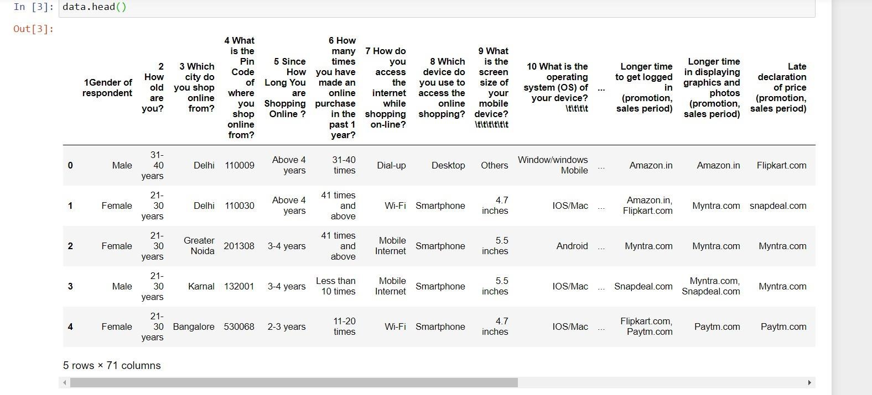

## DATA SOURCES AND THEIR FORMATS

The data has been collected from Indian Online Retailers. Results indicate the e- retail success factors which are very much critical for customer saitisfaction.

Questions that we will try to answer by performing EDA are as follows:

* Online Shopping is preferred in which cities?
* Who are the potential customers: ➢ Which age group they belong to?
* Who shops the most? Males or Females?
* How long people have been shopping for?
* Are they satisfied?
* Do they trust the online store?
* How many times shopped in past 1 year? Did they purchase or cancelled often?
* Time spent before deciding what to purchase?
* Average time spent shopping before making a decision by males and females?
* Preferred payment option?
* group by age groups?
* gender
* How do people access online retail store?
* internet accessibility
* device used
* screen size of the device
* os of the device
* browser used
* channel used2
* how did u reach online retail store after first visit?
* Why do people cancel their orders?
* What factors about the app matters ?
* content readabilty should be simple?
* info on the product?
* navigation of the website
* User friendly Interface
* convenient payment methods
* trust on that retail store will be transacting on time ➢ guarantees privacy of the customer?
* the availability of retails stores on multiple channels?
* Return and replacement policy of the e-tailer is important for purchase decision
* offers a wide product variety?
* if you are getting value for the money spent?
* loading and processing speed
* What are the benefits of online shopping?
* gives monetary benefit and discounts
* access to loyalty programs
* enhances social status
* feel gratification
* helps fulfill certain roles
* gives a sense of adventure
* monetary savings
* convenient and flexible
* enjoyement derived
* User satisfaction depends on what factors?
* cannot exist without trust (38)
* net benefit derived lead to user satisfaction(37)
* achieved while shopping on good quality app/website (36)
* display info (35)

➢ Which online retail store performs better?

* easy to use app?
* visually appealing web page layout?
* variety of products on?
* fast loading websites?
* reliability of website or appn?
* complete relevant info of products?
* easy to do a purchase on?
* several payment options ? • speedy order?

## DATA PREPROCESSING DONE

After loading all the required libraries we loaded the data into our jupyter notebook.

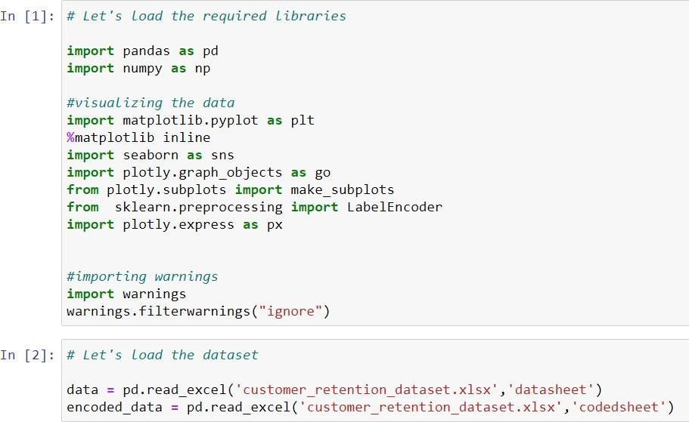

Feature Engineering has been used for cleaning of the data. We first did data cleaning. We first looked percentage of values missing in columns.

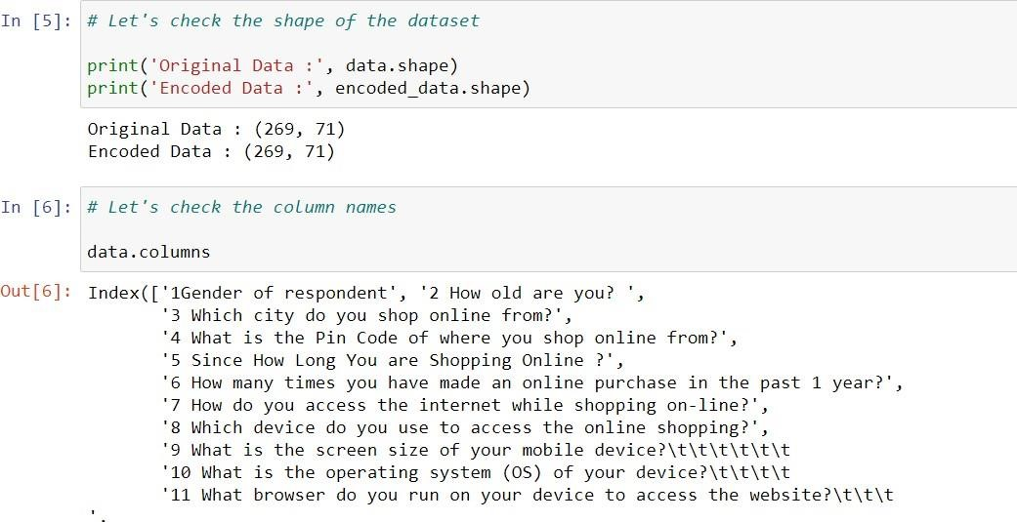

We have renamed our columns label for easy access

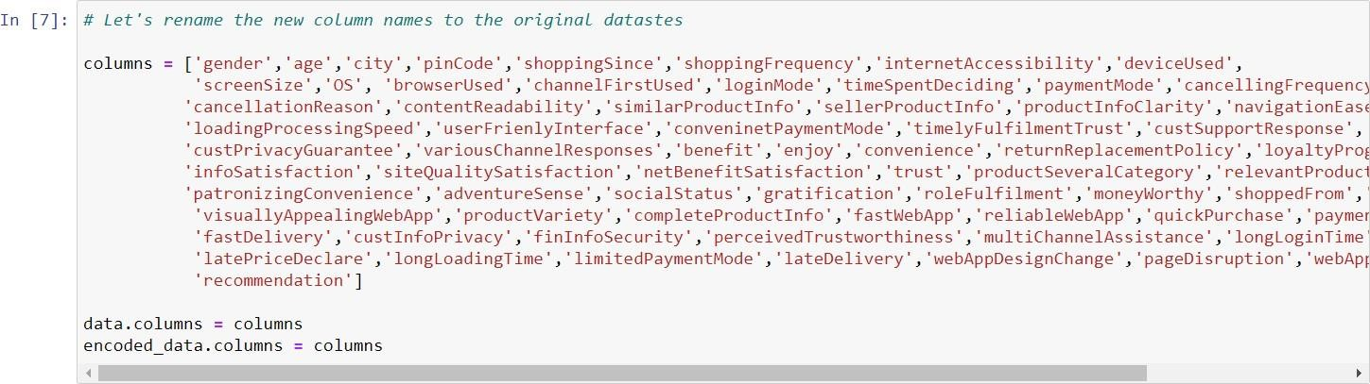

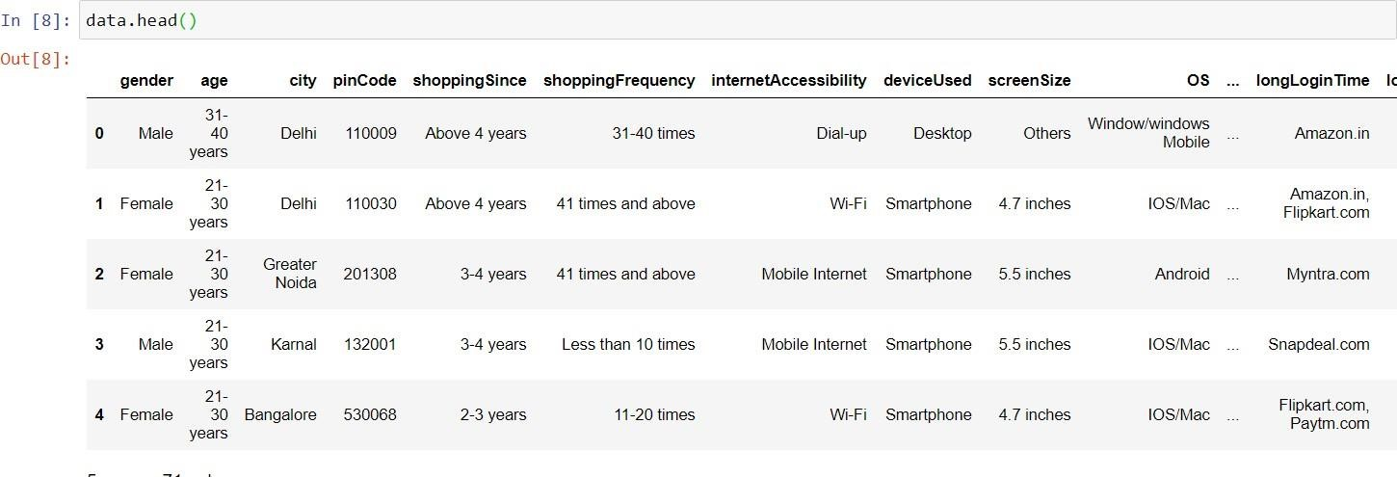

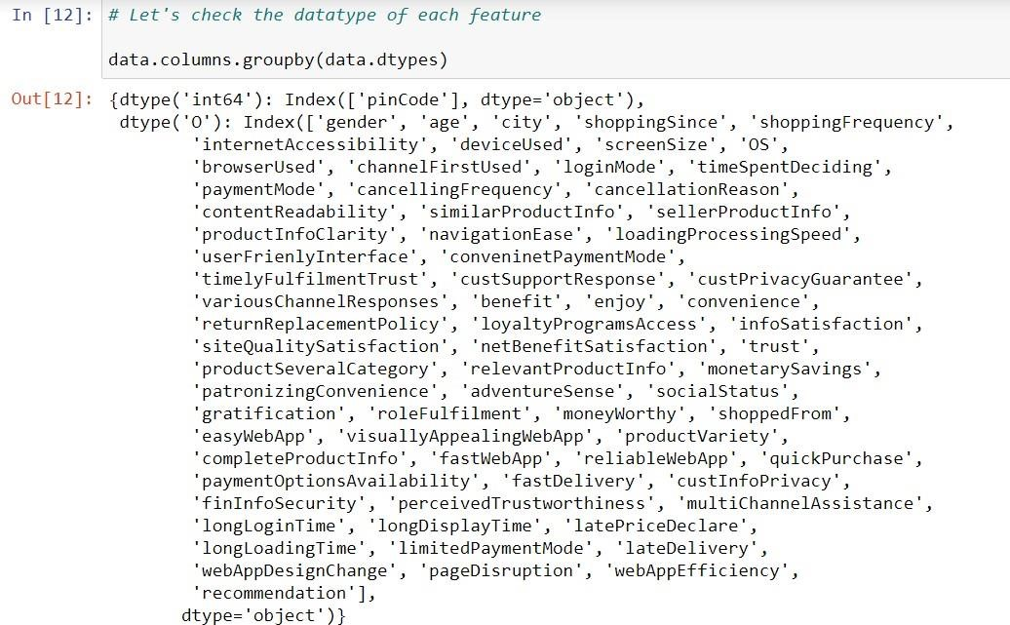

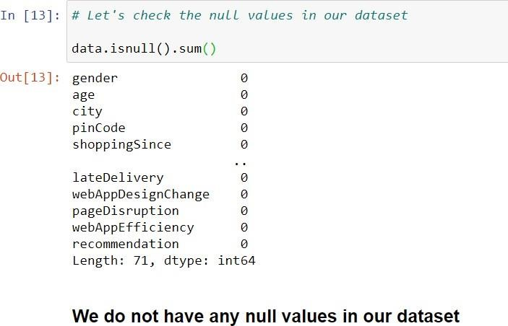

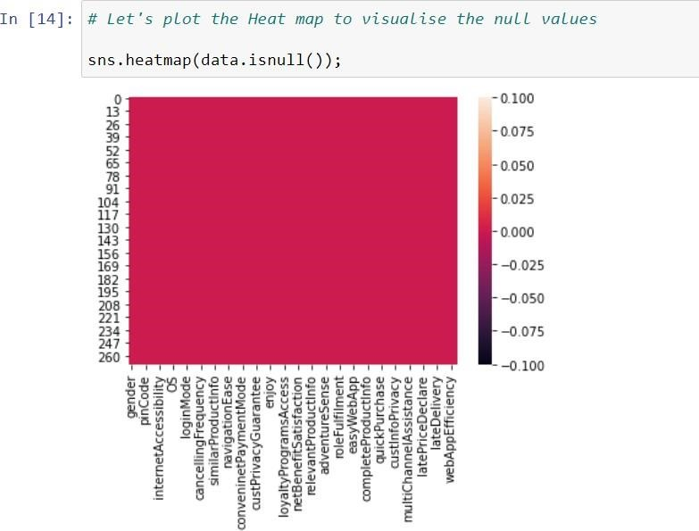

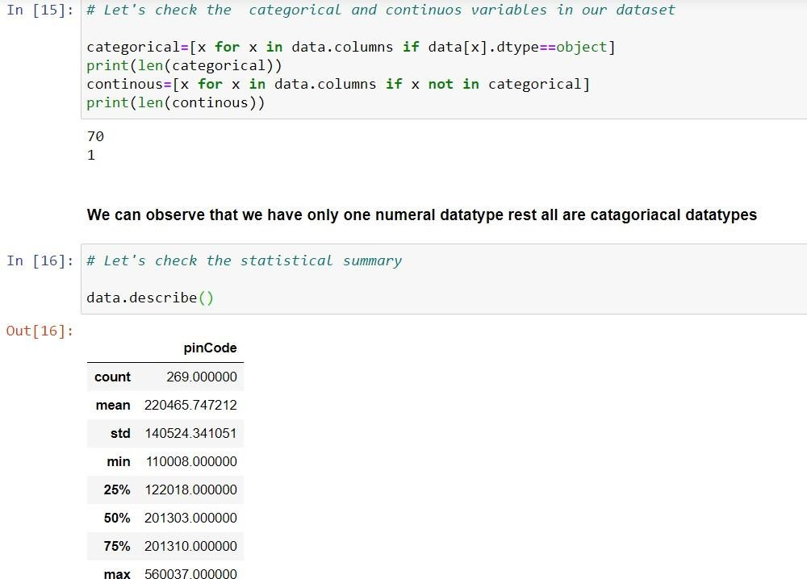

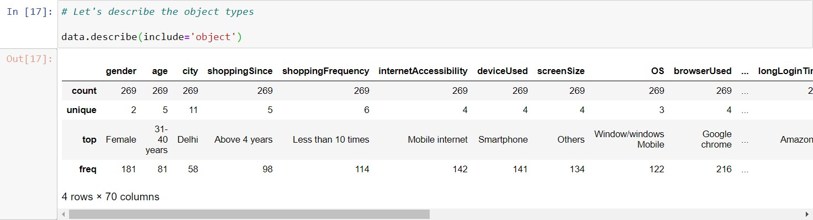

## DATA INPUTS- LOGIC- OUTPUT RELATIONSHIPS

EDA was performed by creating valuable insights using various visualization libraries.

***SOFTWARE:***

Jupyter Notebook (Anaconda 3) – Python 3.7.6

Microsoft Excel 2010

***LIBRARIES:***

The tools, libraries and packages we used for accomplishing this project are pandas, numpy, matplotlib, seaborn, scipy stats,

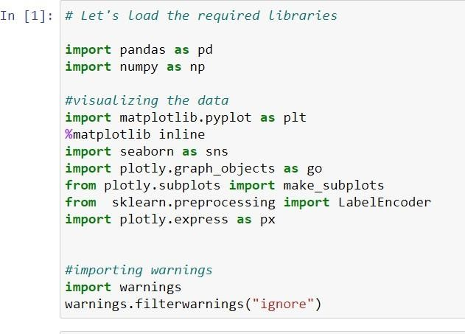

# MODEL/S DEVELOPMENT AND EVALUATION

## IDENTIFICATION OF POSSIBLE PROBLEM-SOLVING APPROACHES

## (METHODS)

Firstly I imported all the required libraries, followed by loading the data. Then did a statistical analysis on the dataset .Then deeply analyzed the data by finding a relationship between each attribute and the Customer according to given details and tried to find the factors that will help in Customer Retention.

## TESTING OF IDENTIFIED APPROACHES (ALGORITHMS)

Visualizations were done using the seaborn library.

## VISUALIZATIONS

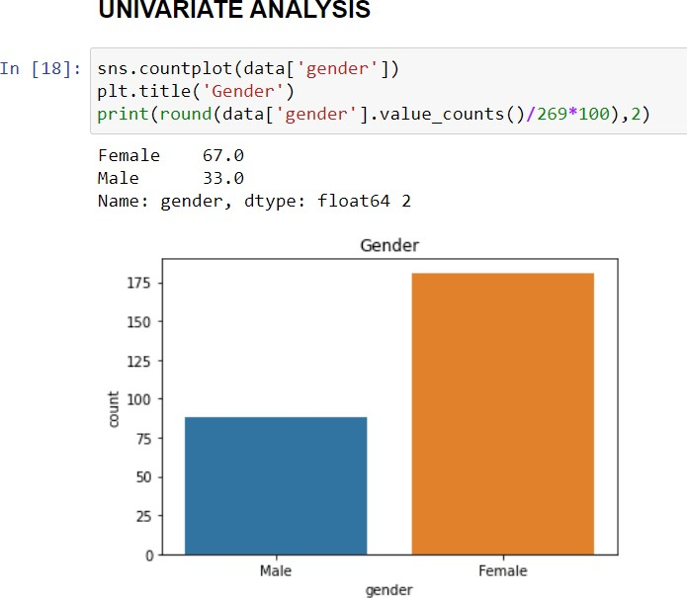

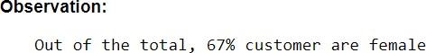

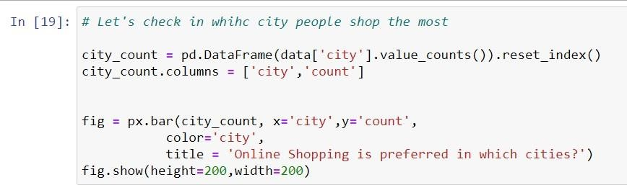

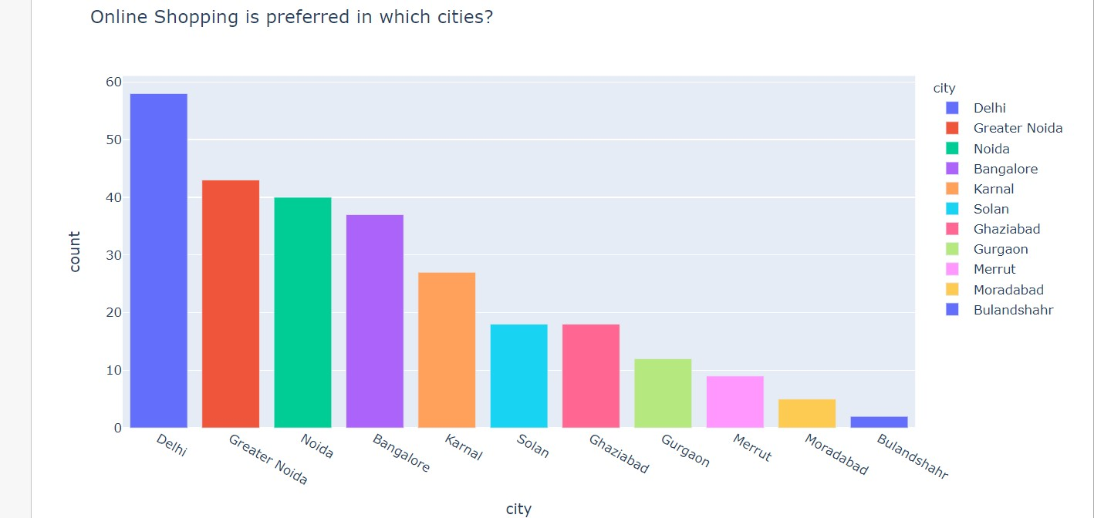





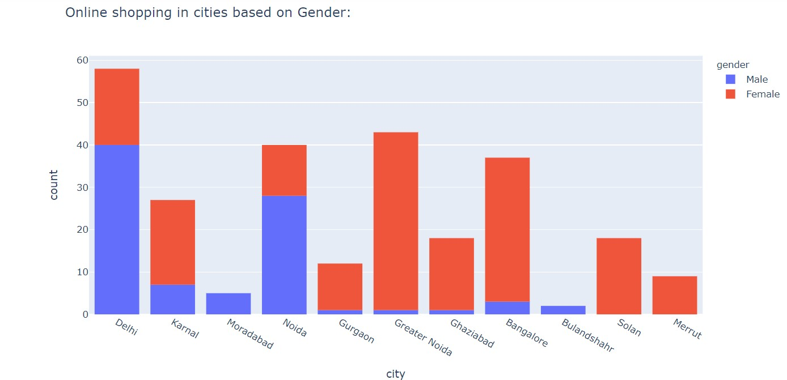



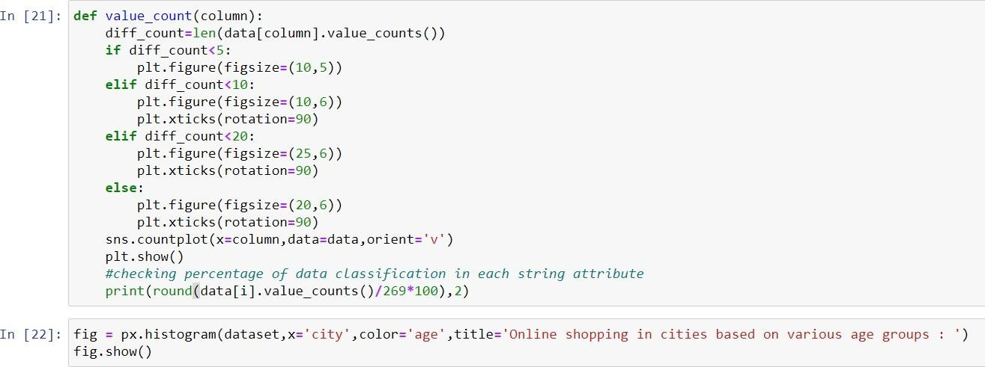

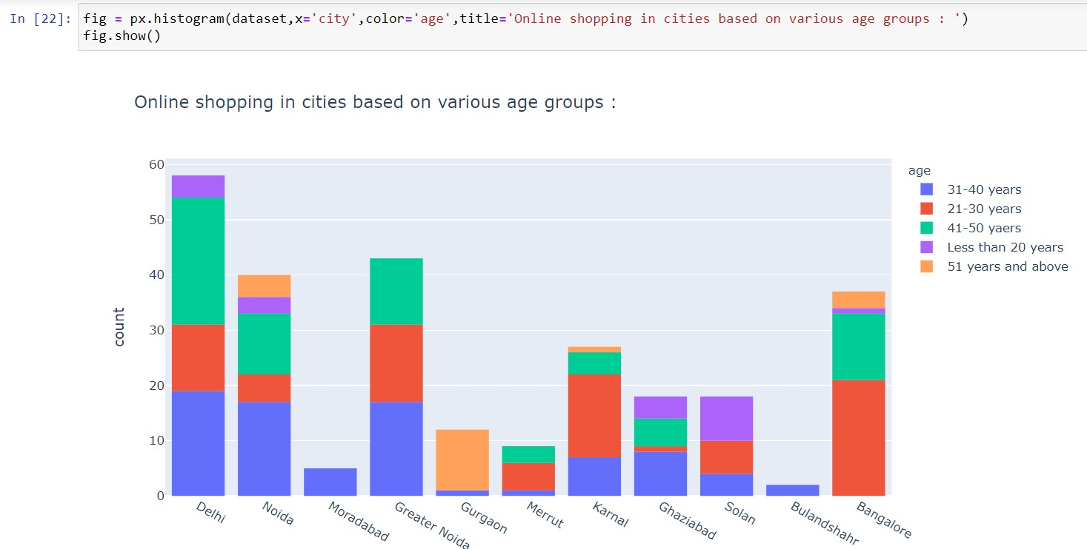

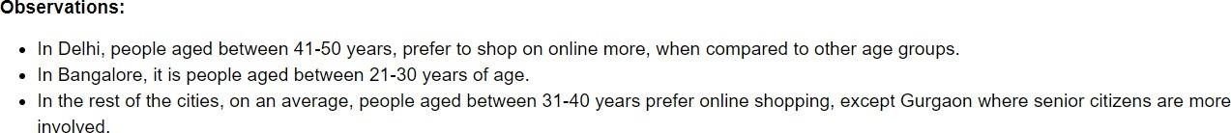

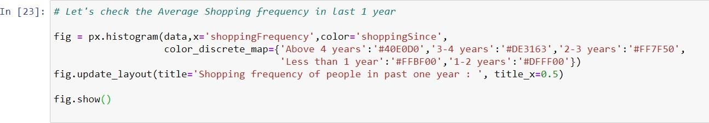

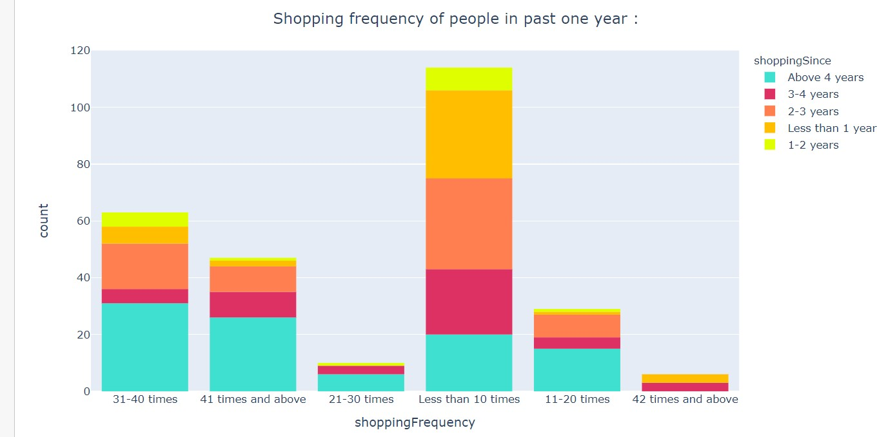



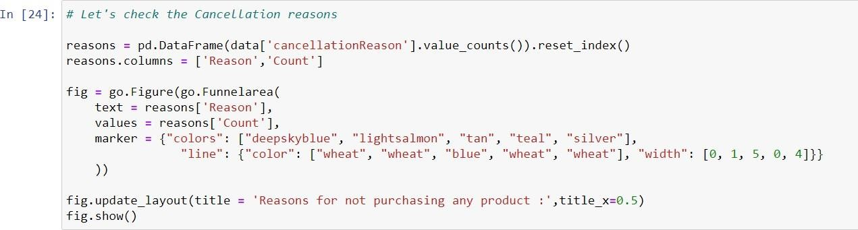

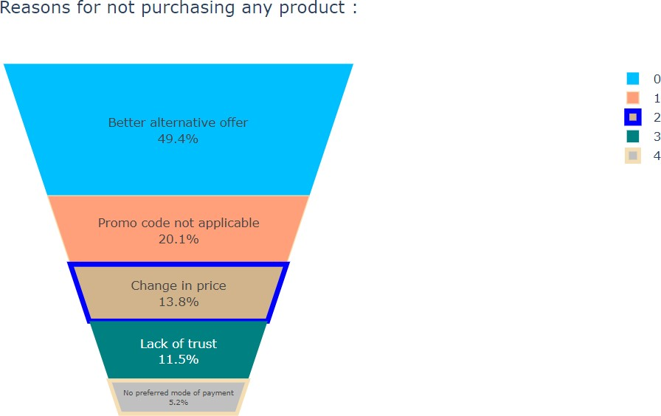

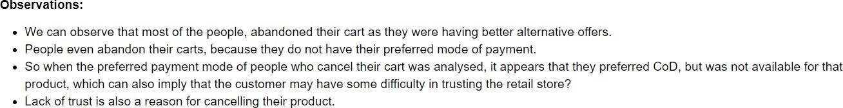

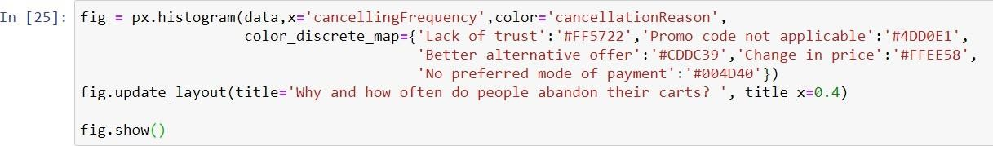

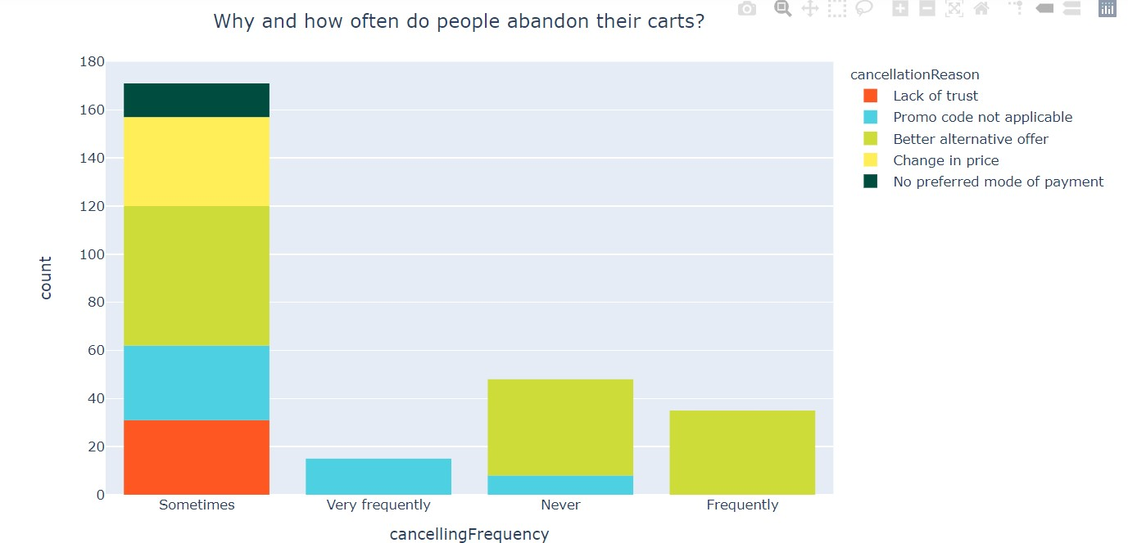

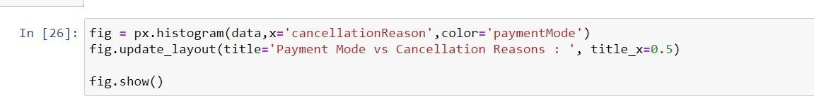

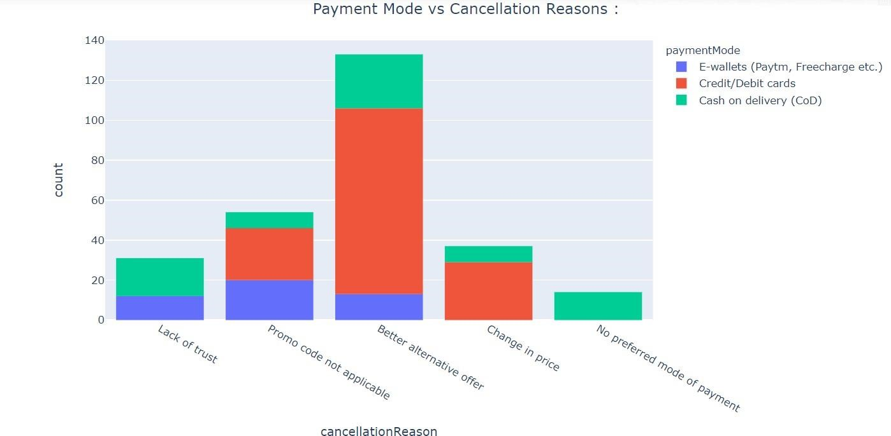



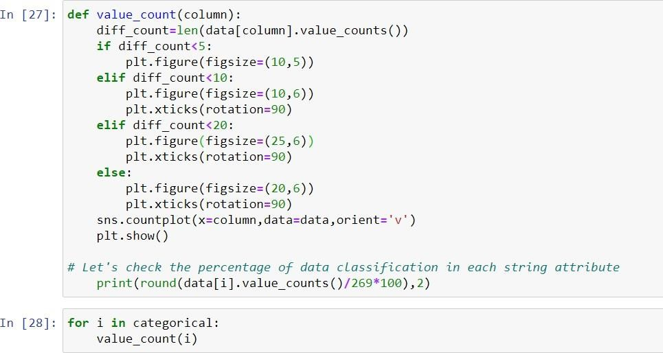

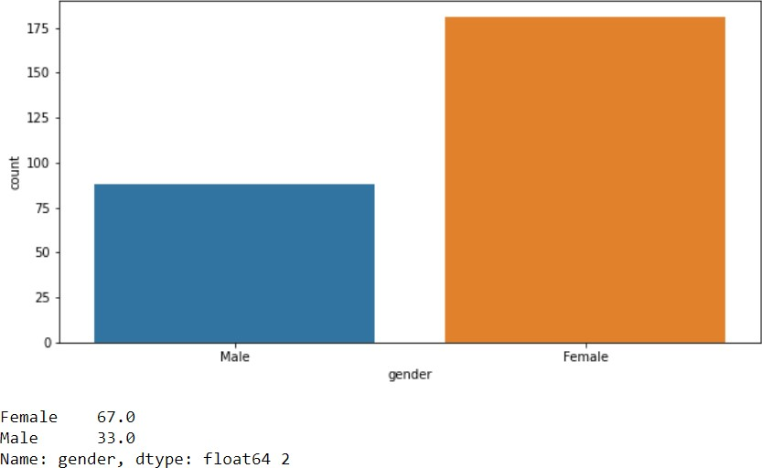

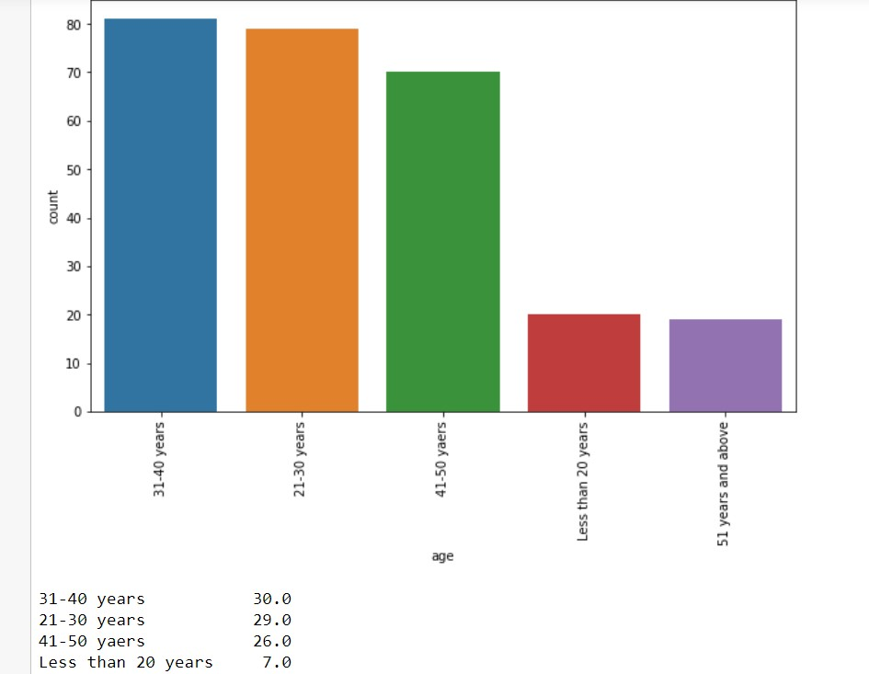

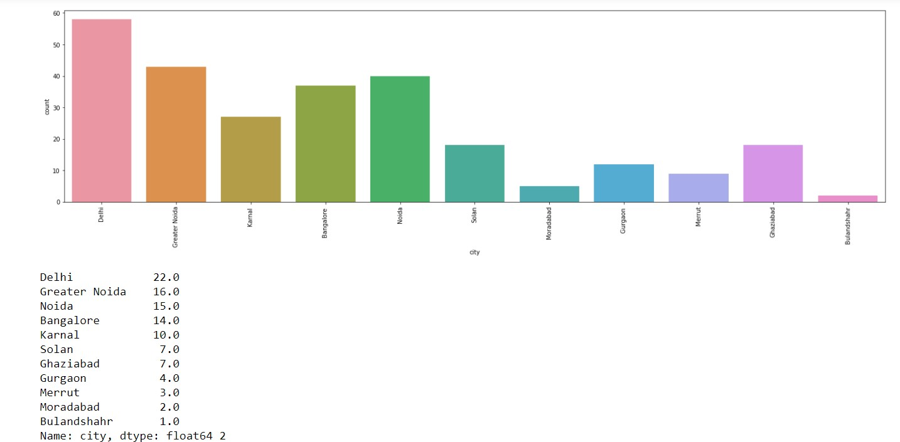

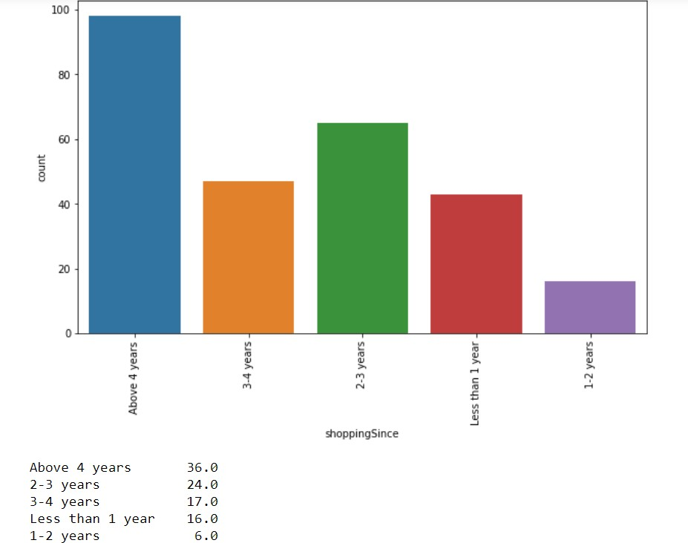

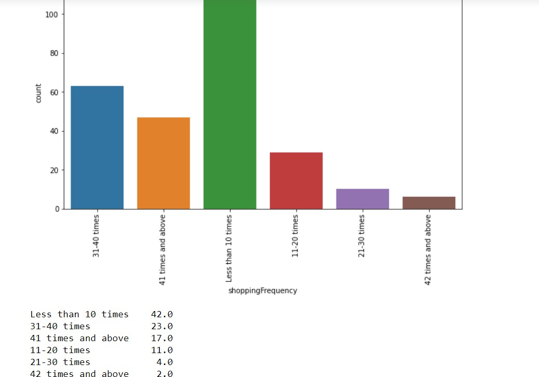

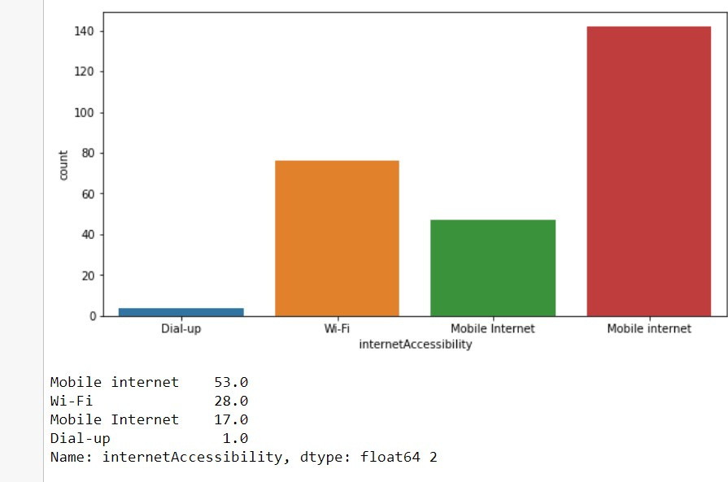

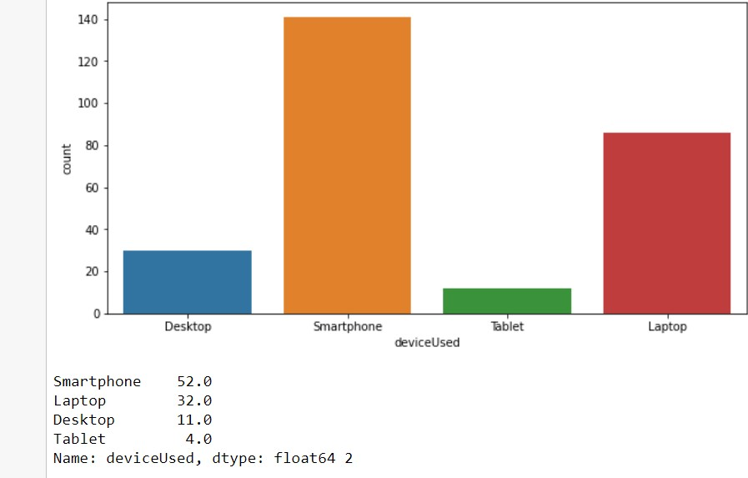

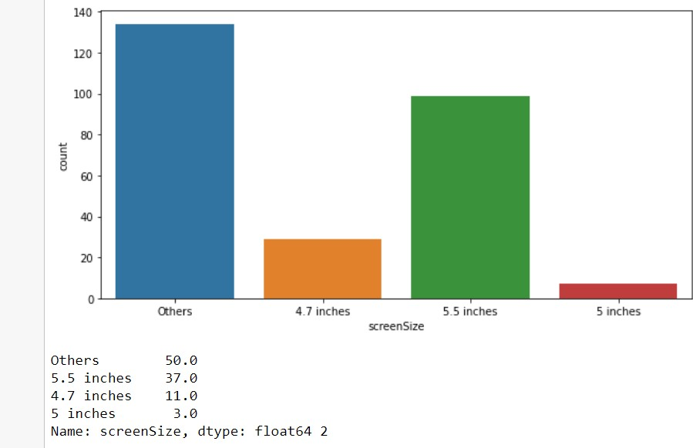

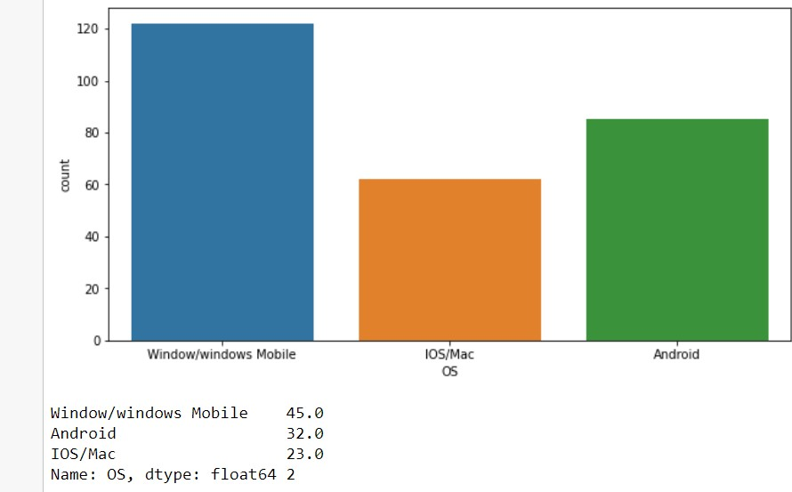

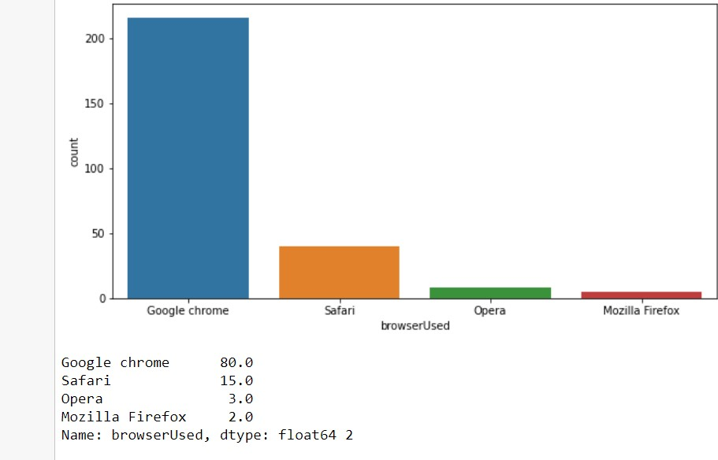

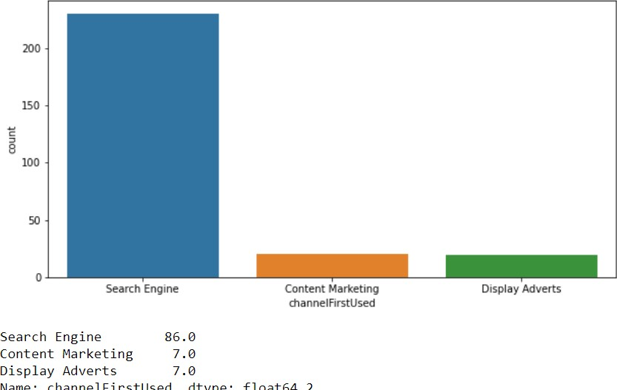

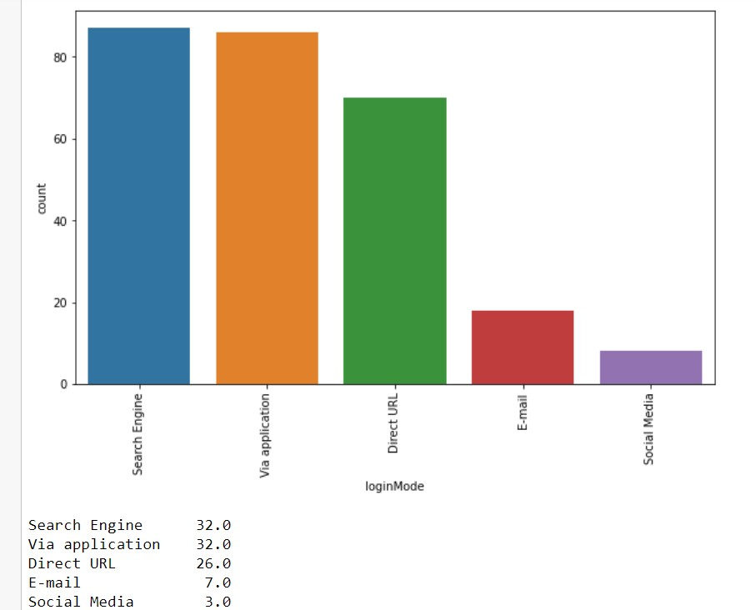

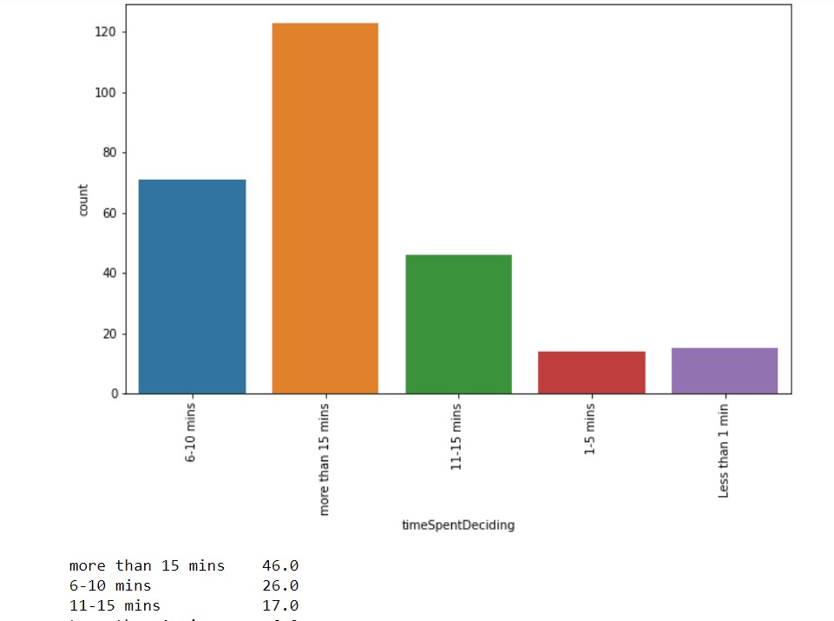

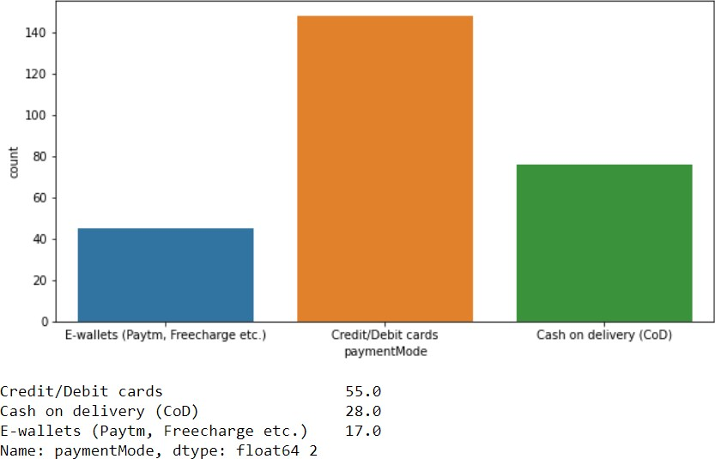

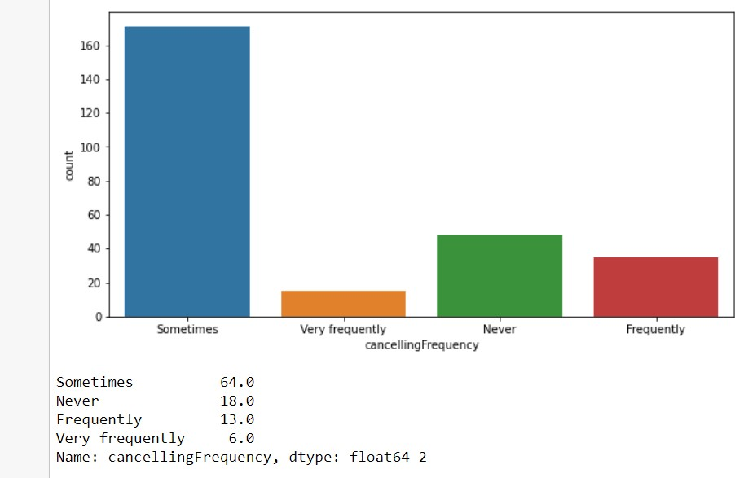

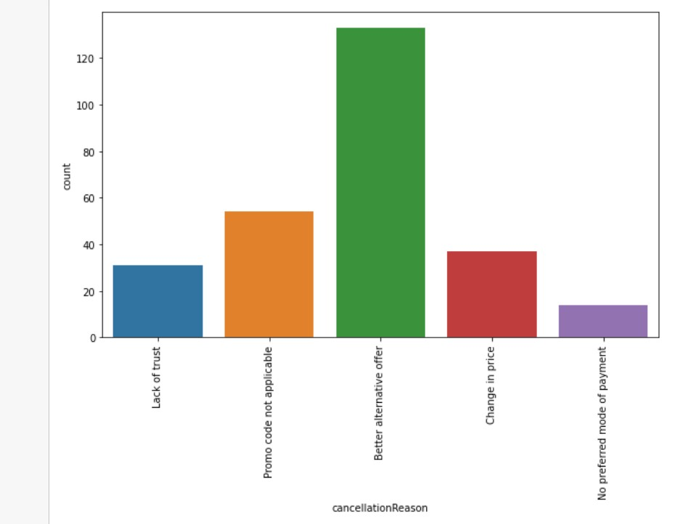

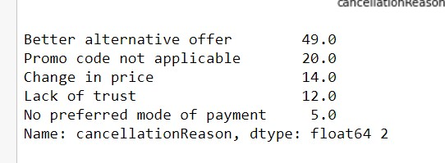

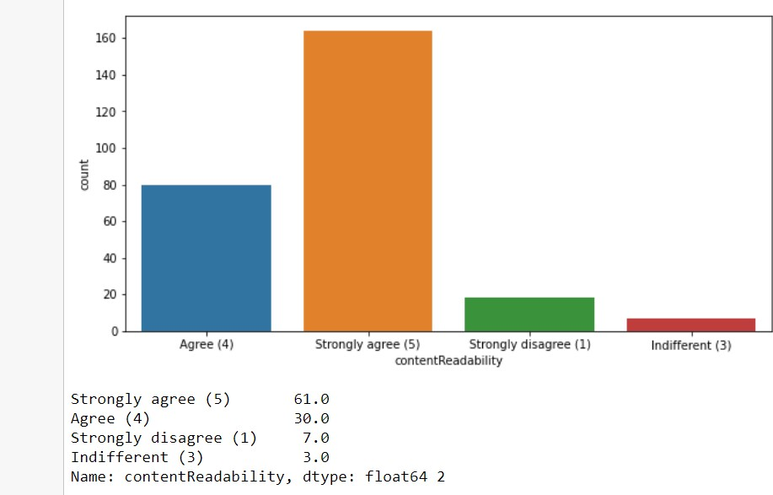

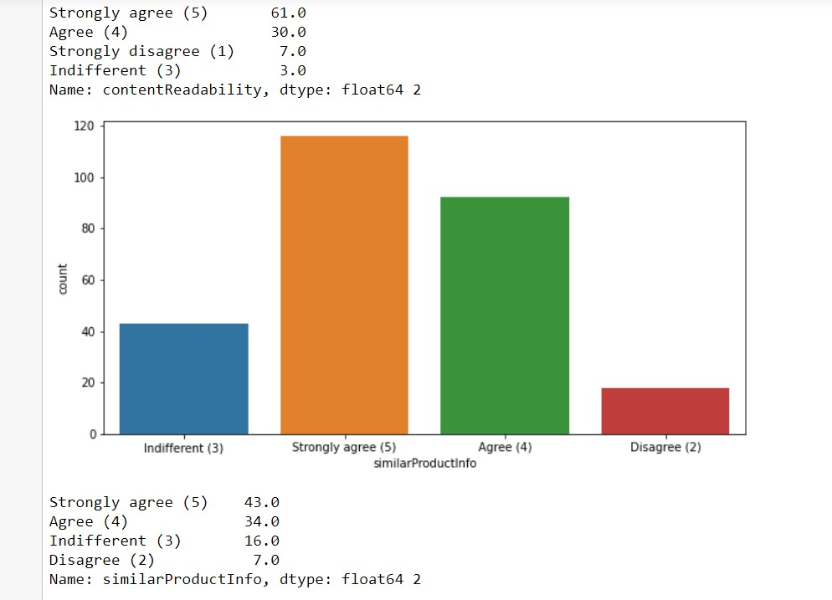

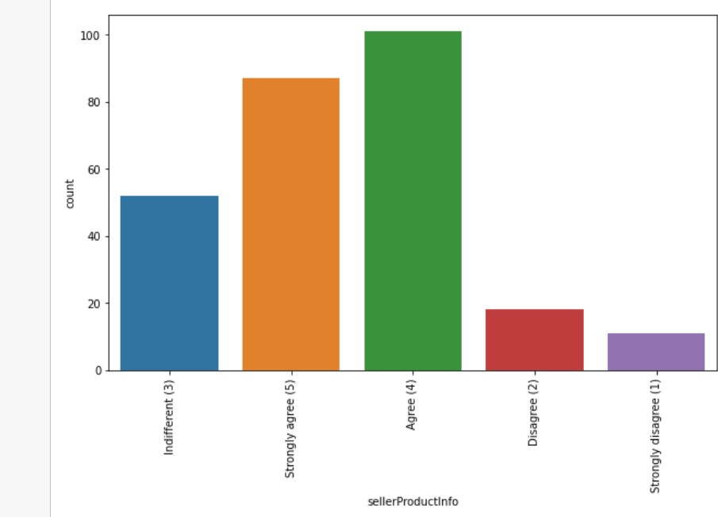

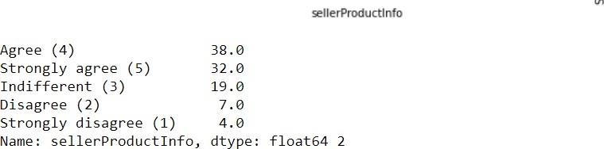

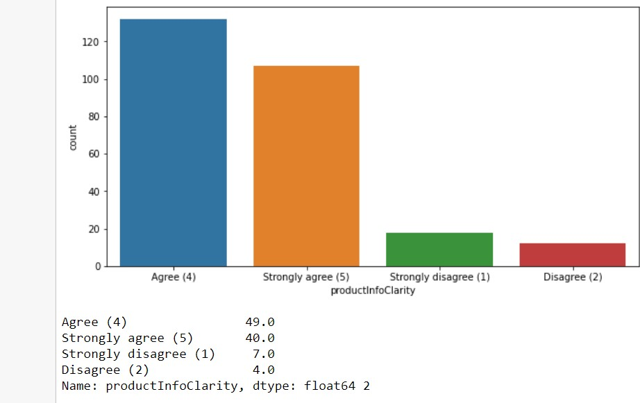

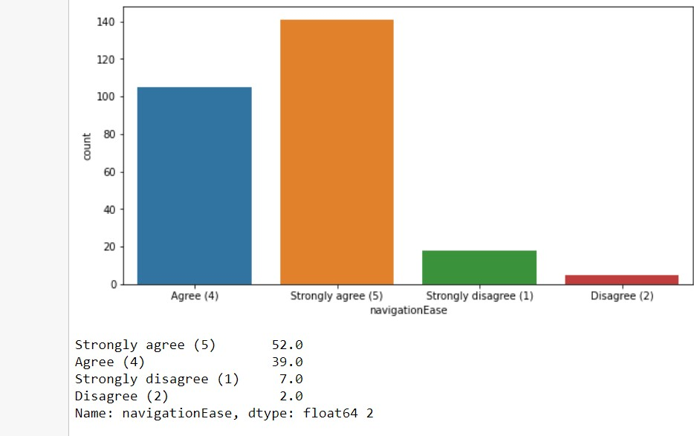

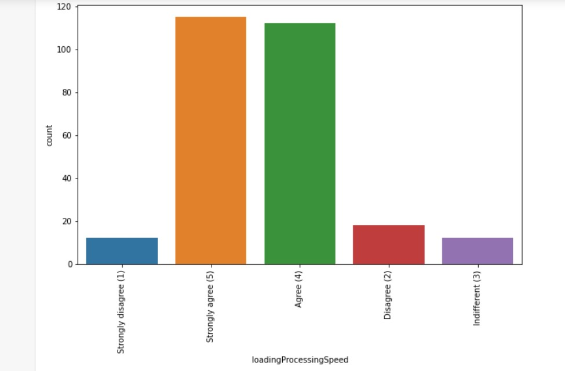

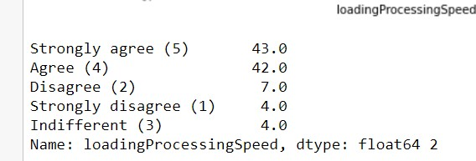

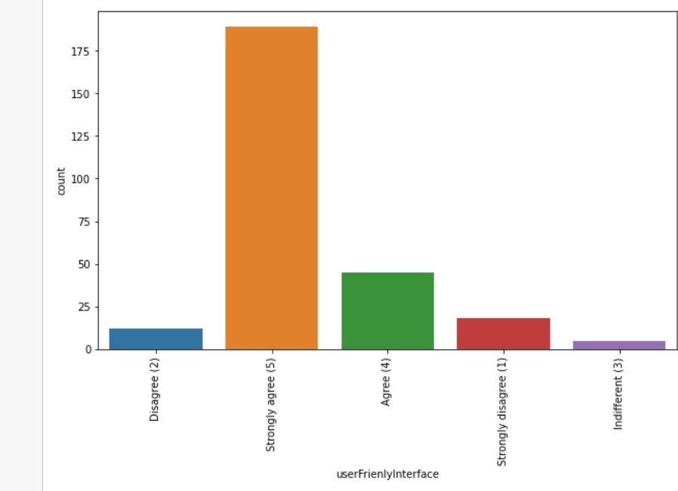

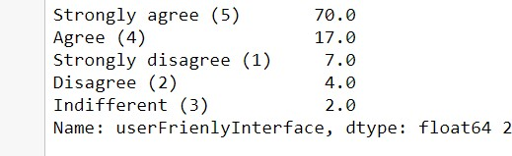

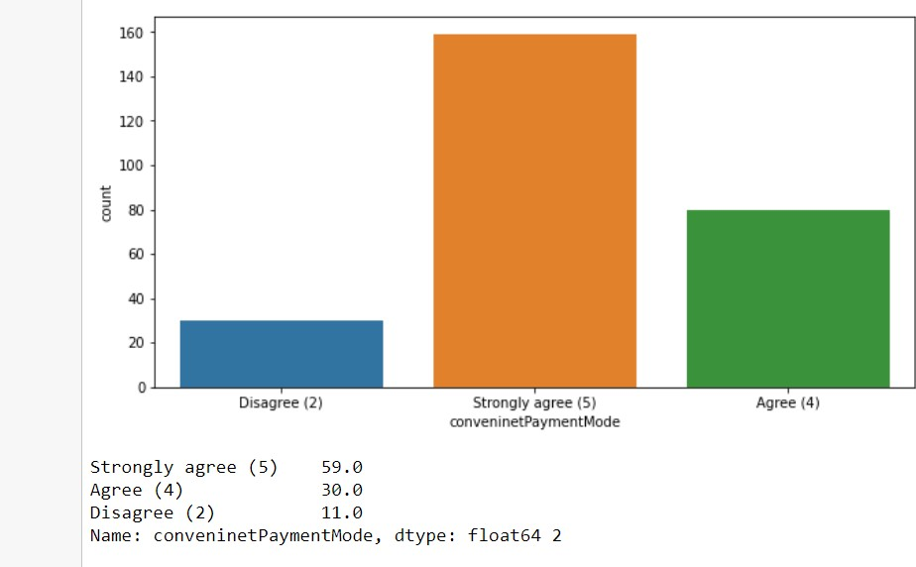

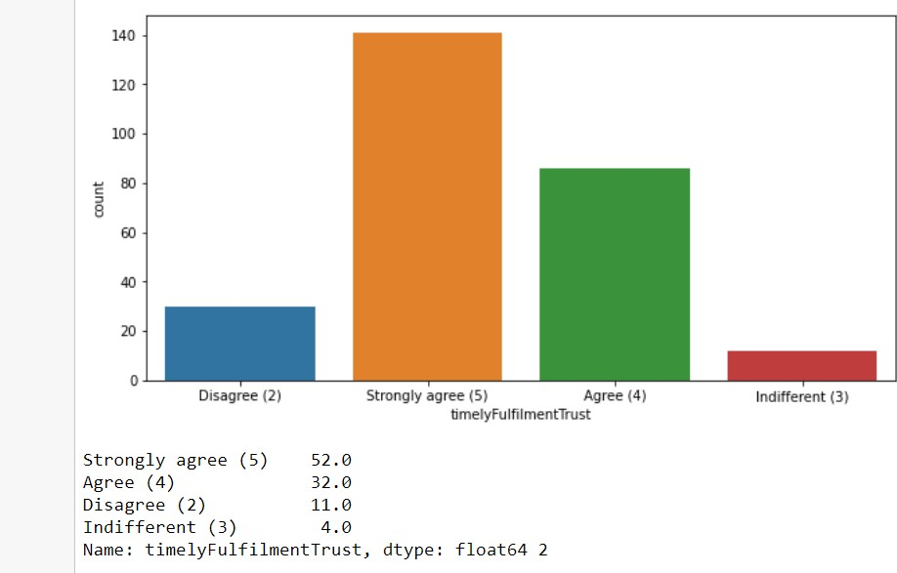

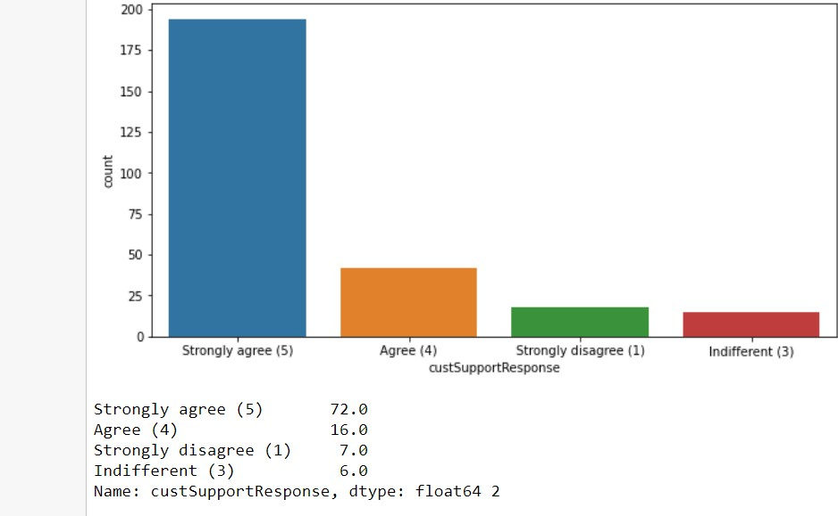

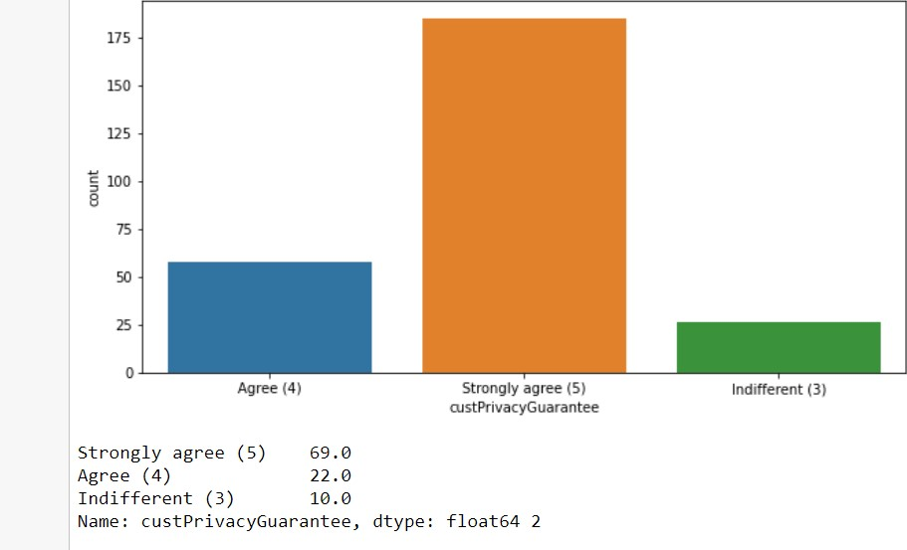

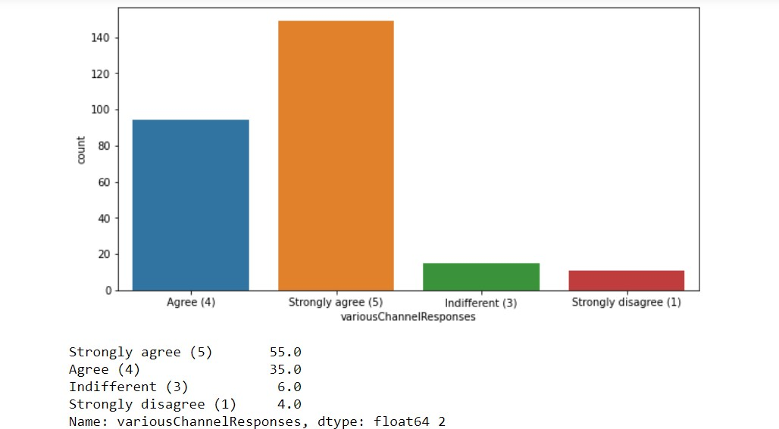

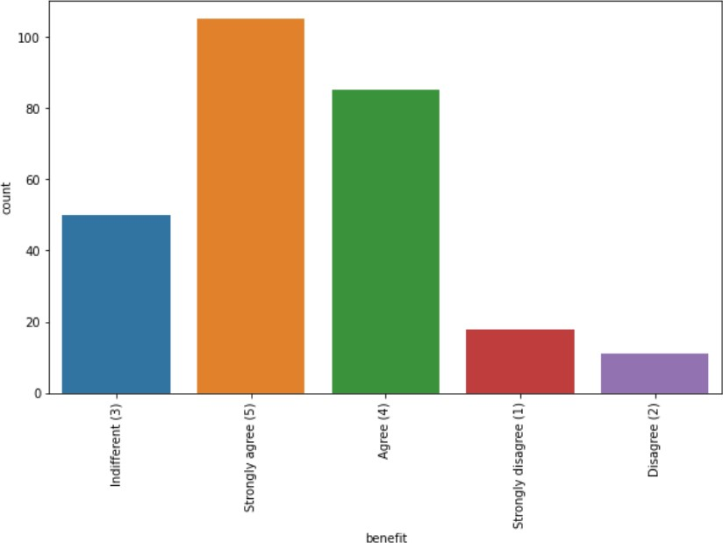

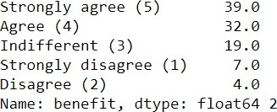

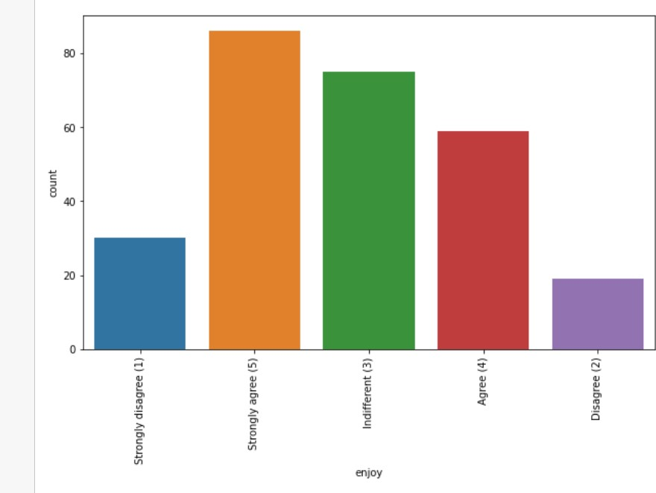

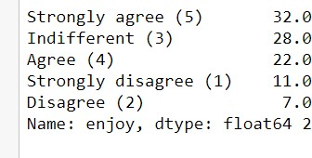

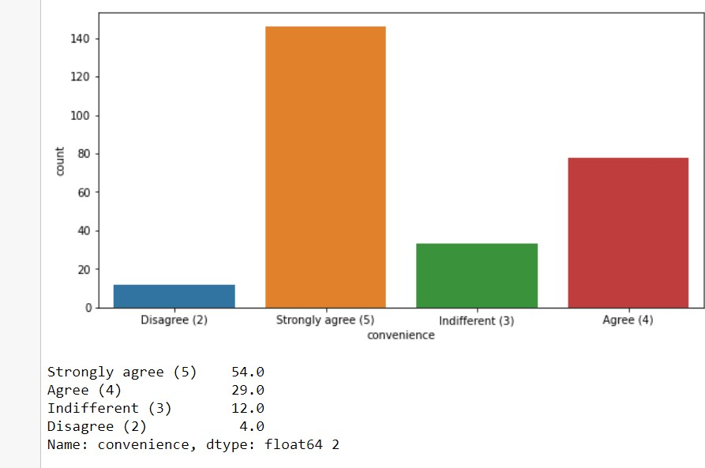

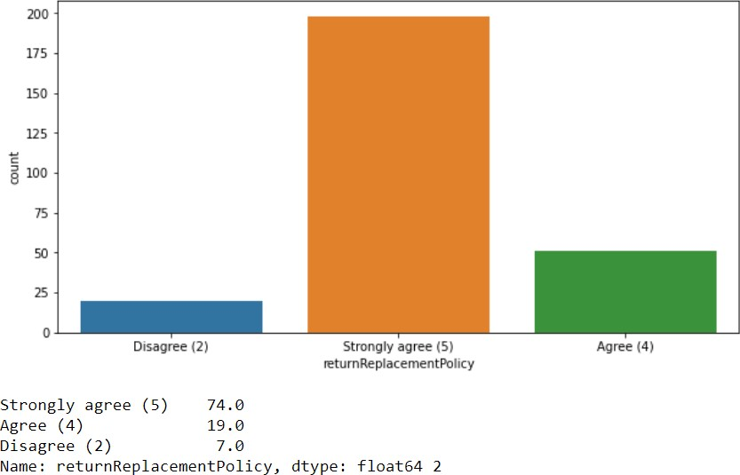

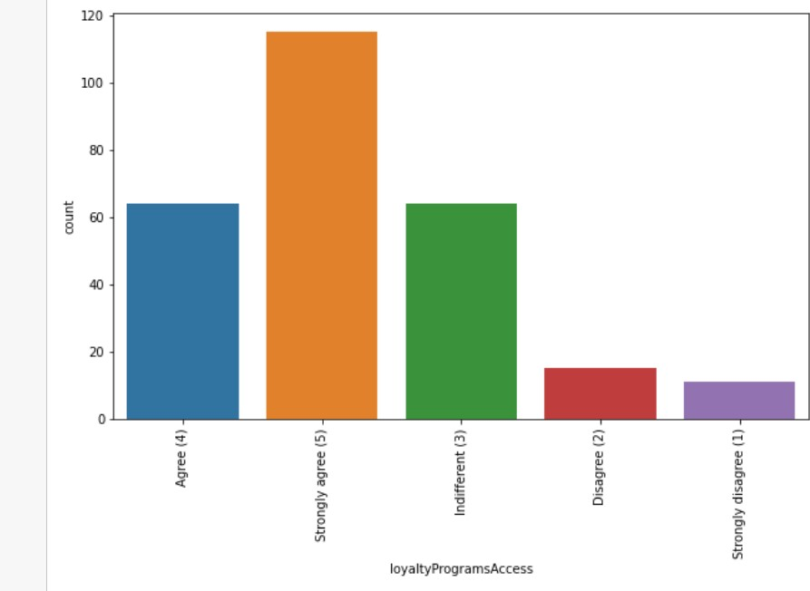

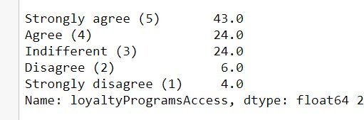

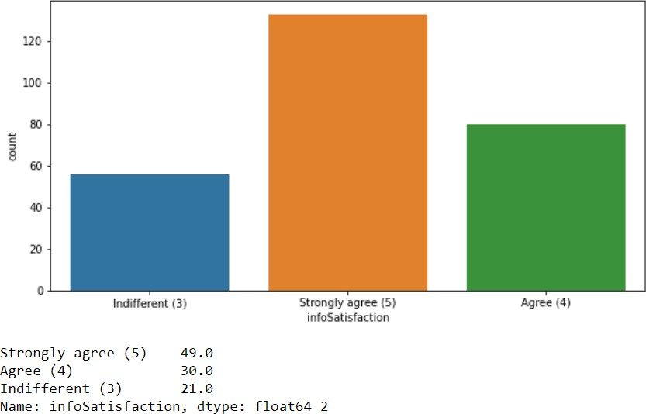

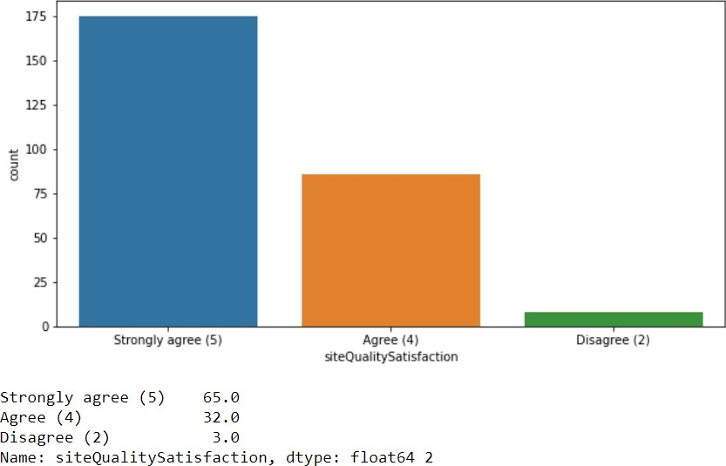

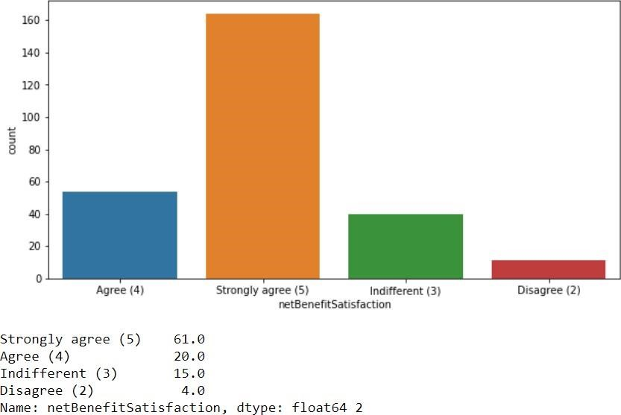

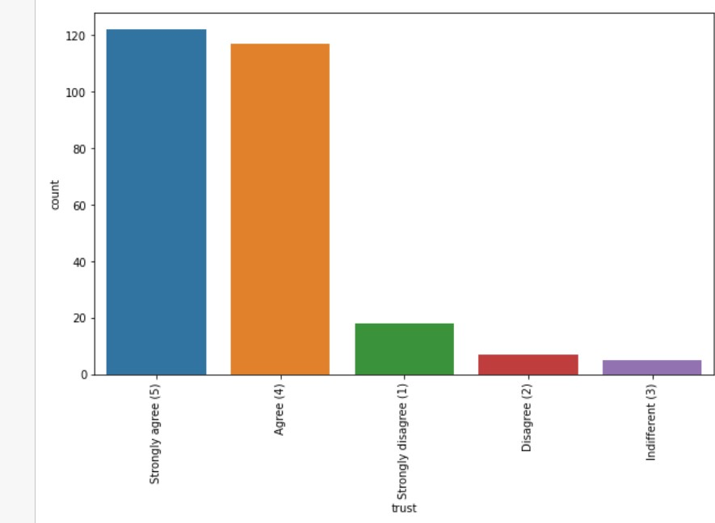

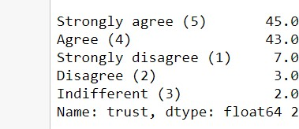

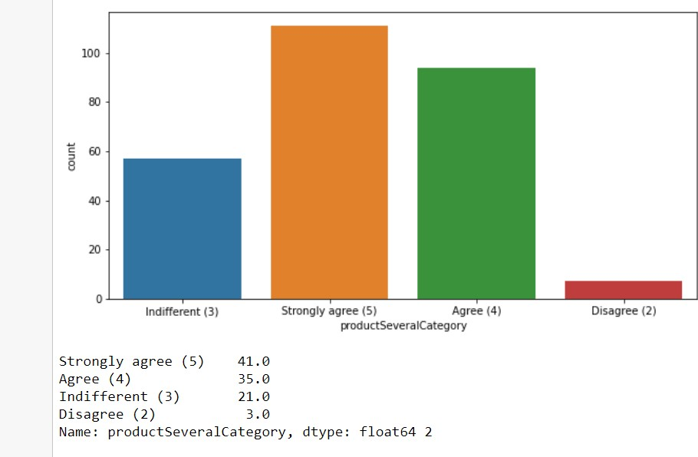

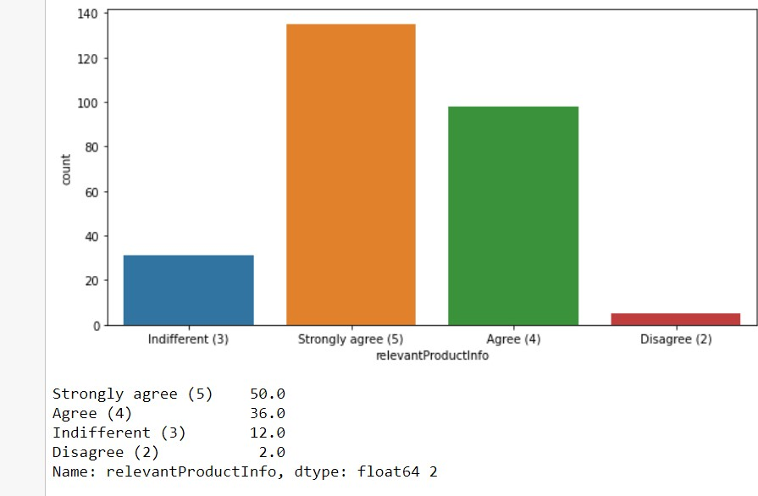

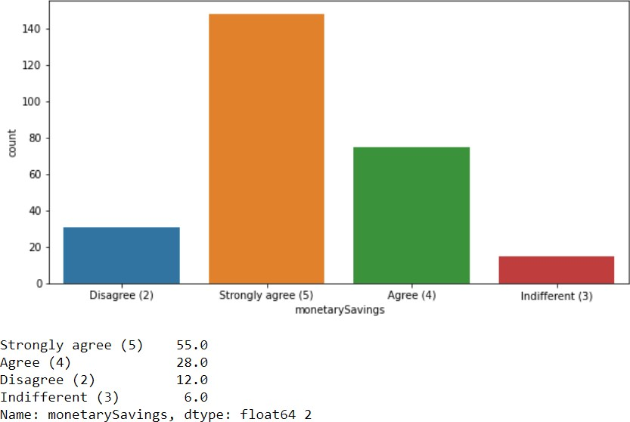

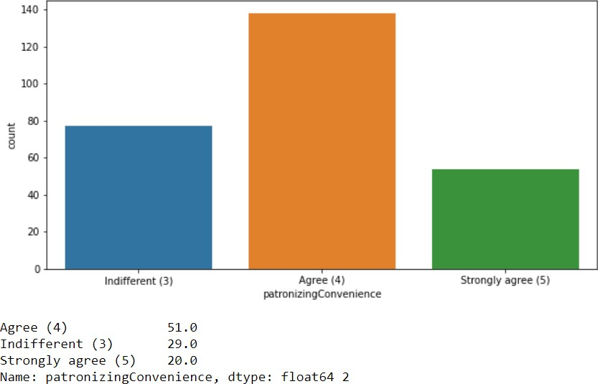

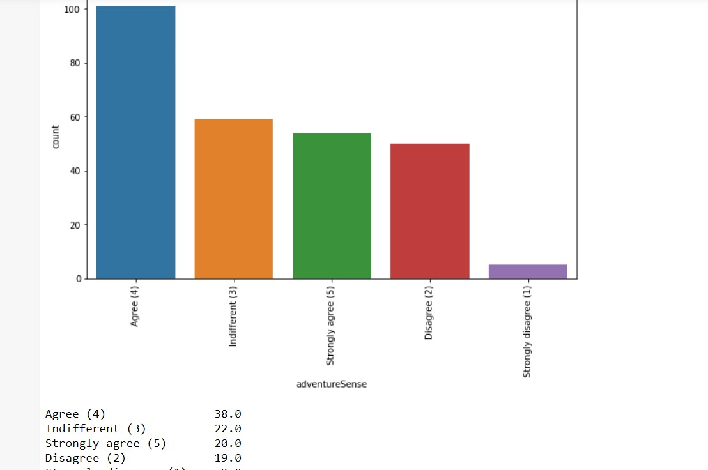

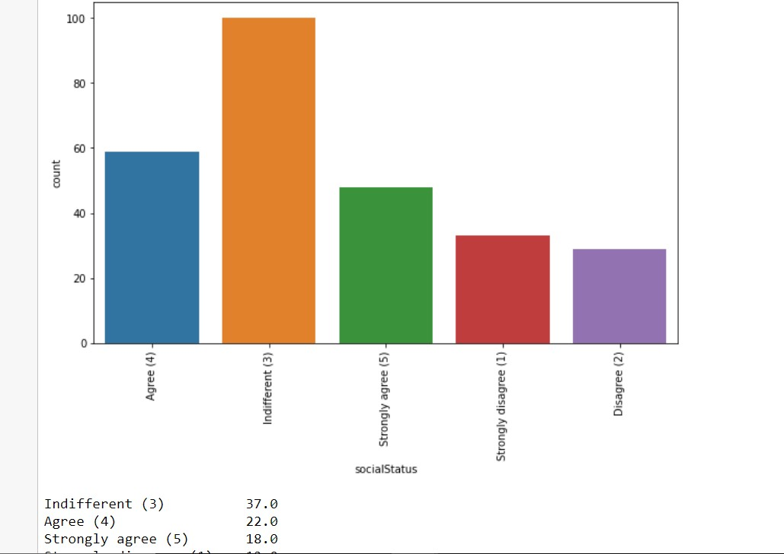

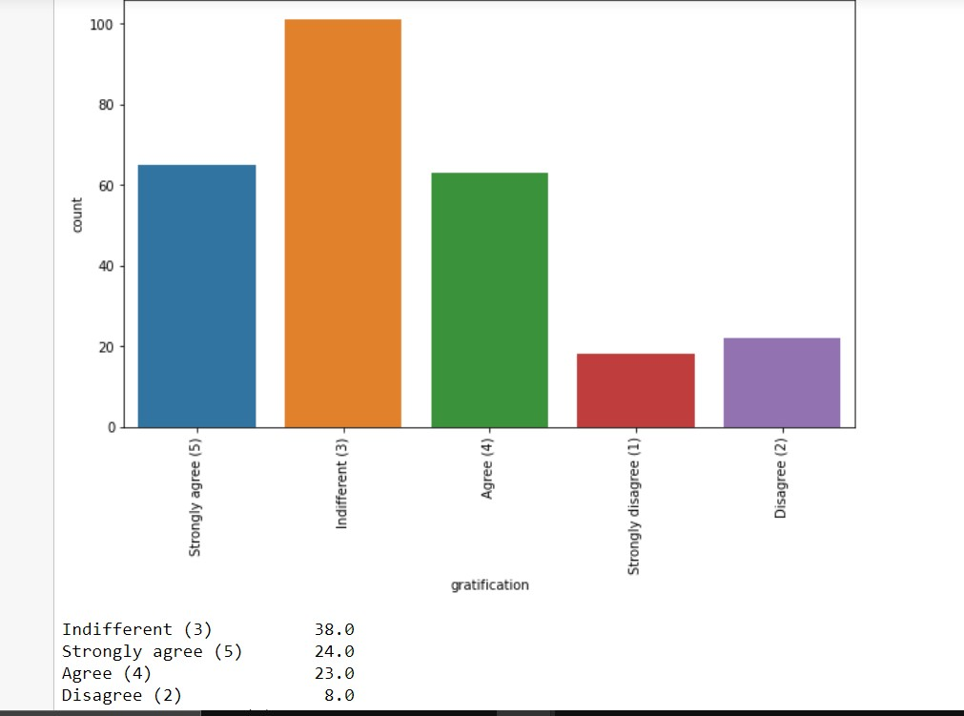

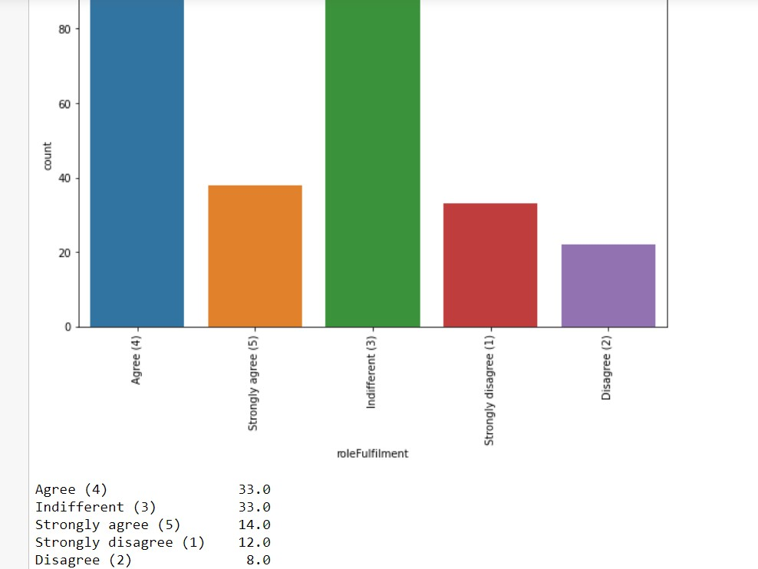

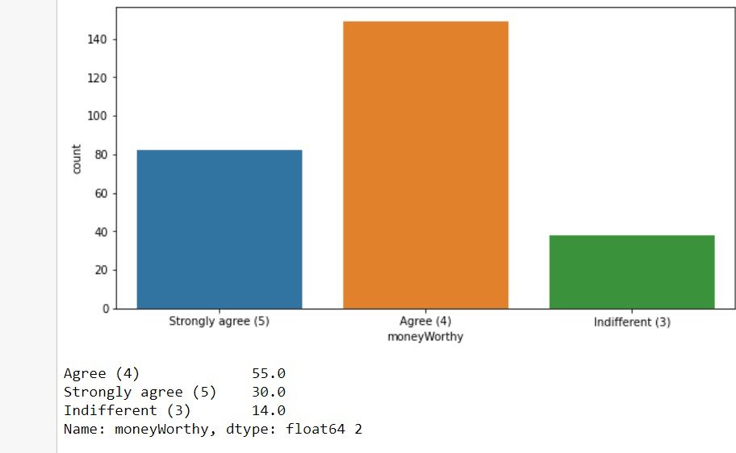

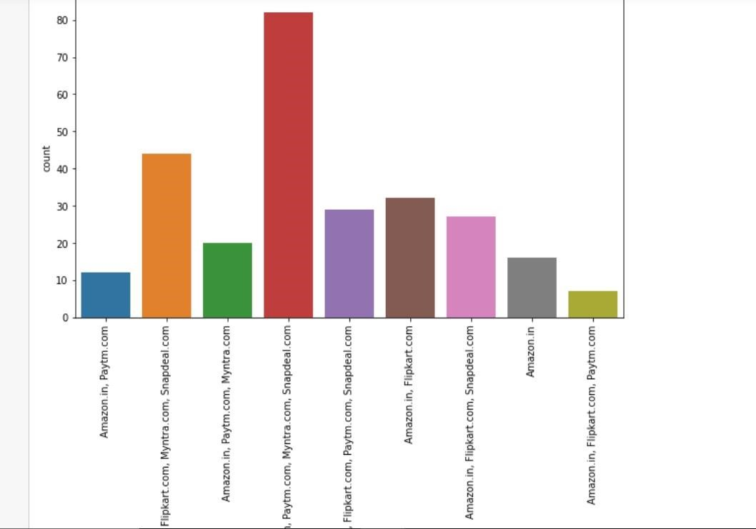

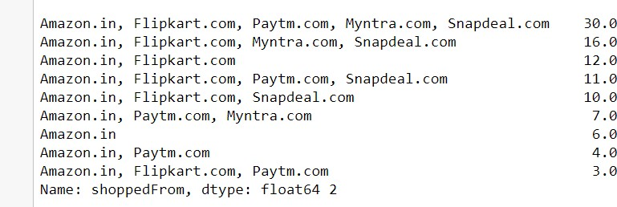

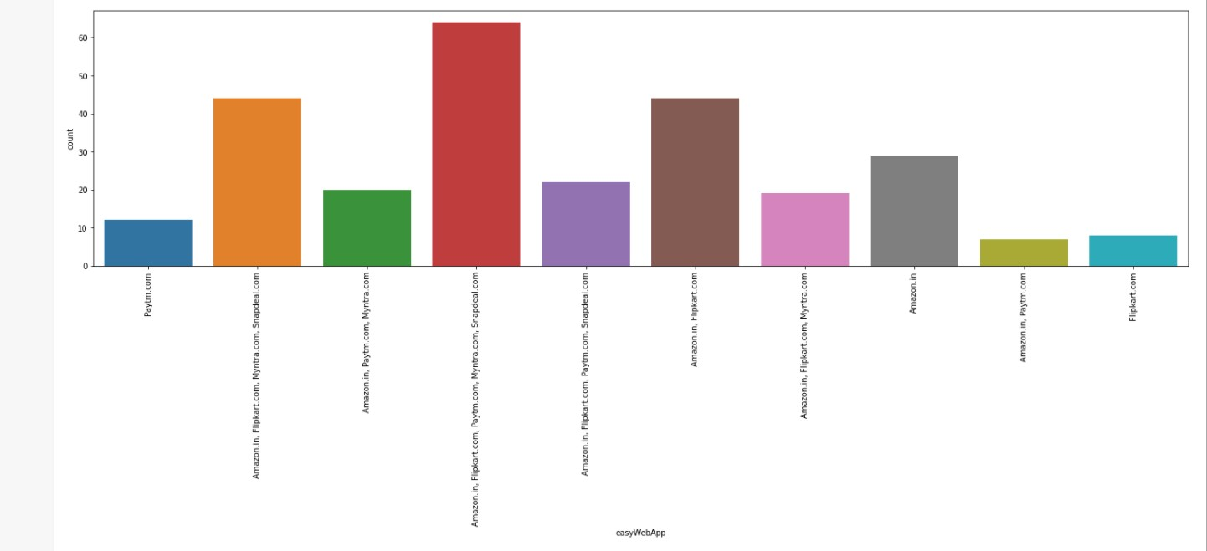

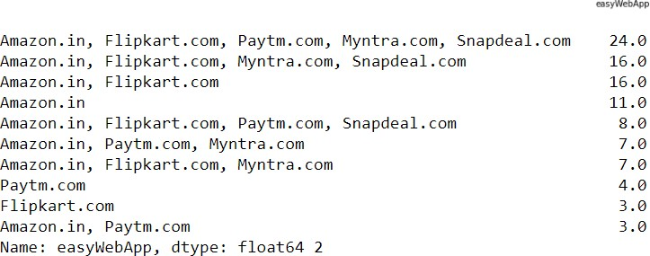

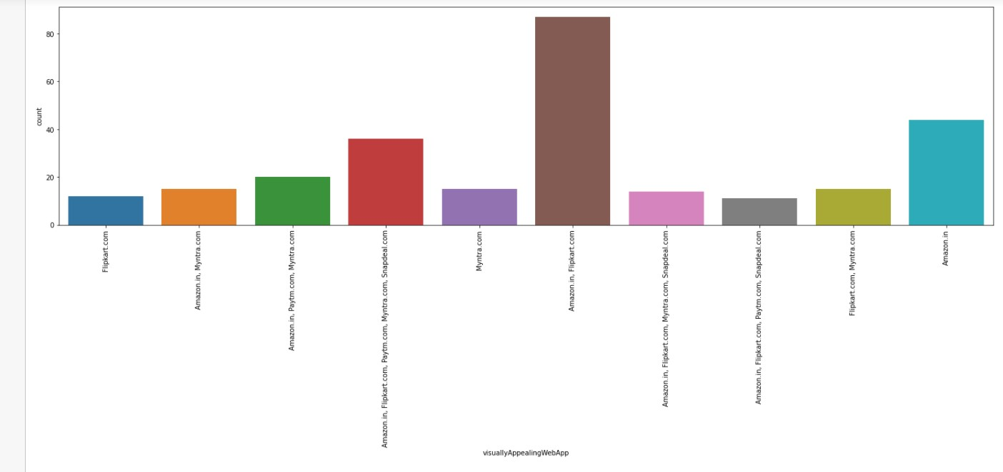

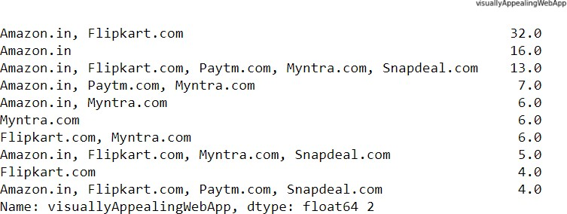

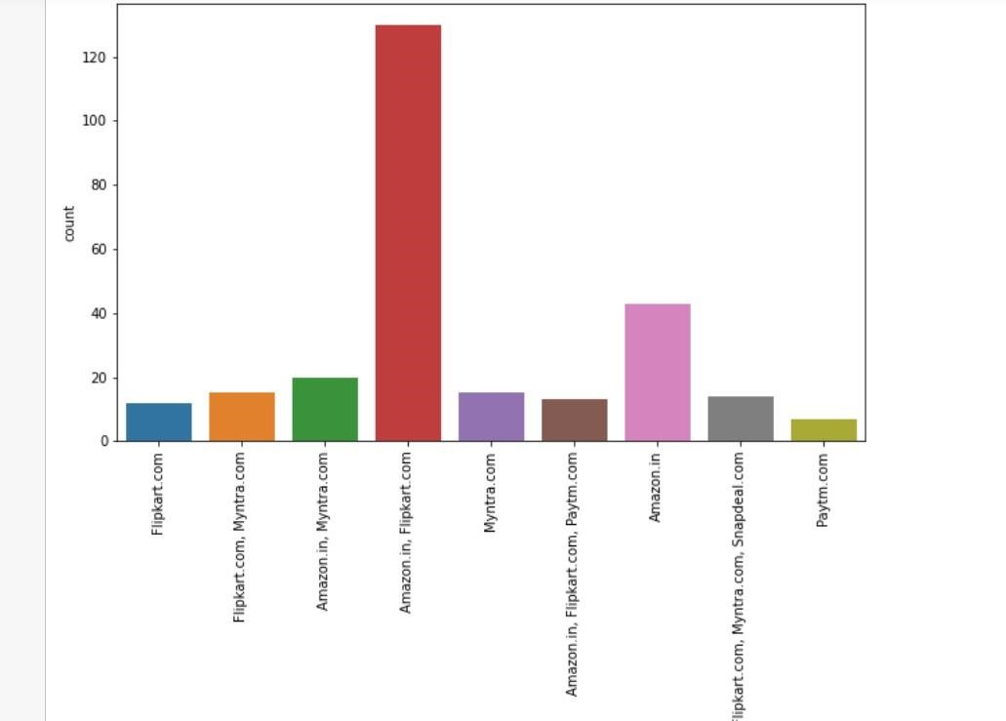

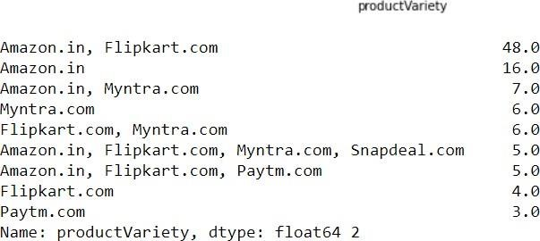

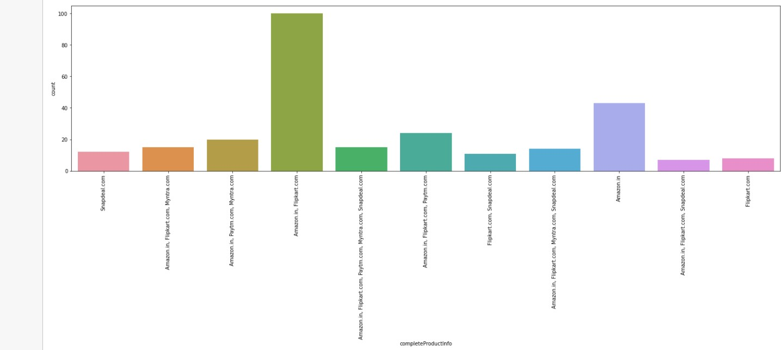

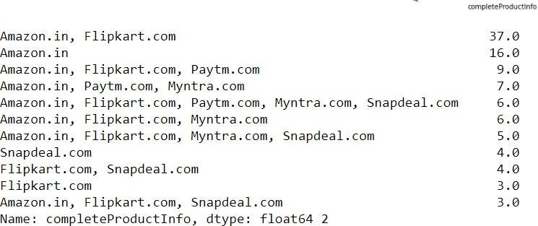

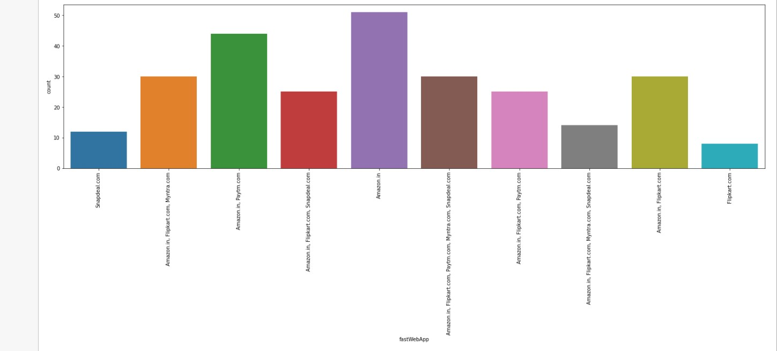

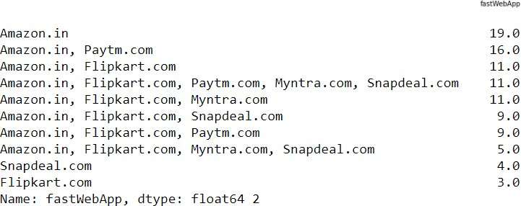

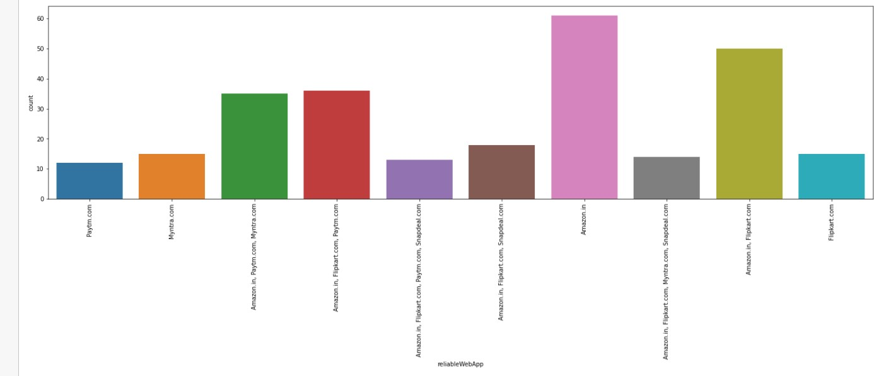

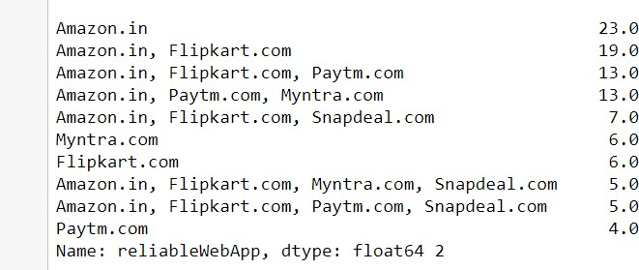

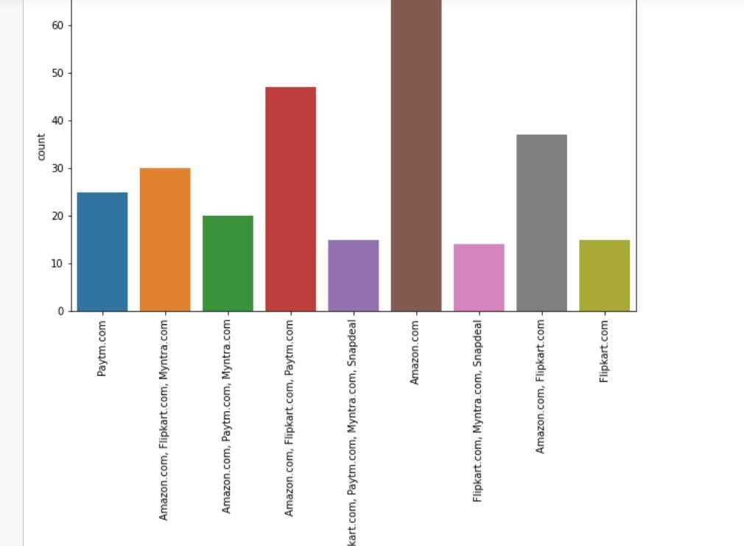

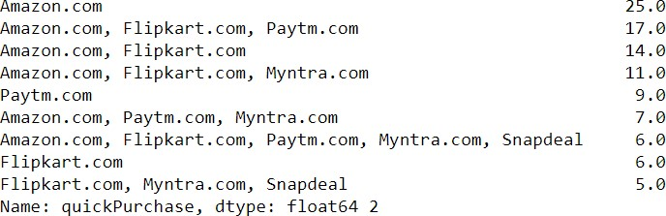

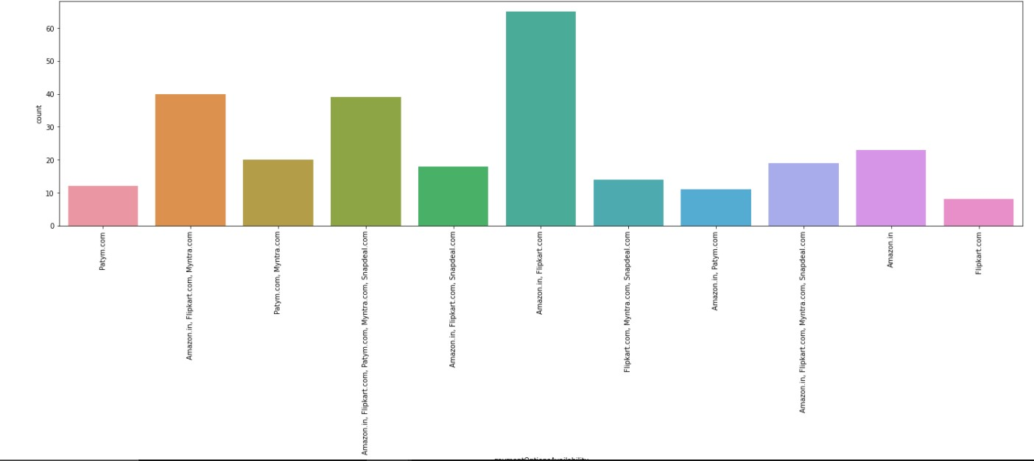

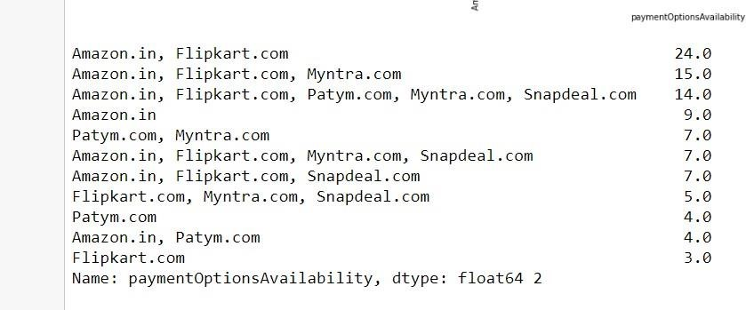

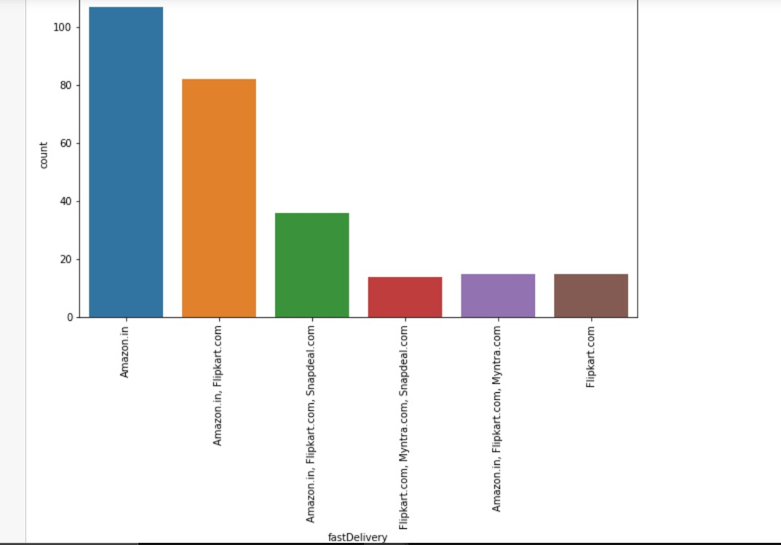

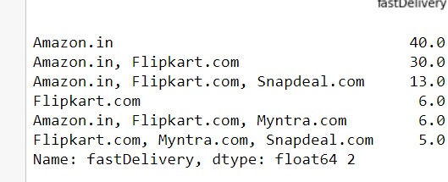

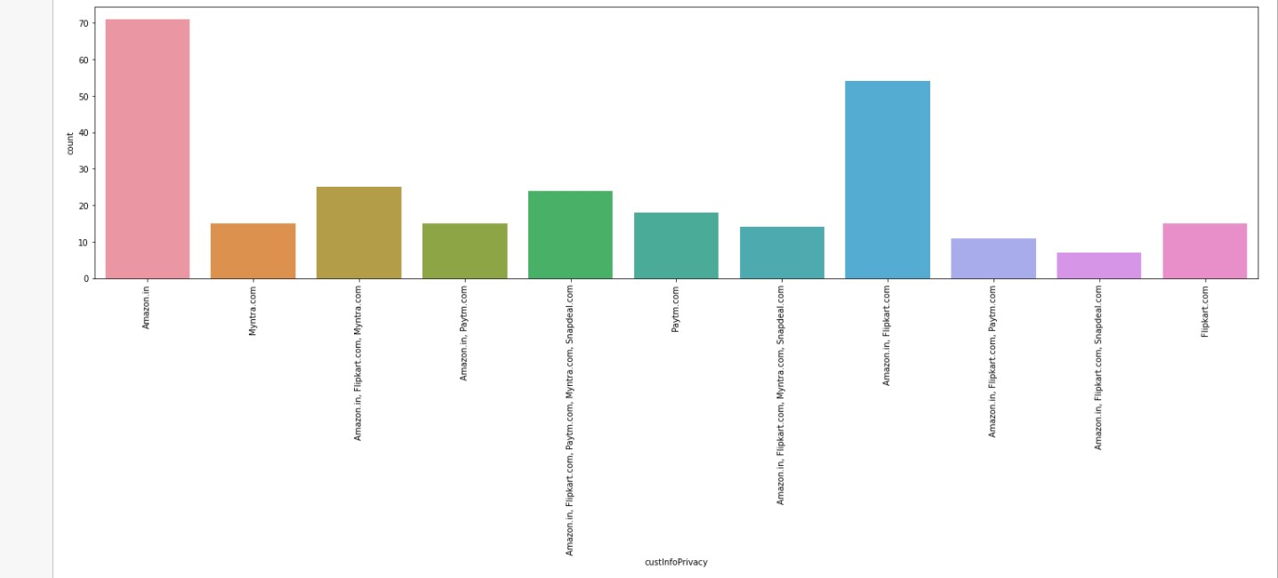

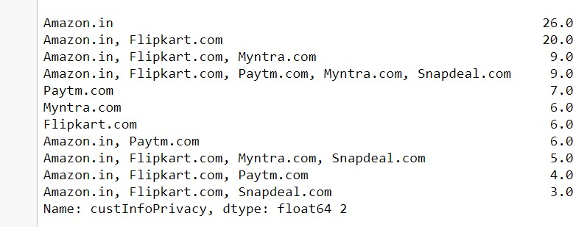

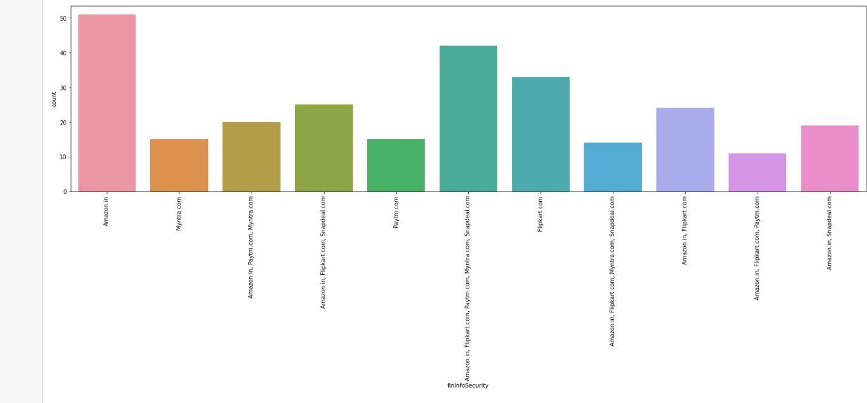

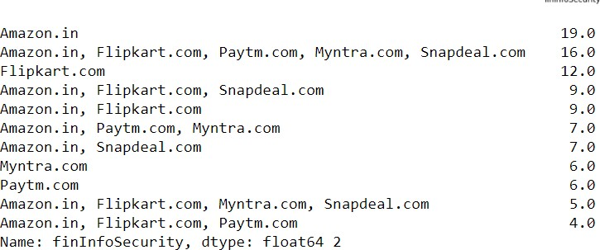

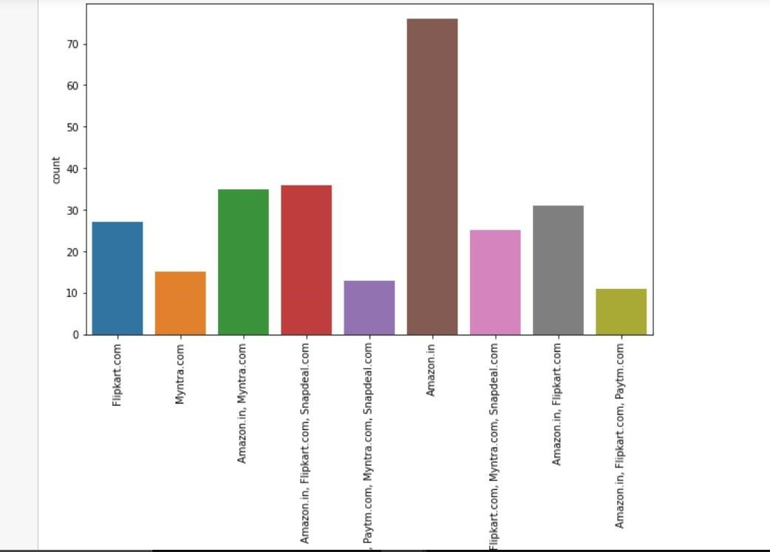

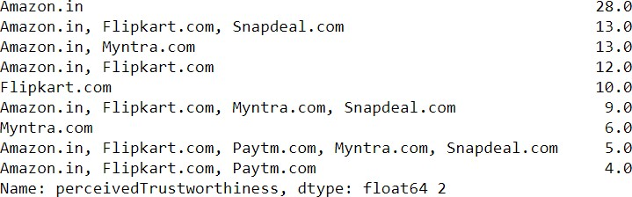

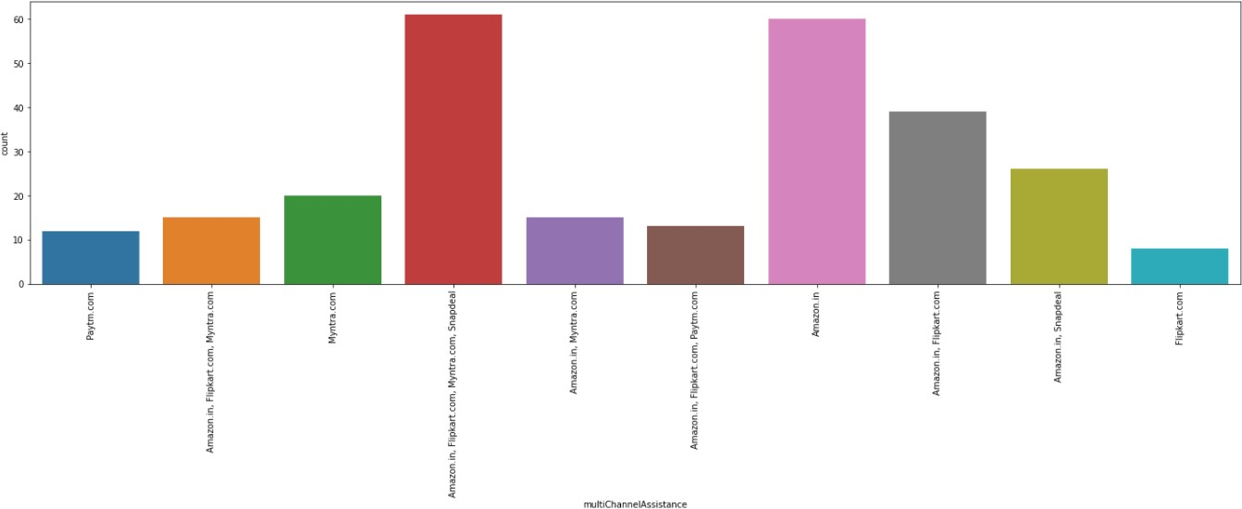

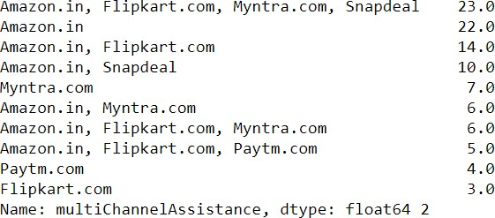

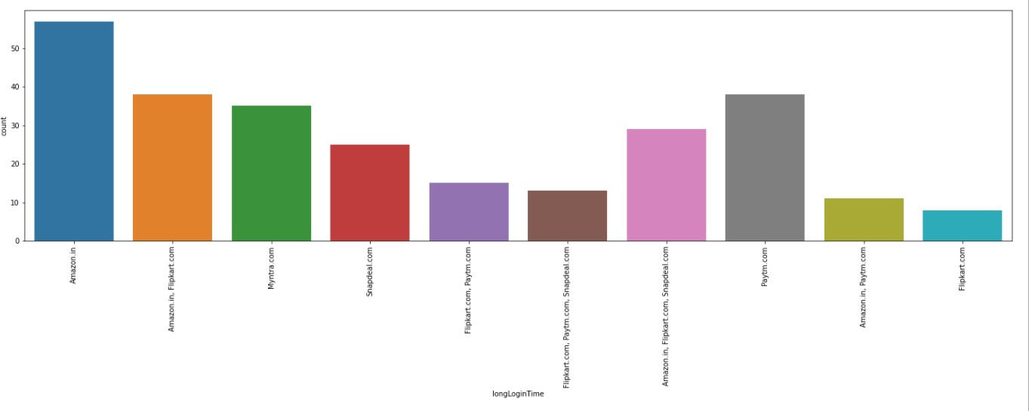

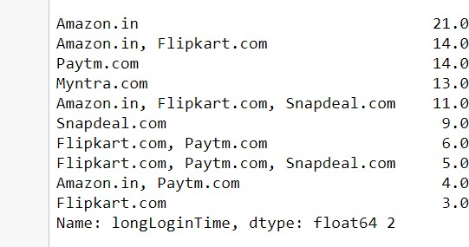

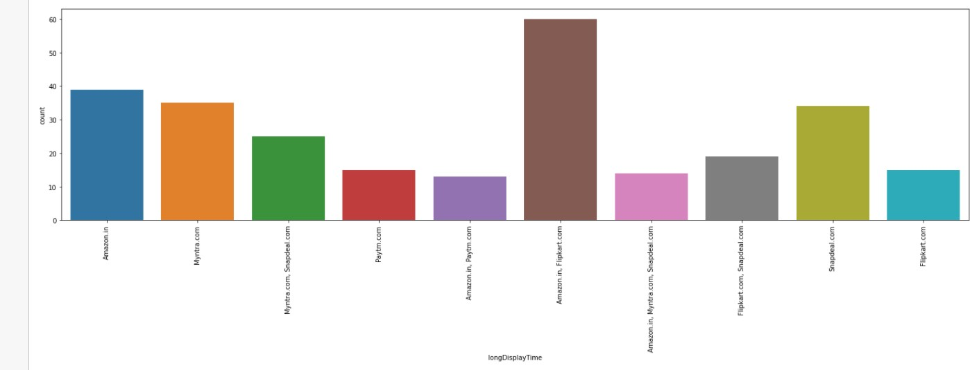

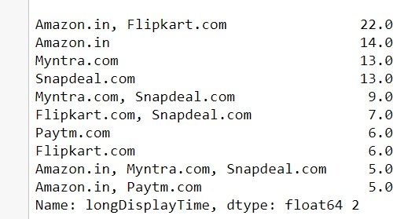

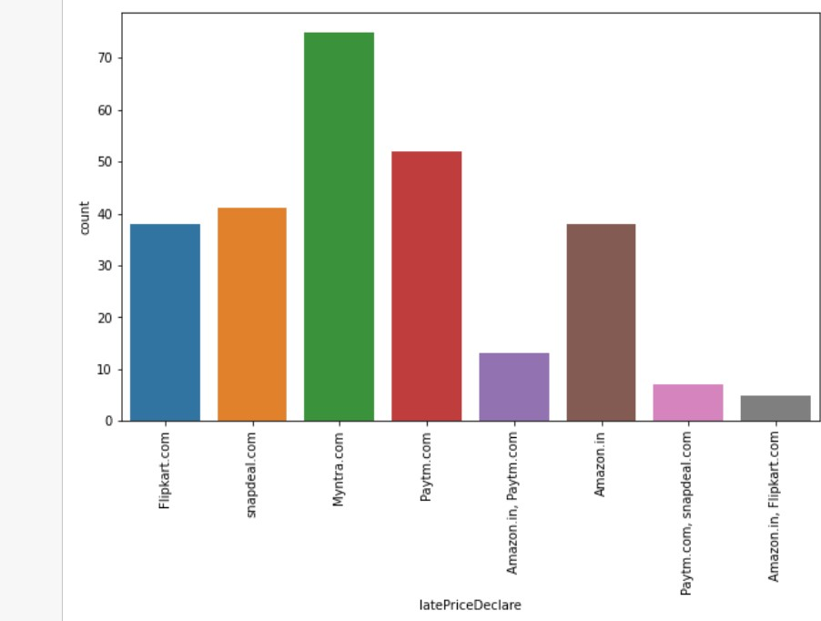

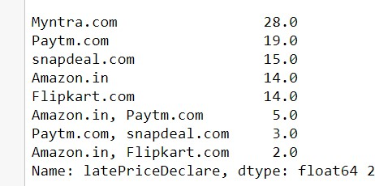

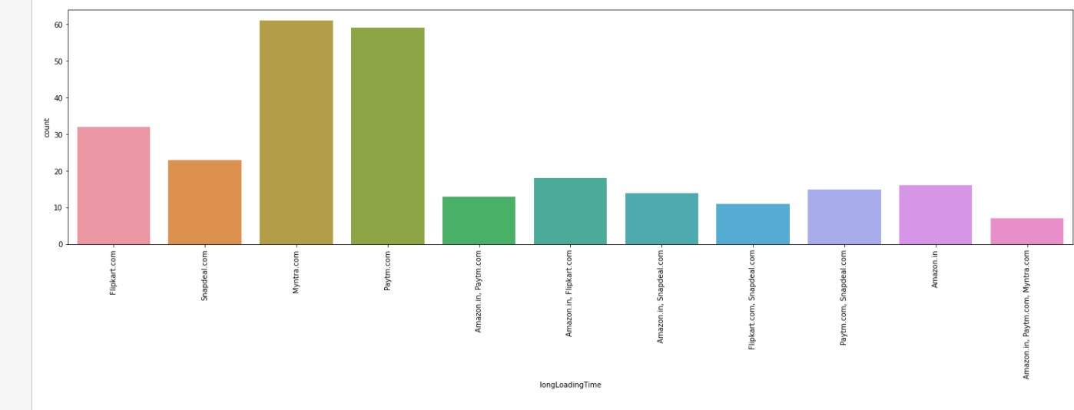

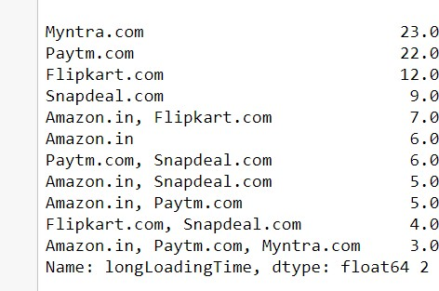

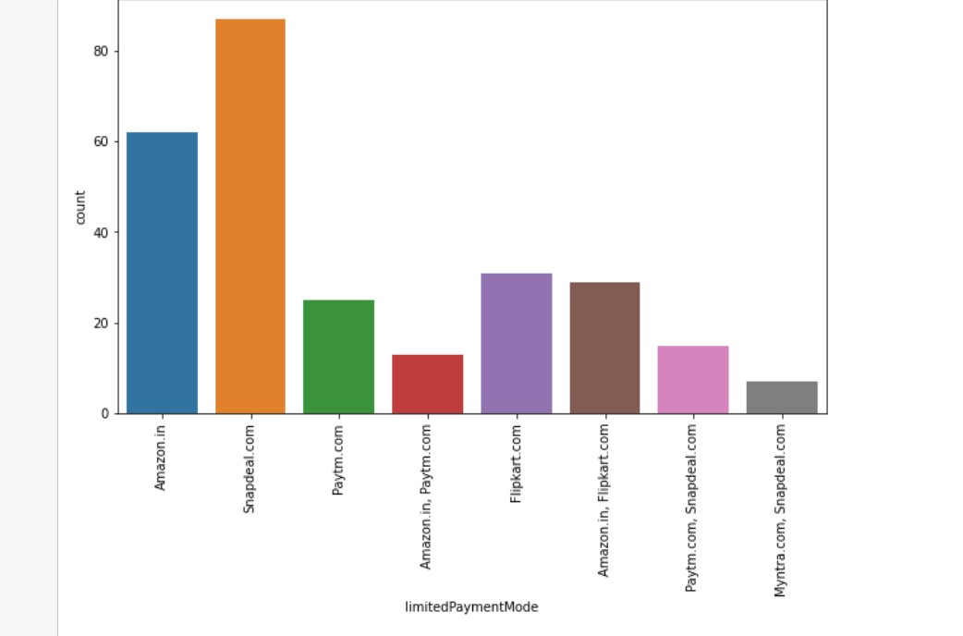

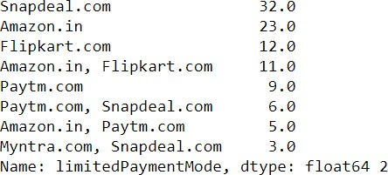

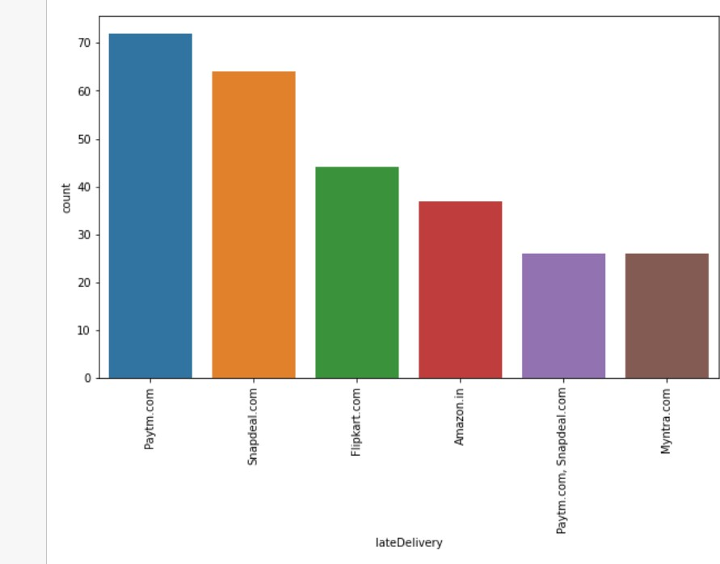

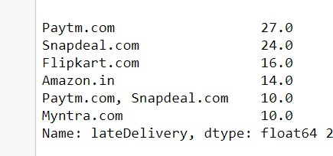

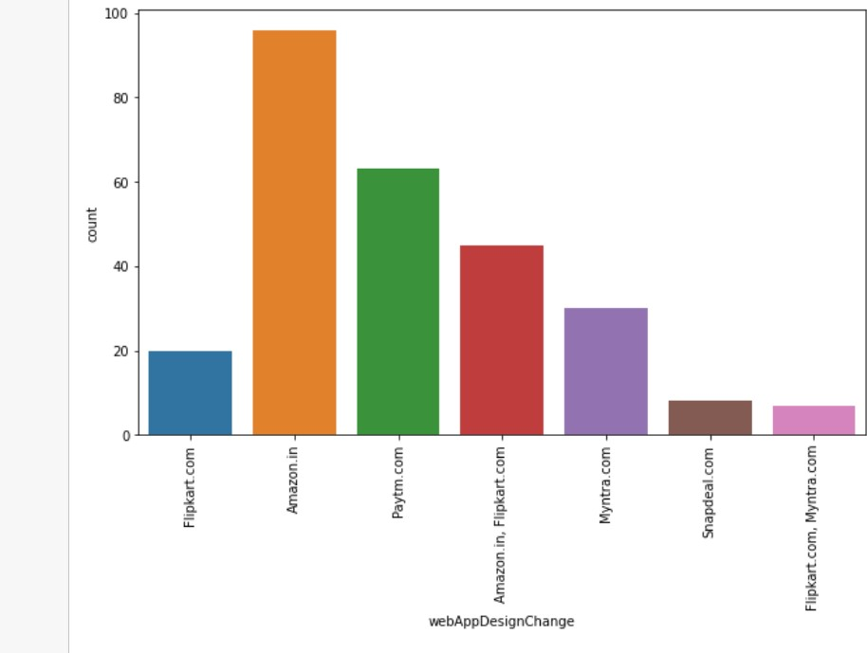

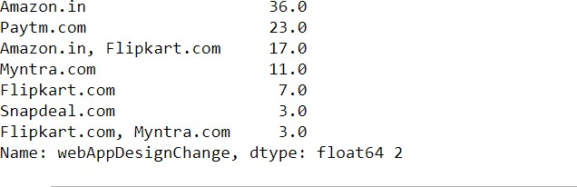

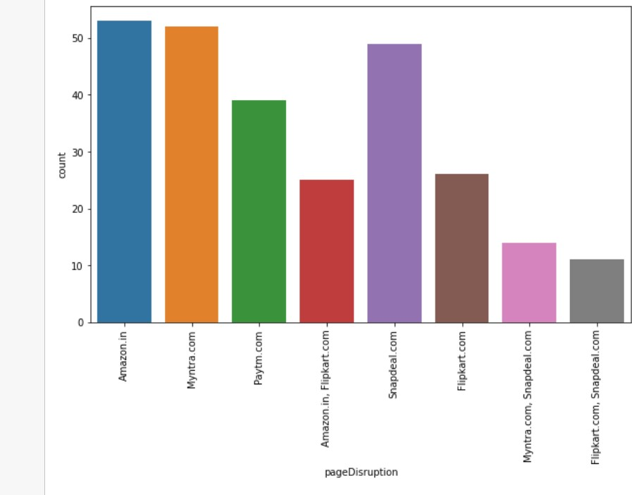

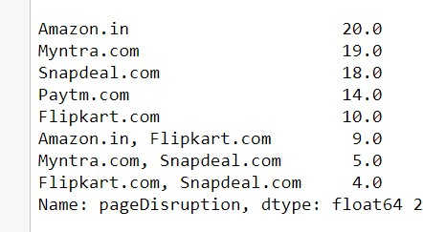

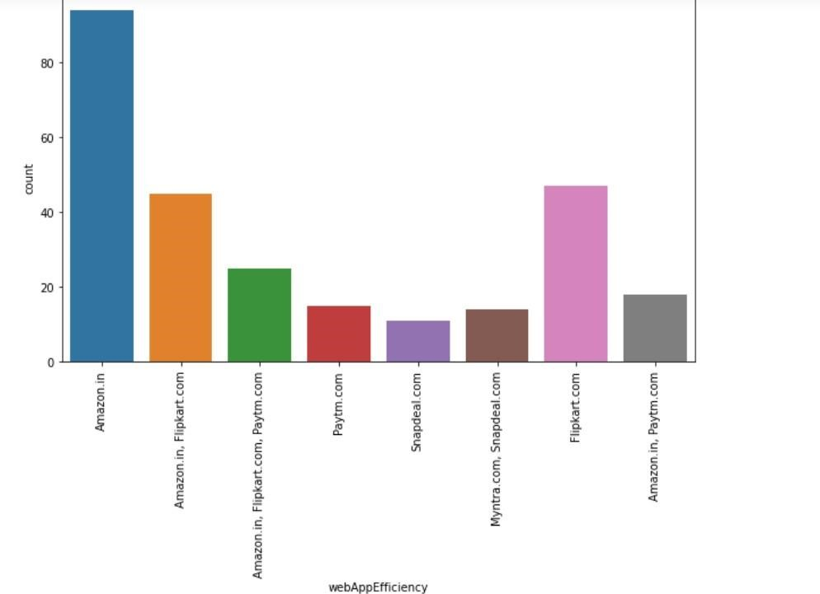

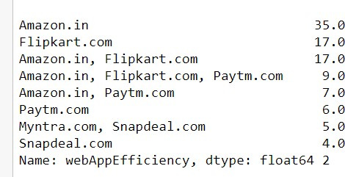

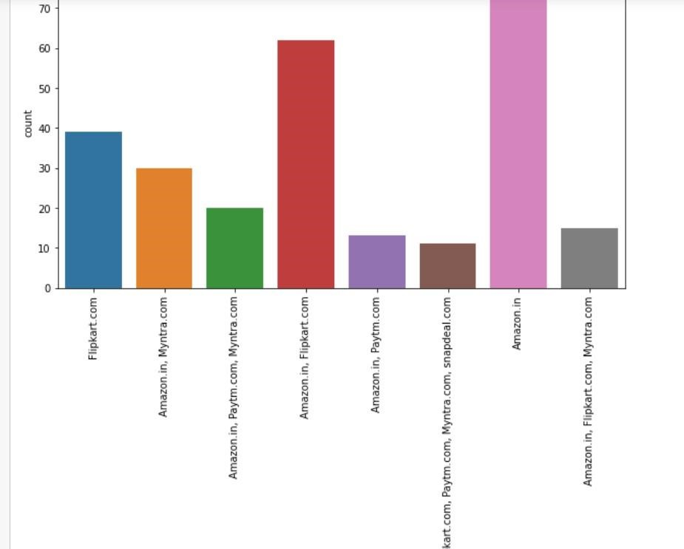

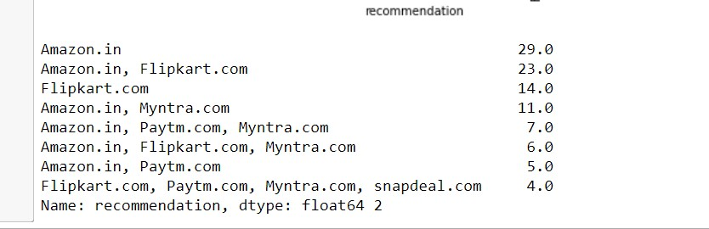

**OBSERVATIONS:**

* Female customers (67%) are more than male customers o Customers between 20 to 50 years shopped more from the online store. 75 % of customers are between 20 to 50
* Delhi, Bangalore, Noida are the cities with high number of buyers

* 36% customers were found shopping online for more than 4 years , 24% were shopping for 2-3 years
* IN last one year 42% customers have purchased online less than 10 times,23% customers purchased 31-40 times only 2 percent customers purchased more than 42 times
* 70% customers used mobile internet for online purchase o 52% customers used Smartphone for online purchase, 32% used laptop least

4% used tablet o 45% customers use Windows phone o 80% customers used Google chrome for online purchase o 86% customers uses Search engine to reach their favorite online store o After first visit 32 % customers used search engine to reach online store and 32% uses application. We can assume that these customers have been retained by the E commerce website as they have downloaded the application on their phone and have a fair chance of shopping again. Also, there are a few customers who are using Desktop/Laptop, for which, there are no applications for online shopping and you have to stick with the web browser.

* 46% customers take at least 15 minutes before making a purchase, 26% take

6-10 minutes only o 55% customers prefer Credit/Debit cards to make payments ,28% preferred

COD and 17 % preferred Wallets o 64% customers abandon their shopping cart sometimes, 19% abandon their cart frequently

* 49% customers abandon their bag due to better alternative offer, 20% abandon due to promo code not applicable
* 61% customers have strongly agreed to have easy website content which is easy to understand
* 43% customers agree that Information on similar product to the one highlighted is important for product comparison.
* 70% customers agree that Complete information on listed seller and product being offered is important for purchase decision
* 90% customers agree all relevant information on listed products must be stated clearly.
* 90% customers agreed that the website should be easily navigable
* 85% customers had no issues with the loading and processing speed o 87% customers agree with user friendly website interface. The online stores should invest heavily in creating user friendly apps and websites, so that the customers do not have to work around much and the overall shopping experience is smooth.
* 59% customers strongly agree with the convenient paying methods. The reluctance to make online payments is gradually reducing. The acceptance has been built by addressing the trust issue over time by giving customers an option to pay online or to pay Cash On Delivery (COD)
* 52% customers trust that online store will fulfill its part of transaction at stipulated time
* 85% customers like the organization's readiness to assist with queries o Being able to guarantee the privacy of the customer: This also got 69% strongly agree. Costumers are concerned about the unauthorized access to their data. Protecting user privacy will enable stores to drive more revenue and gain more customers
* Responsiveness, availability of several communication channels (email, online rep, twitter, phone etc.): 90% customers agreed to it. In case one channel is not available, customers can reach out to multiple channels which again is an important factor. Being able to communicate easily can make the difference in both their shopping experience as well as fulfill business goals of online store.
* 50% agree that online shopping gives monetary benefit and discounts to the customer: Most online shopping sites offer amazing round-the-year discounts. Banks and Digital Wallets have happily jumped on the online shopping bandwagon by providing Reward Points, and instant Cashback offers in addition to brand discounts, which will help to gain new customers
* 60% customers enjoys online shopping o 84% customers agree that online shopping is convenient and flexible:
* 90% customers agree that return and replacement policy helps them making purchase decision. It is evident from the fact that people cannot actually try & touch the products, they are purchasing before it reaches home and they would want to return or replace in case of dissatisfaction. Online shopping websites should make strategies around easy return and replacement policy if they want to retain their customers.
* Around 50% customers agree that gaining access to loyalty program is a benefit of shopping online
* Displaying quality Information on the website improves satisfaction of customers: 80% customer agreed to it. It means displaying quality information have a significant association with customer satisfaction, and repurchase intentions
* 95% customers are satisfied while shopping on a good quality website o Net Benefit derived from shopping online can lead to users satisfaction:90% customers agreed
* User satisfaction cannot exist without trust: 85% customers agree that customer satisfaction cannot be built without trust. Trust is important factor to attract e-commerce buyers. So, it is important for companies to learn how to manage consumers' trust
* Offering a wide variety of listed product in several categories: 75% use agreed.
* 86% customers like to have complete and relevant information o 80% customers agree to receive monetary savings while shopping online o 50% agree with the convenience of patronizing the online retailer o 50% customers agree that online shopping give the sense of adventure o only 30% customers agree that online shopping enhances their social status o 45% customers feel gratified while shopping with their favorite retailer o 45% customers feel that shopping online helps them fulfill certain roles o 85% customers agree they get value for their money while shopping online

* Observations from Multiple Options based Questions i.e. related to company name specific parameters, after 47th rows o Maximum people have shopped from these 5 companies - Amazon.in, Flipkart.com, Paytm.com, Myntra.com, and Snapdeal.com.
  + 48% customers says flipkart, amazon shows wide variety of products o 37% customers like flipkart and amazon in terms of displaying complete and relevant information of the products
  + In terms of speed Amazon.in is liked by 90% customers , 60 % like Flipkart ,

27% Myntra o 78% customers trust Amazon to be reliable , 55% likes flipkart , 25% Myntra o 80% customers likes Amazon's quickness to complete the purchase , 60% likes Flipart's, 30% likes Myntra's

* + 86% likes Amazon's delivery speed , 56% likes Flipkart's , 5% likes Myntra's o 82% customers trust amazon in terms of keeping the privacy of their data,

56% trust flipkart 20% trust Myntra , 12 % trust Snapdeal o 70% trust amazon in terms of keeping their financial information secured, 56%

Flipakrt, 34% Myntra , 21% Snapdeal , 22@ Paytm o 84% customers believe Amazon perceived trustworthiness, 43% - Flipkart ,

33% - Myntra ,Snapdeal 27% Snapdeal o 86% customers like Amazon in terms of online assistance through multi- channel , 51% -Flipkart ,42% Myntra

* + 50% customers agree that Amazon takes longer time to log them in while in sales period/promotions , 39% goes with flipkart, 13% goes with Myntra , 16%

Snapdeal o 46% customers says that amazon takes longer time in displaying photos in sales/promotion , 35%- flipkart, 21% Snapdeal, 14% Myntra, 11% Paytm

* + In terms of late declaration of price in promotion/sales 28% goes with Myntra,

21% amazon , 16% flipkart , 18% Snapdeal, 23% Paytm o In terms of longer page loading in promotion/sales 26% customer goes with

Myntra, 23% flipkart, 23% amazon, 24% Snapdeal o In terms of limited mode of payment on most products during sales period/promotions 41% goes with Snapdeal, 40% -amazon, 23% flipkart, 20% Paytm and only 3% Myntra. Hence Myntra gives most payment options during sales/promotion.

* + In terms of time taken in product delivery Paytm has highest votes of 37%, Snapdeal 24%, flipkart 16%, amazon 14% and Snapdeal and Myntra 10%.

Hence Snapdeal and Myntra take minimum time for delivery among all.

* + 20% customers dislikes disruptions while moving to another page on amazon,

24% on Myntra, 27% Snapdeal, 14% Paytm, 23% Snapdeal o 61% customers says that amazon website is as efficient as before, 43% for flipkart, 22% for Paytm, 9% for Snapdeal

* + 81% customers would like to recommend amazon to a friend, 43% would like flipkart , 22% would like for Myntra , 9% for Paytm and least 4 % would like to recommend Snapdeal

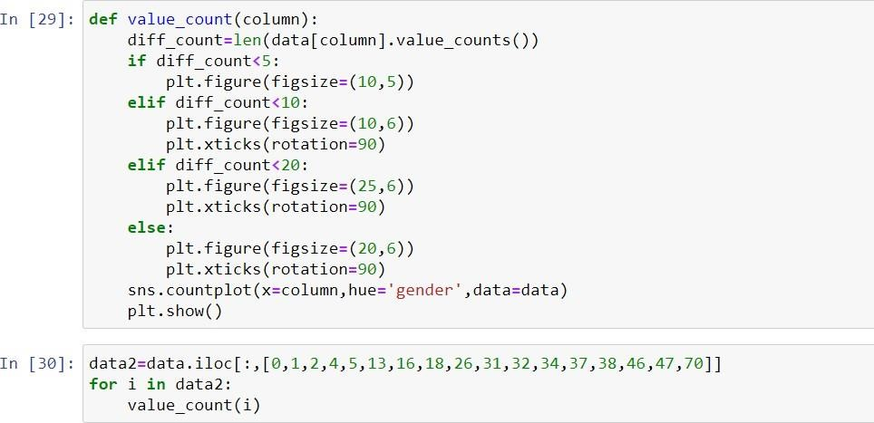

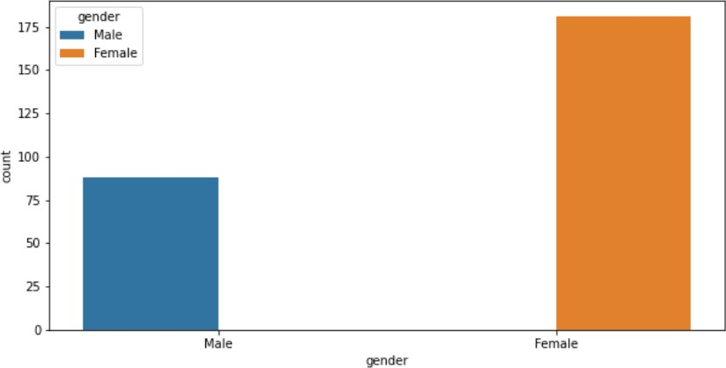

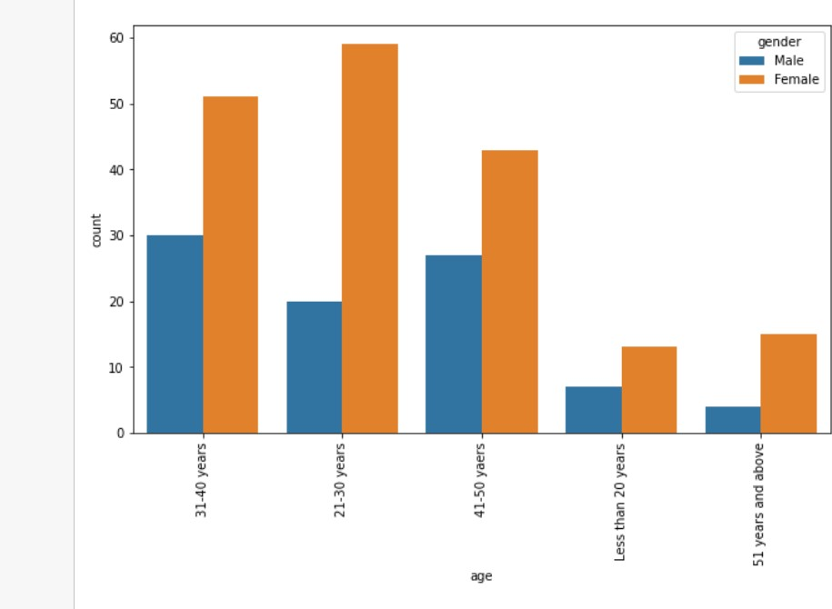

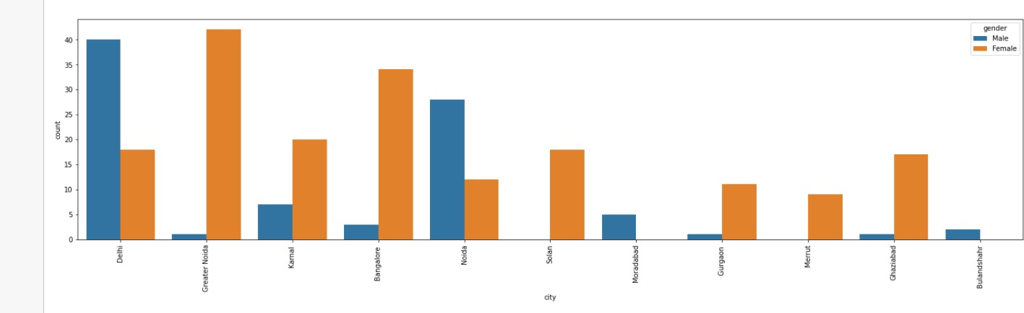

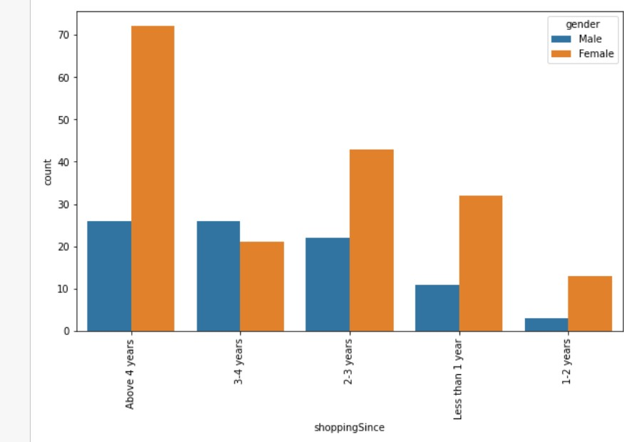

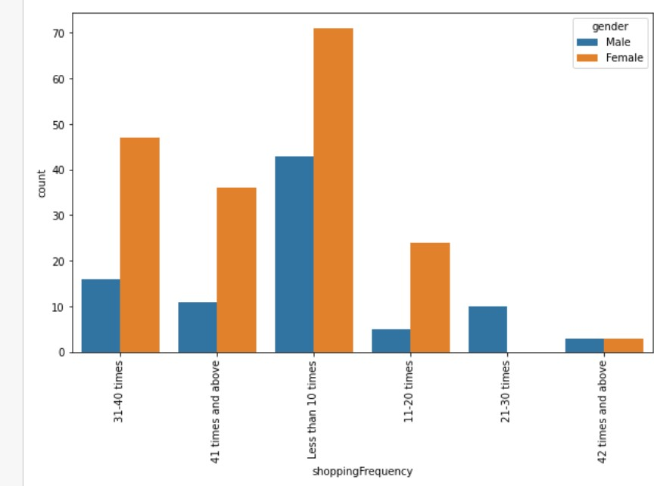

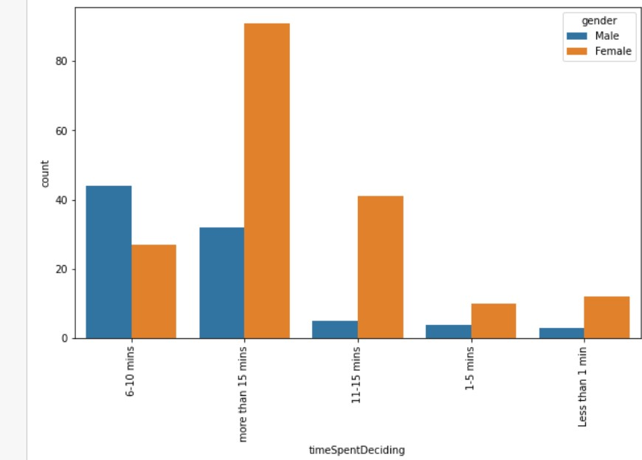

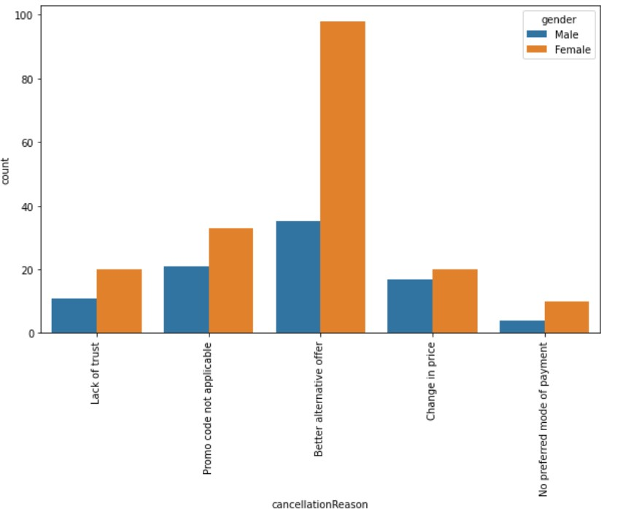

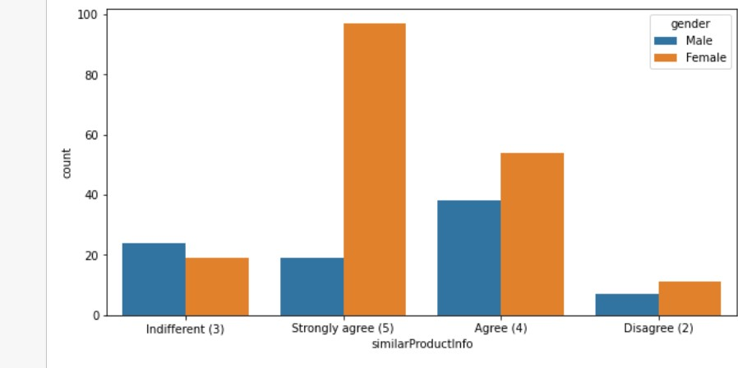

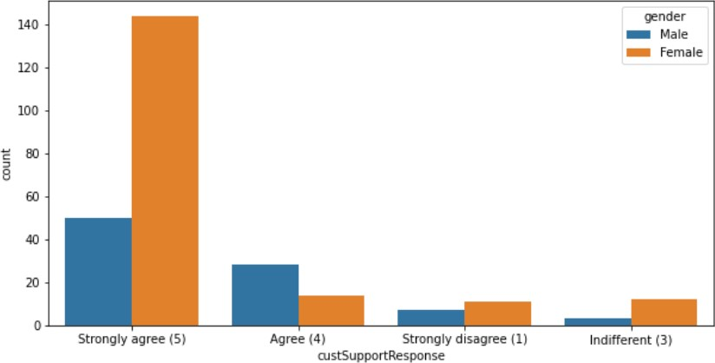

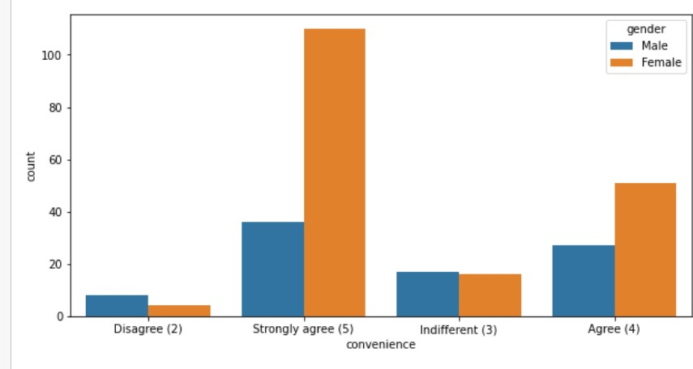

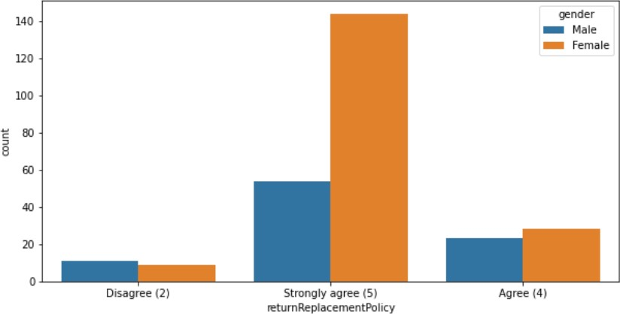

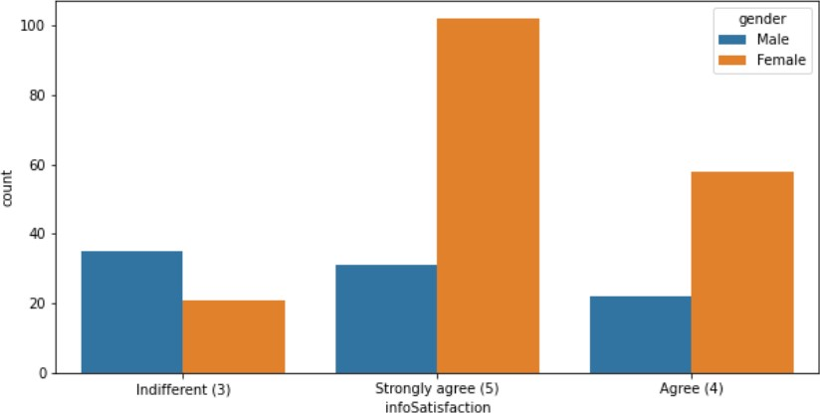

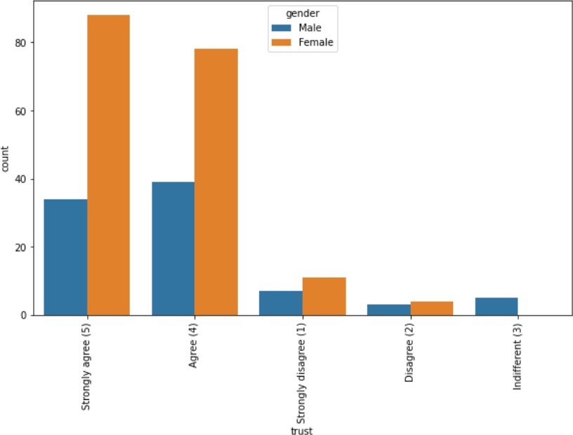

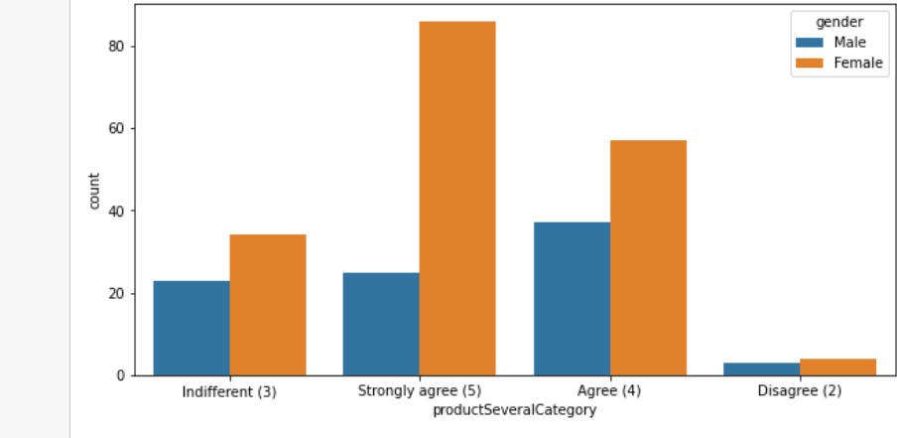

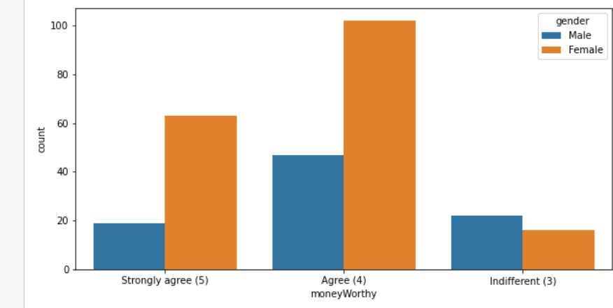

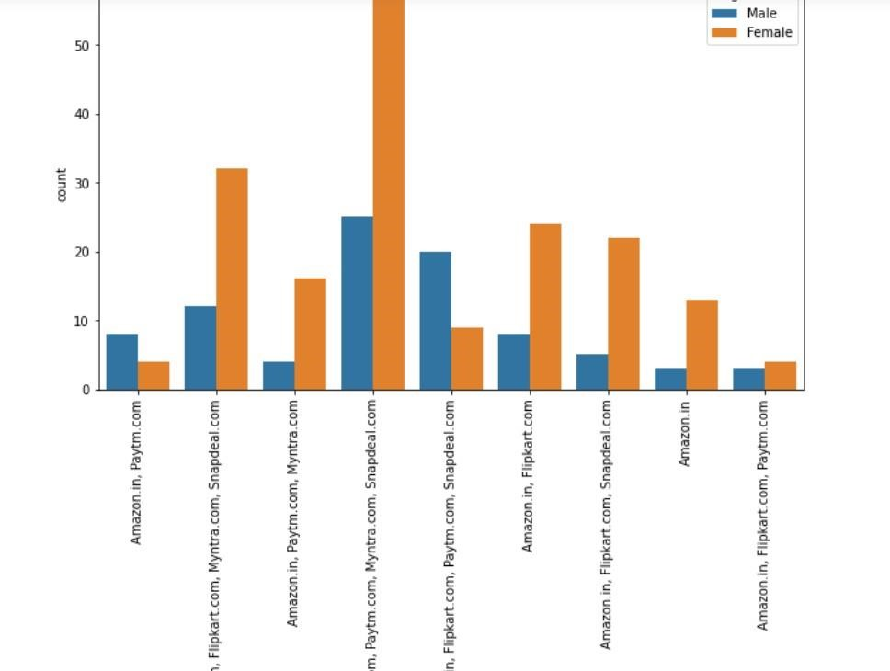

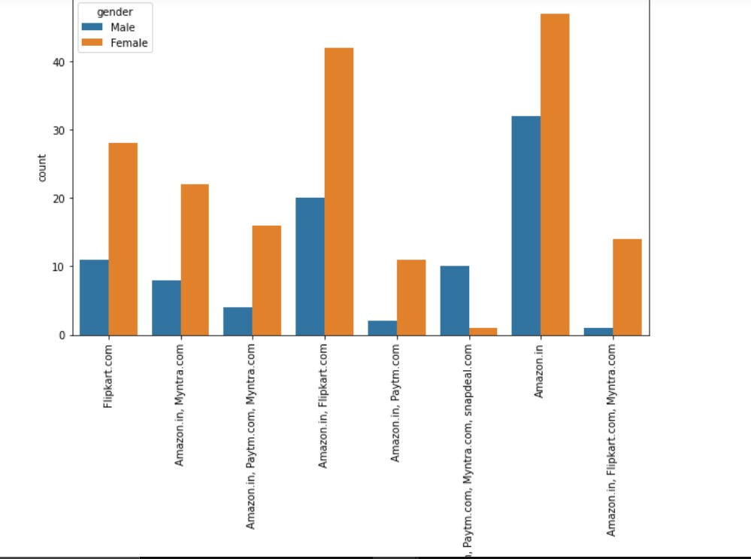

**OBSERVATIONS:**

* Even though females are dominant in the dataset, female population using ecommerce is not dominant everywhere In Delhi and Noida more numbers of males are using ecommerce than female.
* Bulandshahr and Moradabad - both cities in Uttar Pradesh has no female shoppers at all.
* Numbers of females who are shopping since long are more than number of males.

* Frequency of females shopping online is more than males

* Most of the females usually take more than 15 meanwhile most of the male spend 6-10 min before making a purchase decision.
* More females strongly agree with the fact that there must be similar products to compare. Males do agree with the fact but the data suggests that it is okay if there exists a product but also okay if there does not exist one.

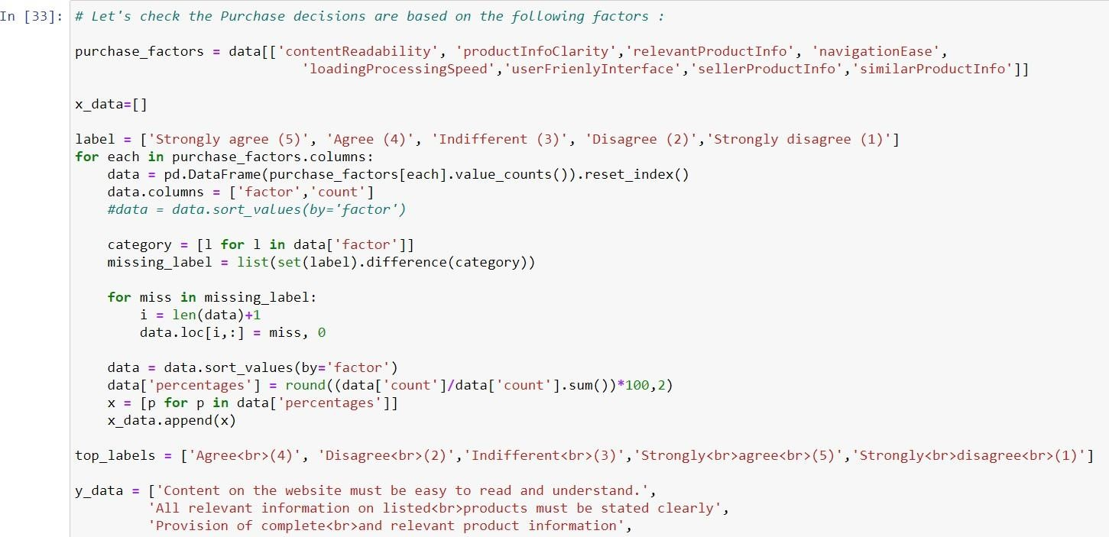

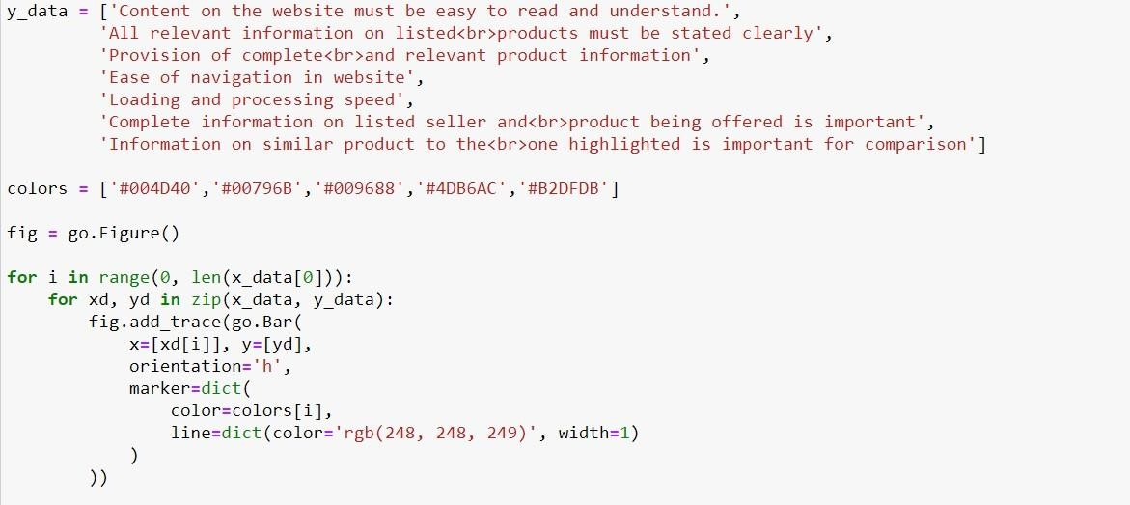

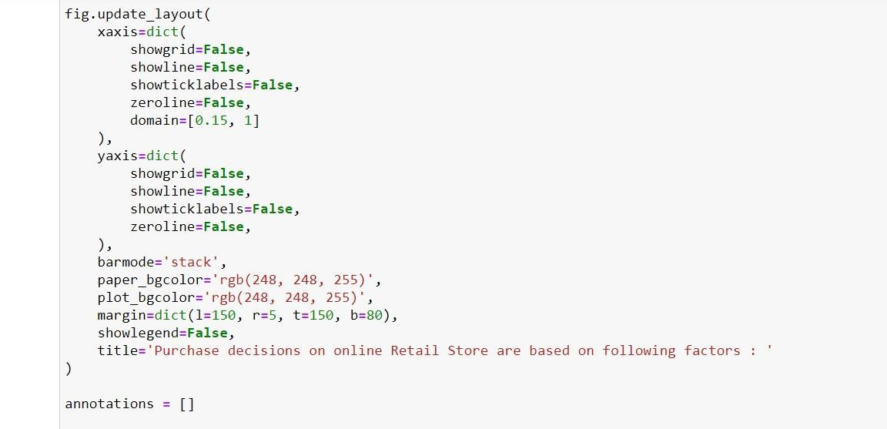

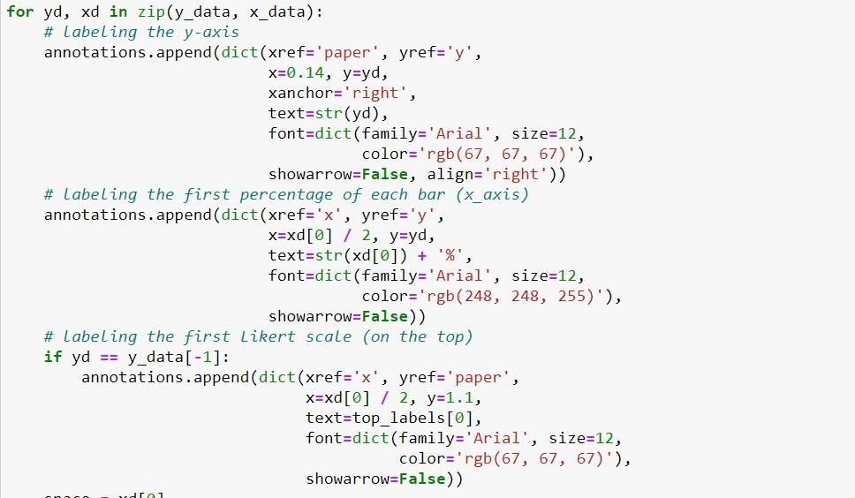

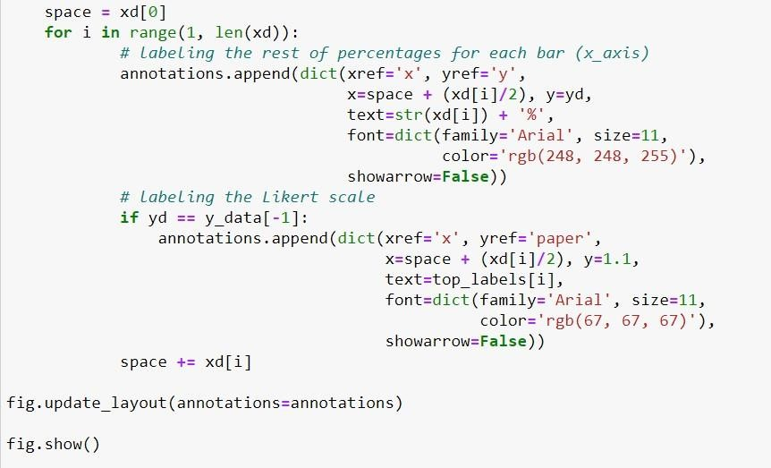

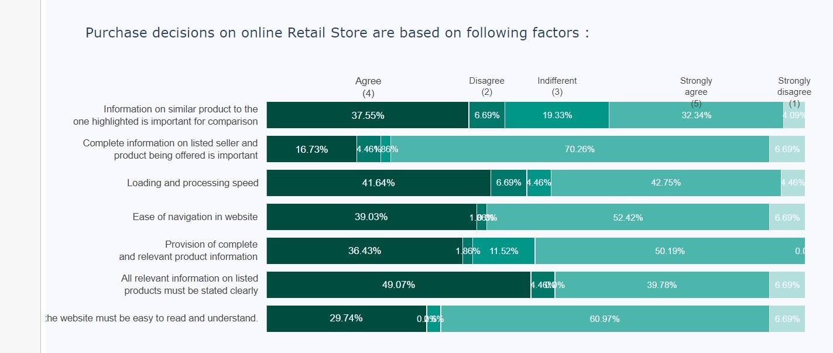



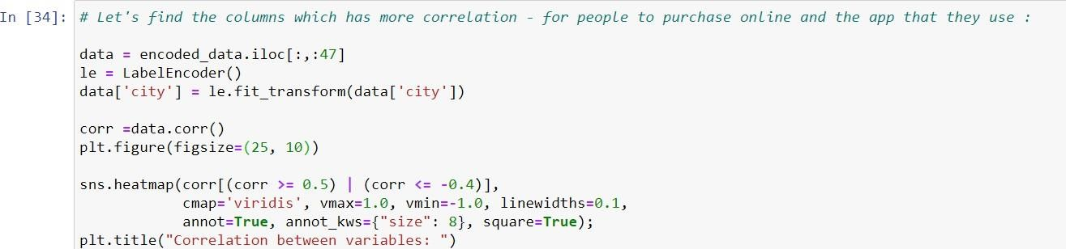

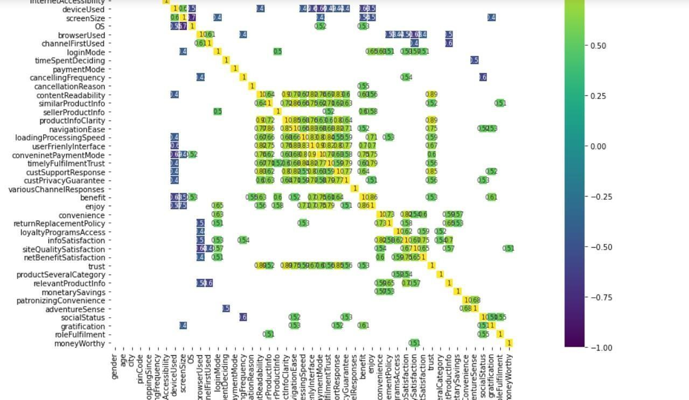



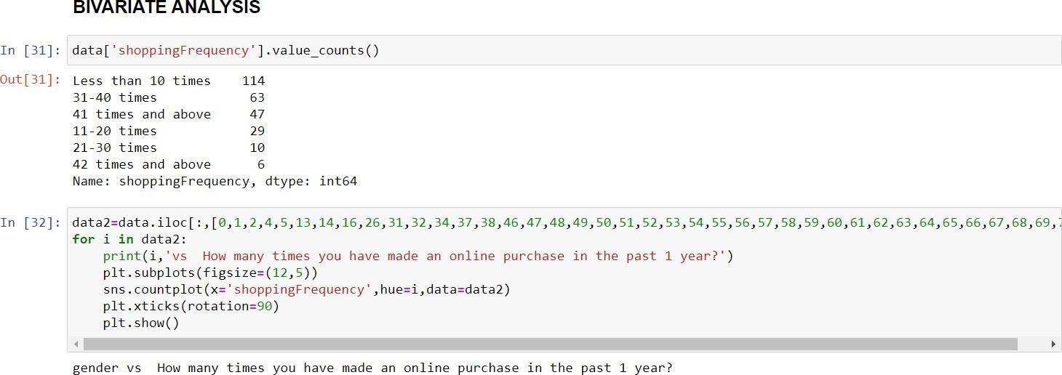

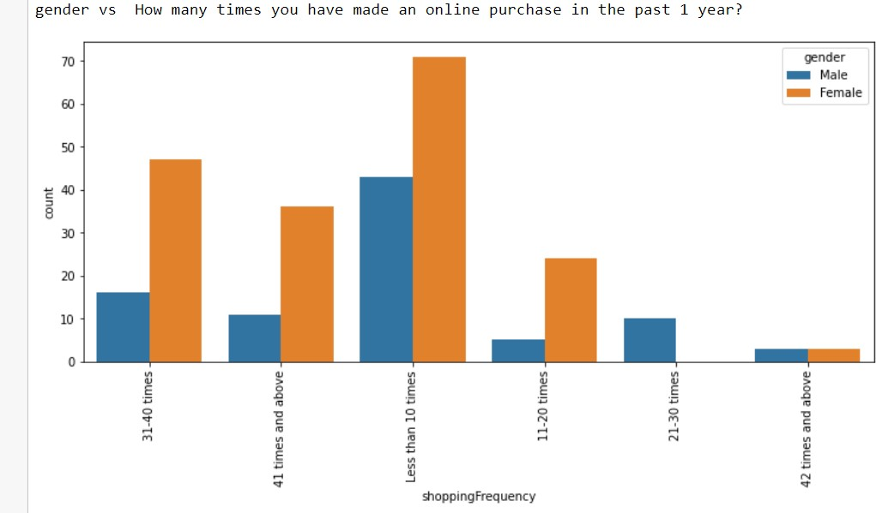

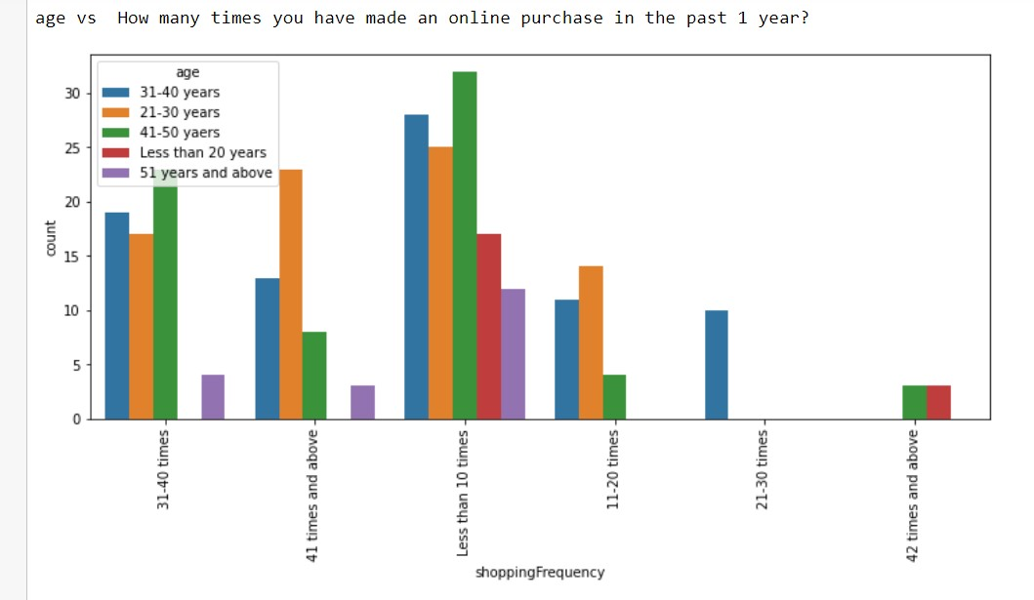

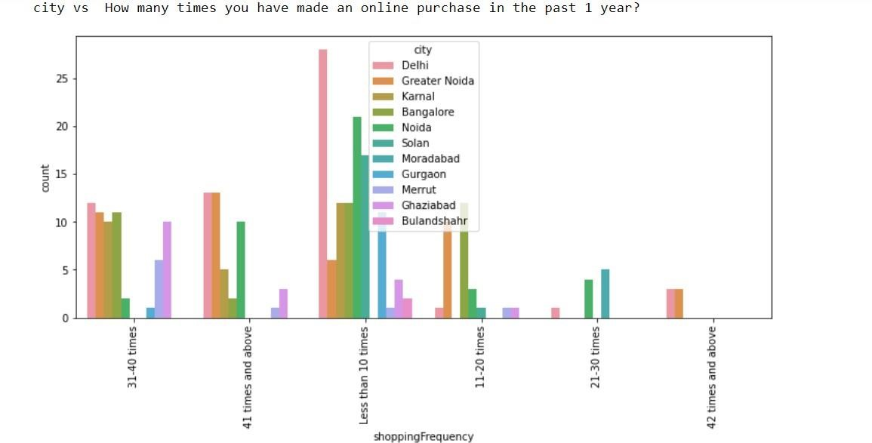

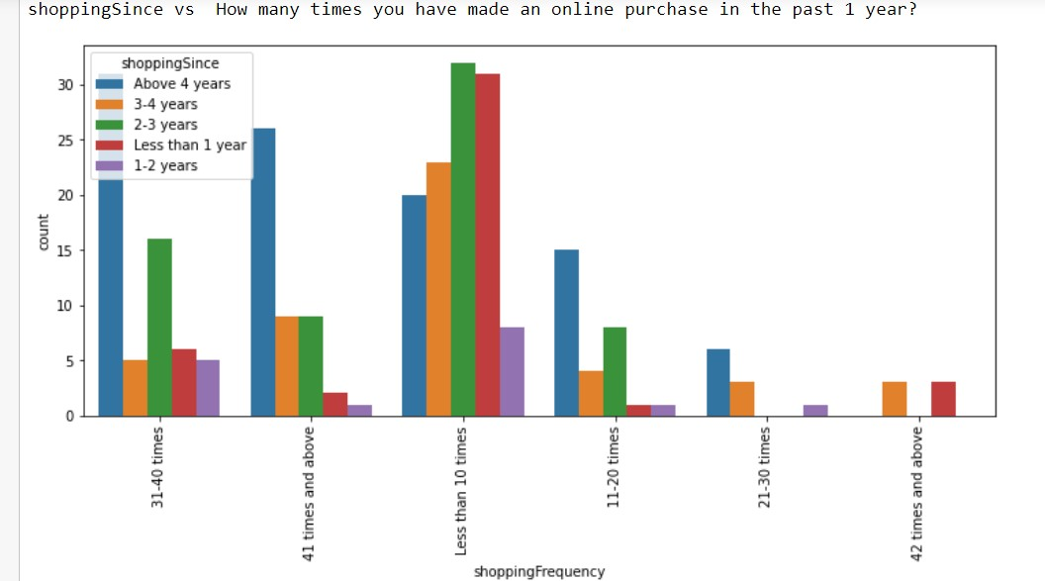

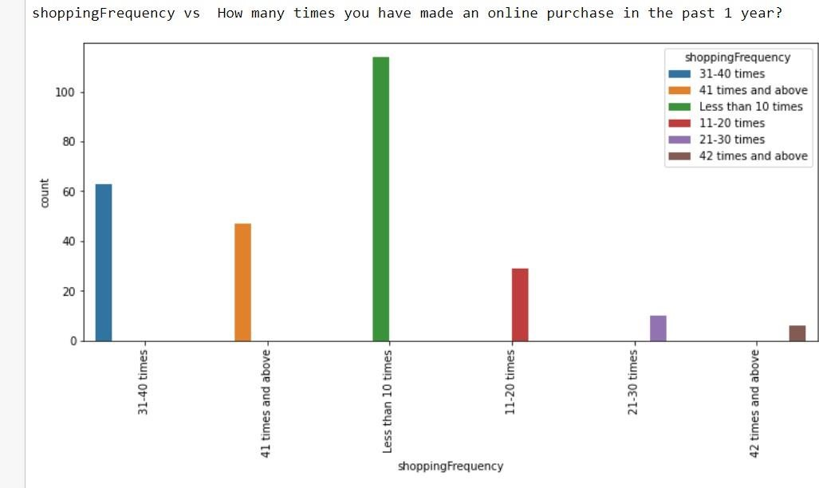

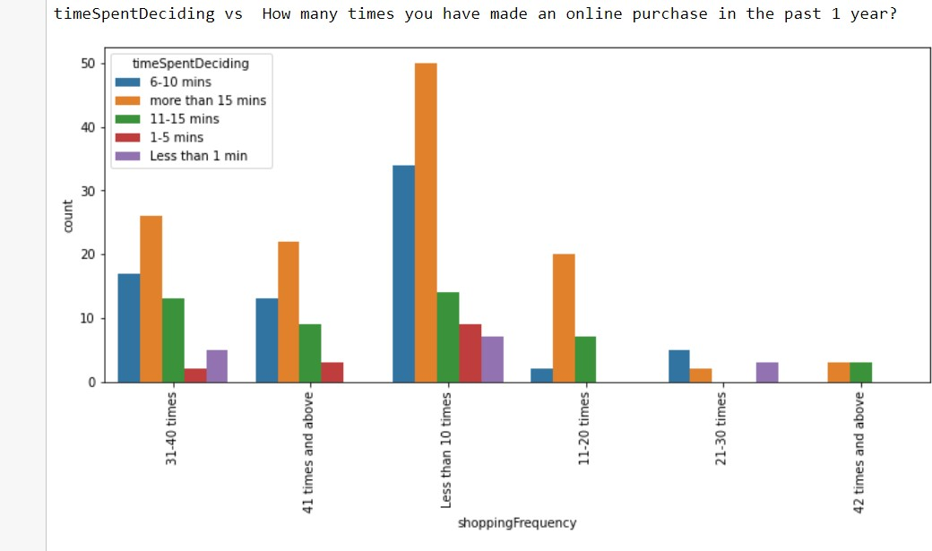

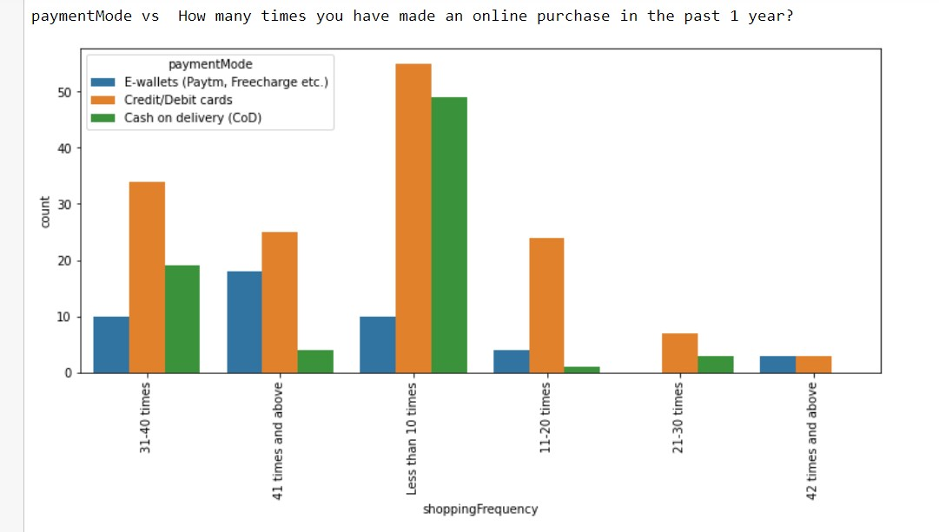

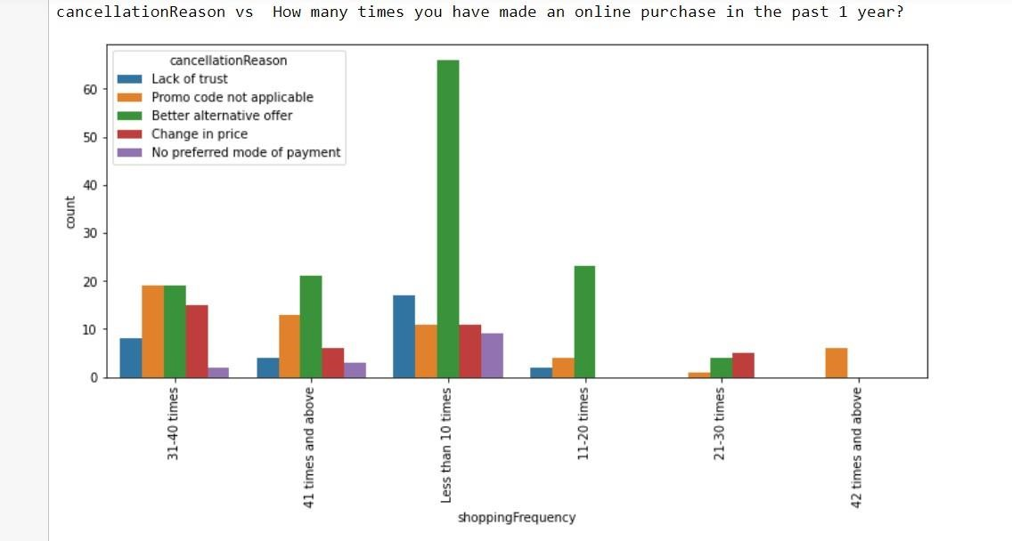

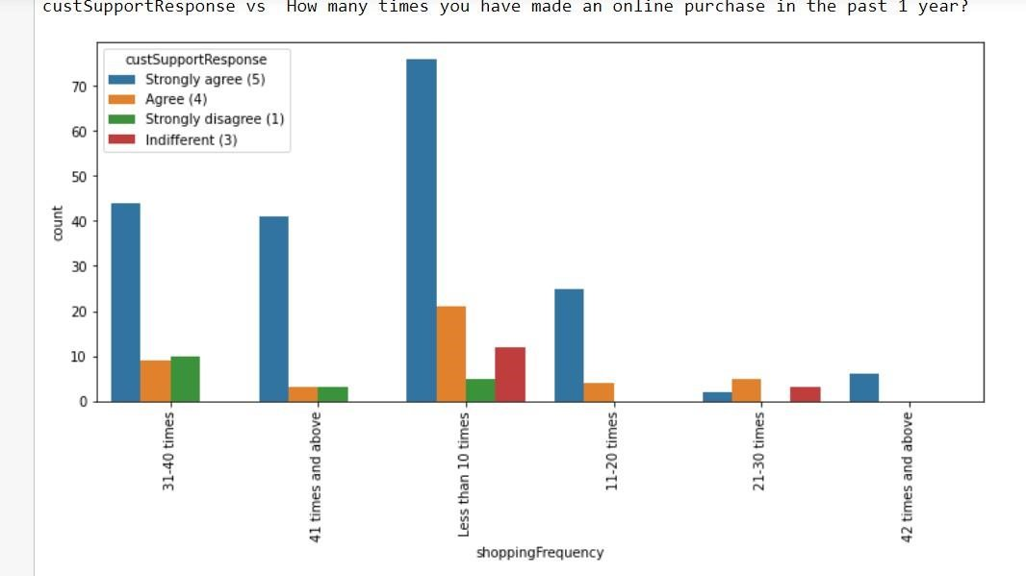

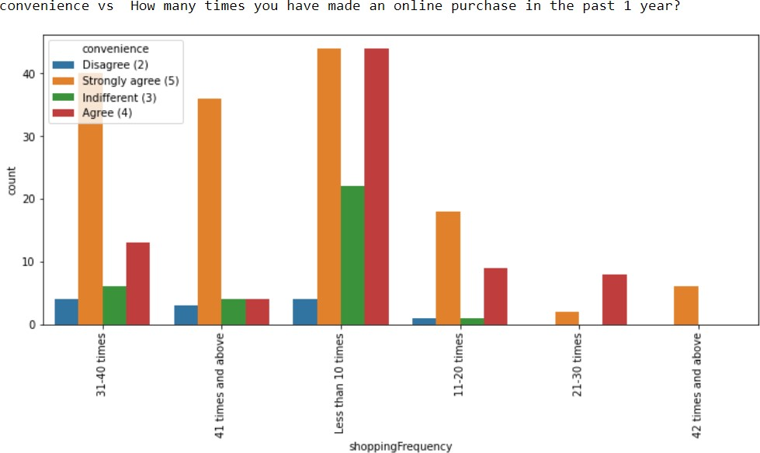

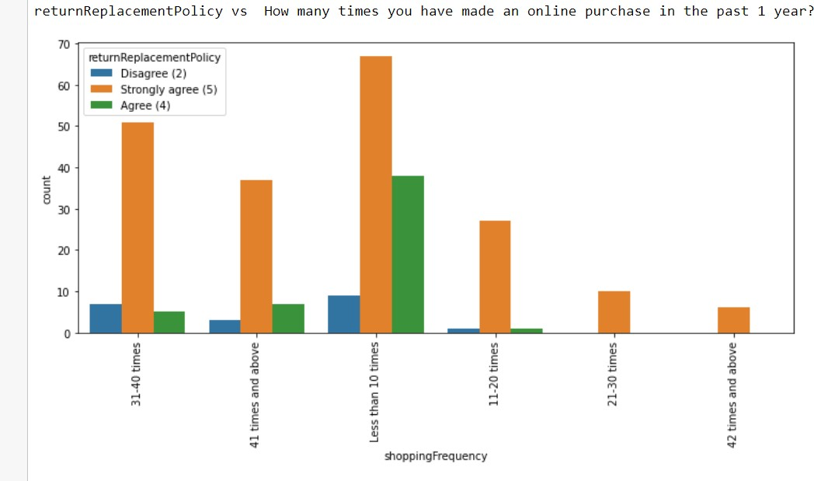

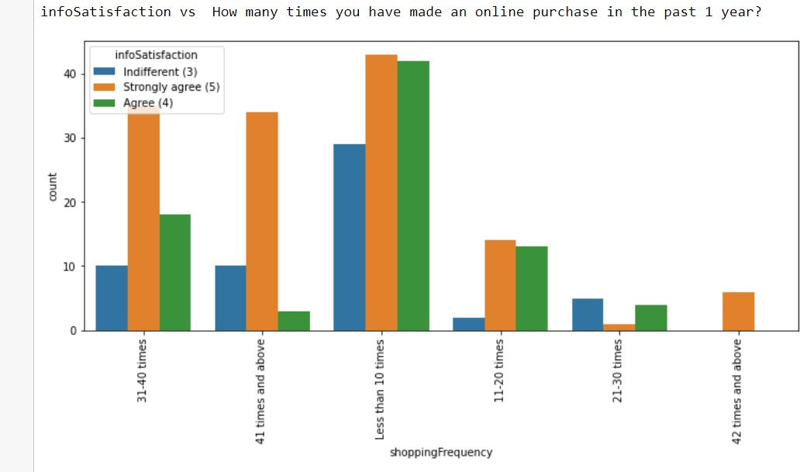

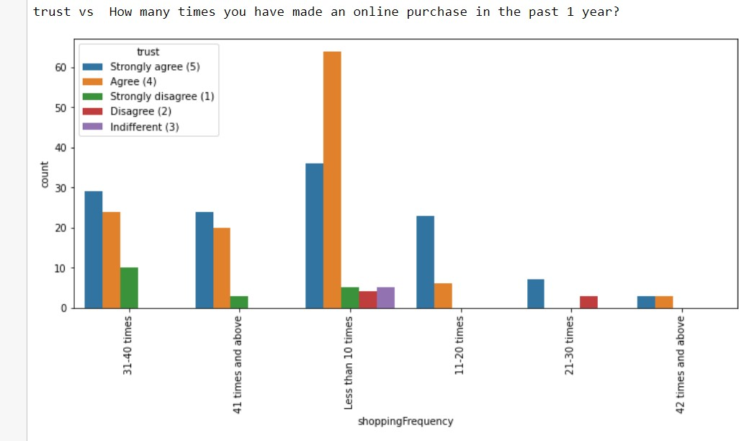

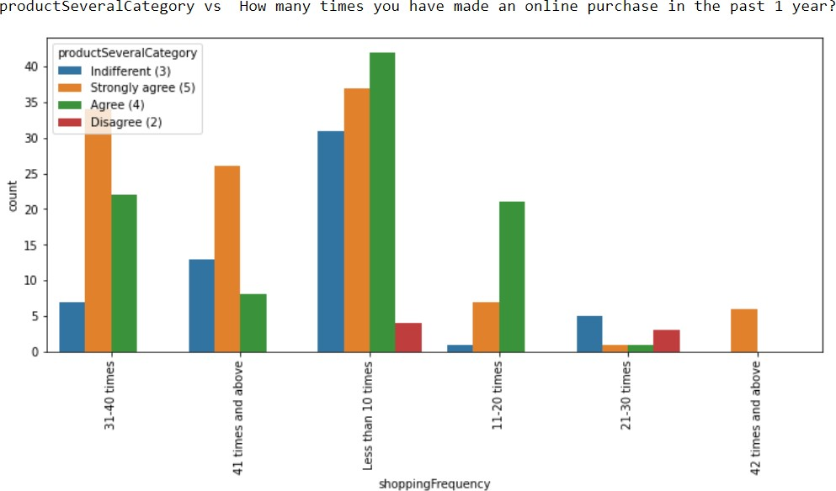

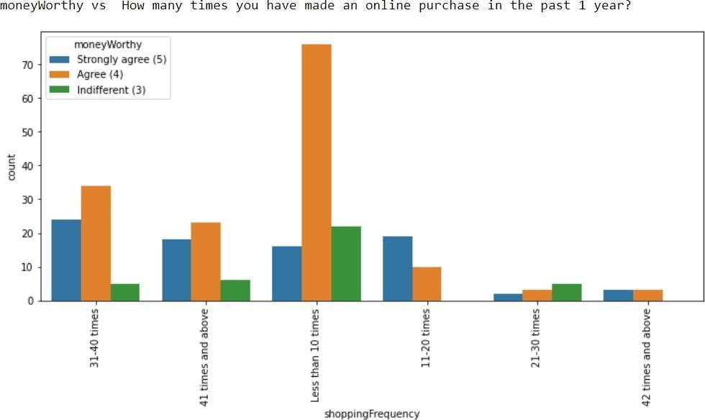

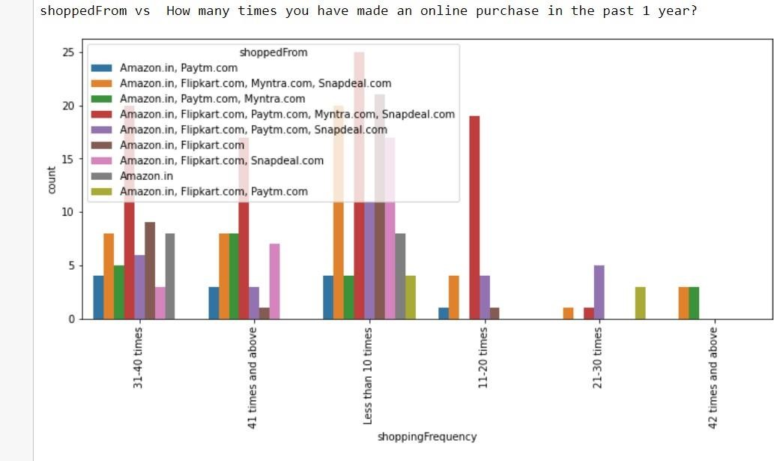

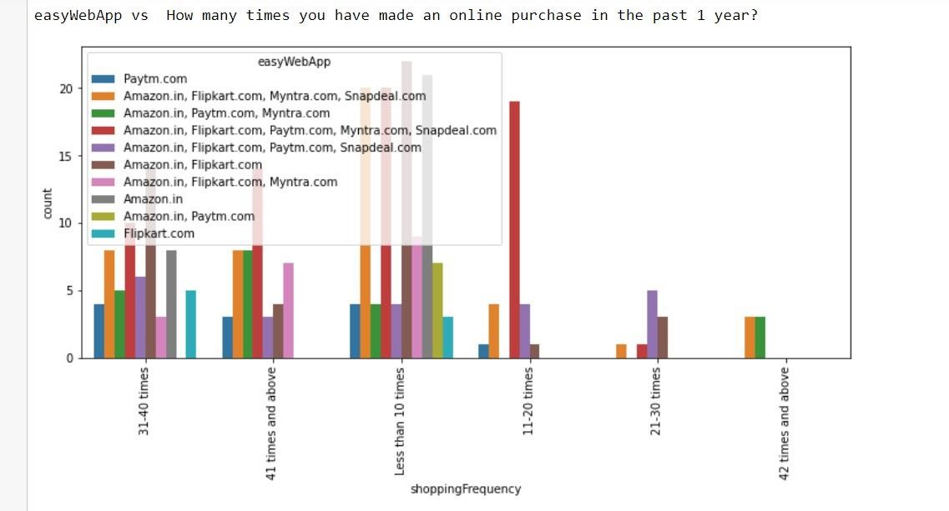

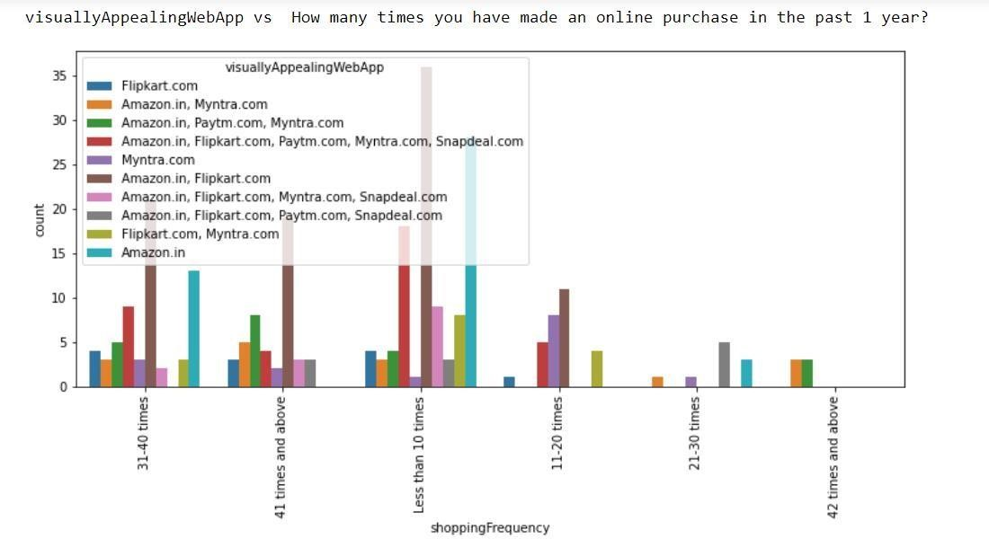

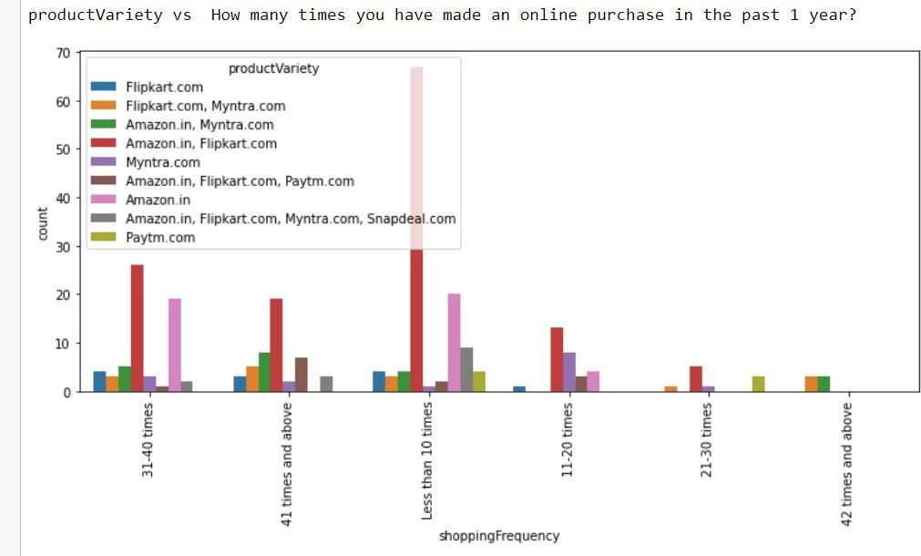

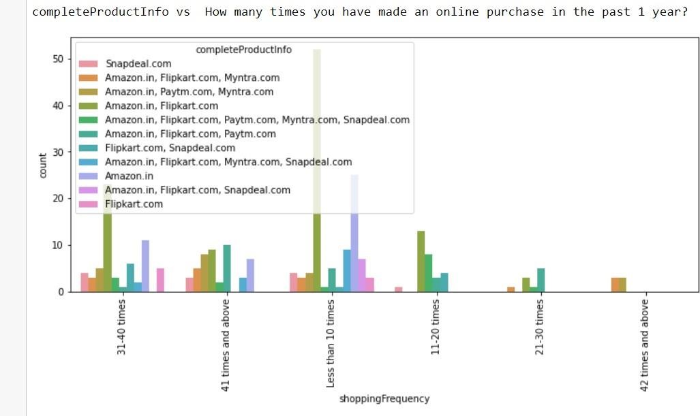

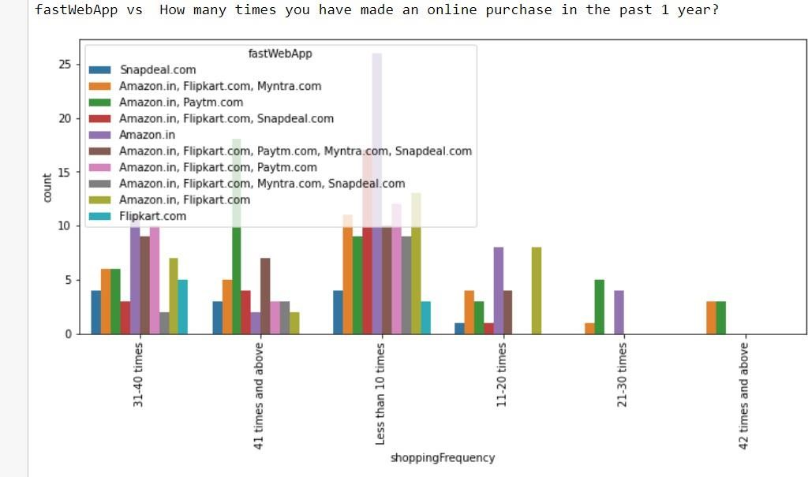

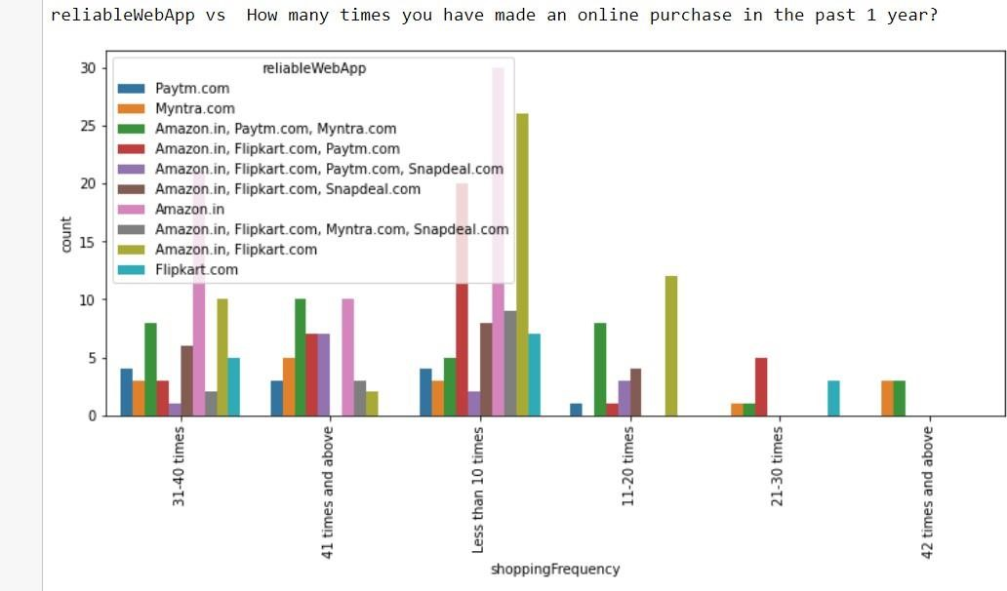

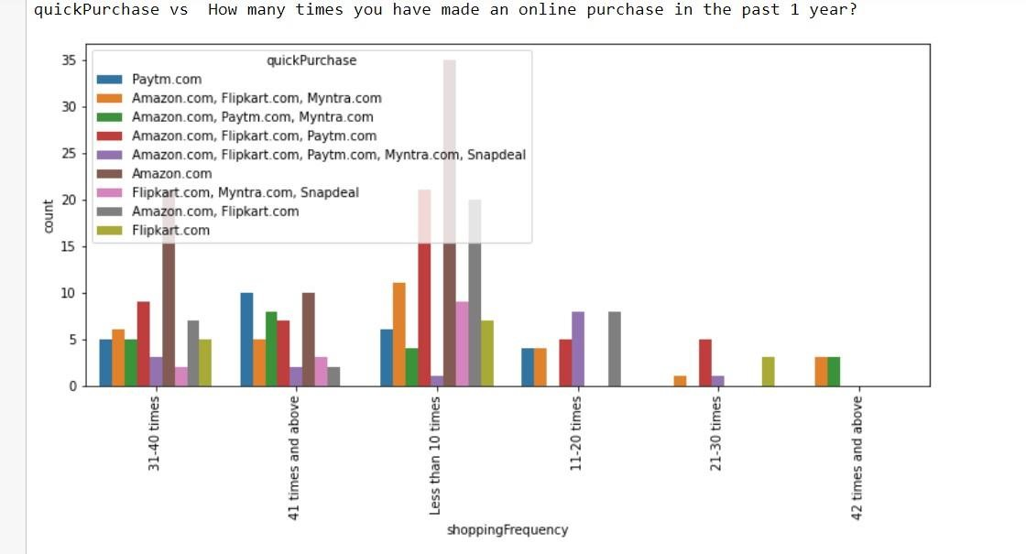

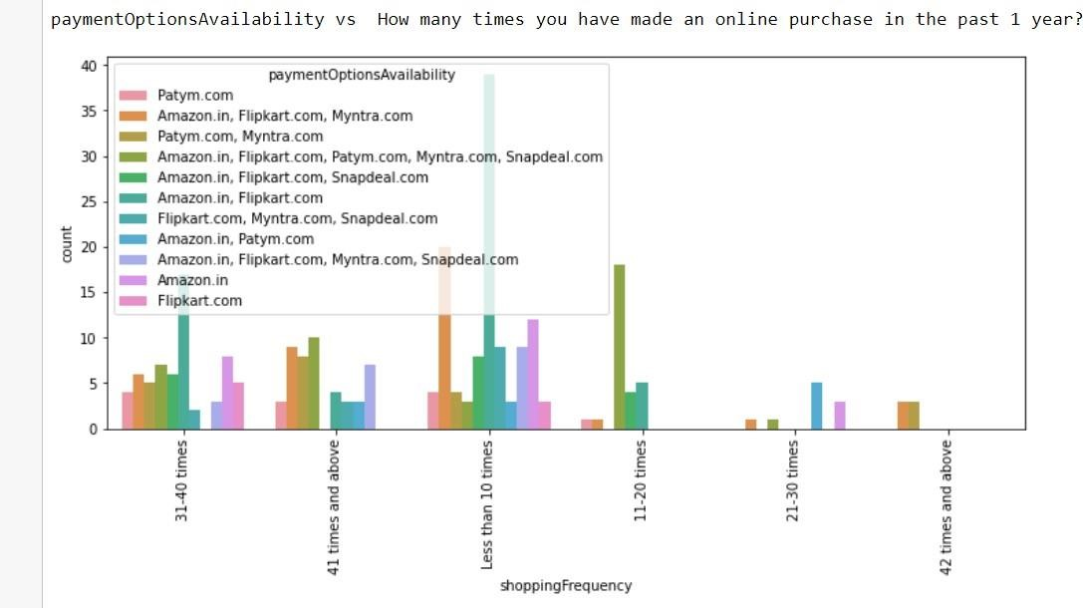

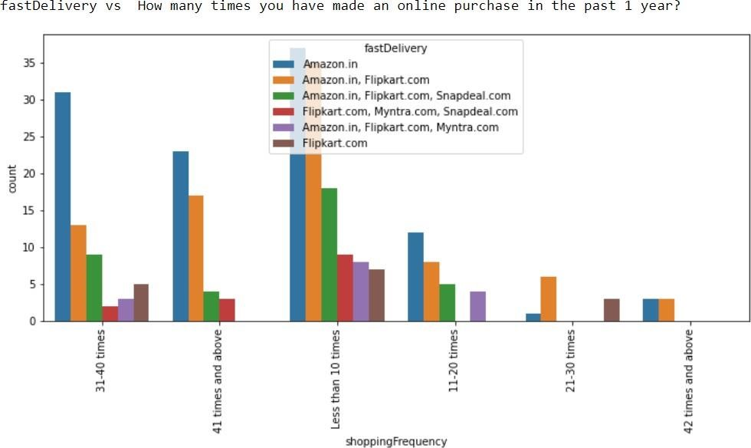

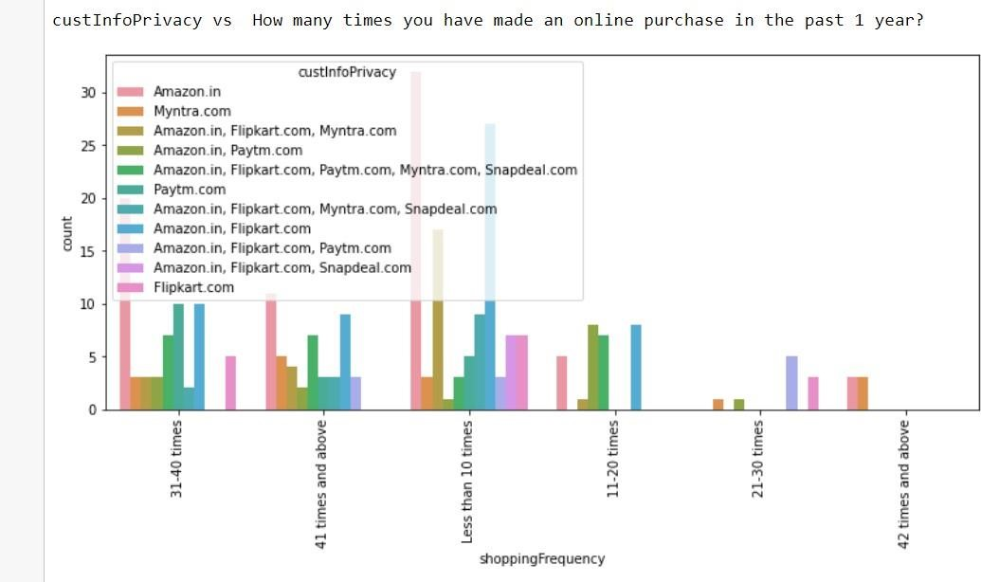

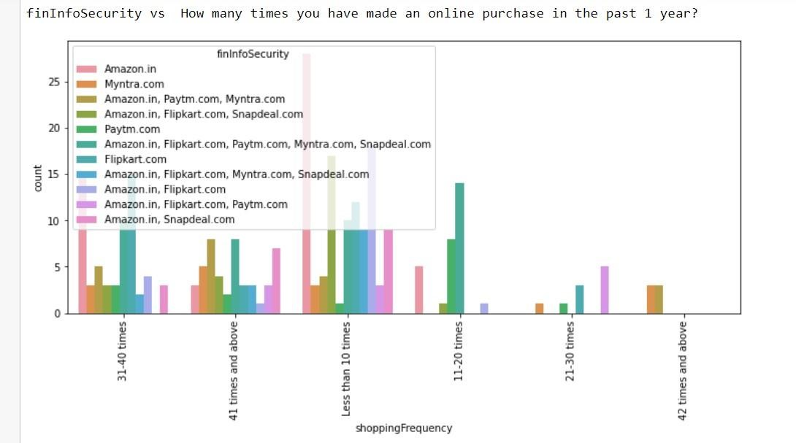

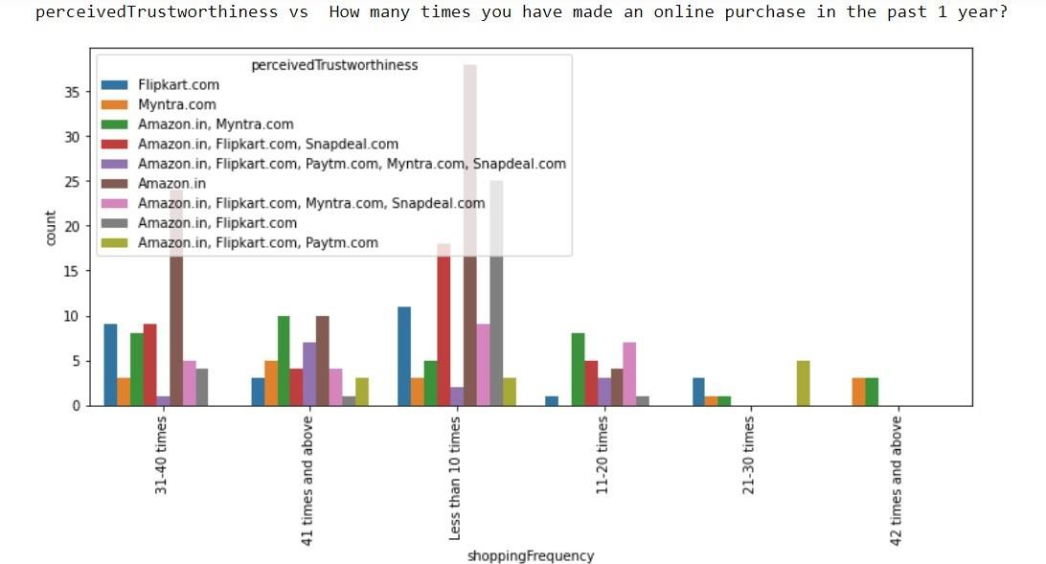

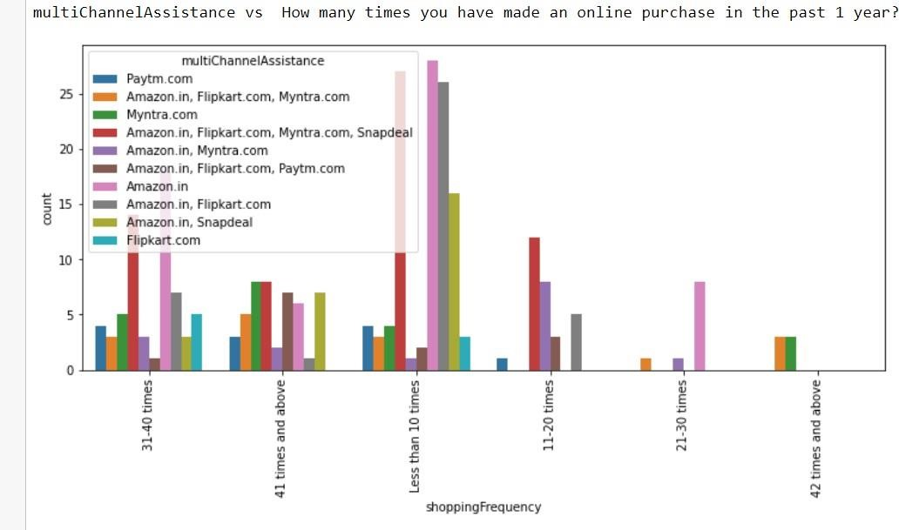

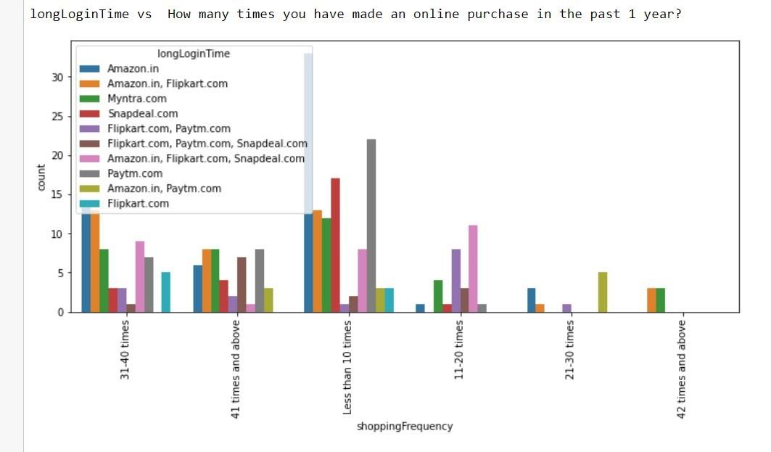

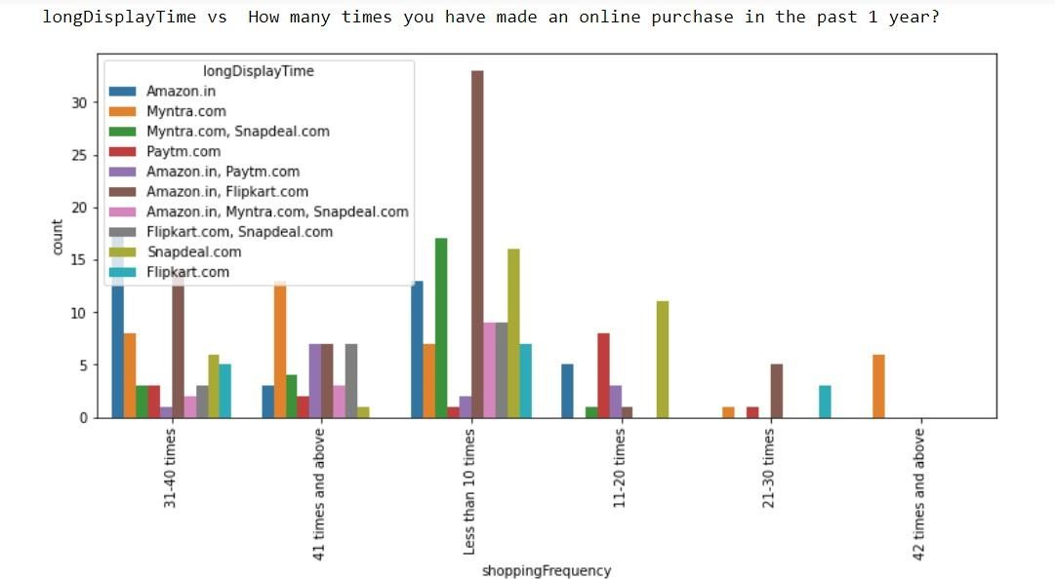

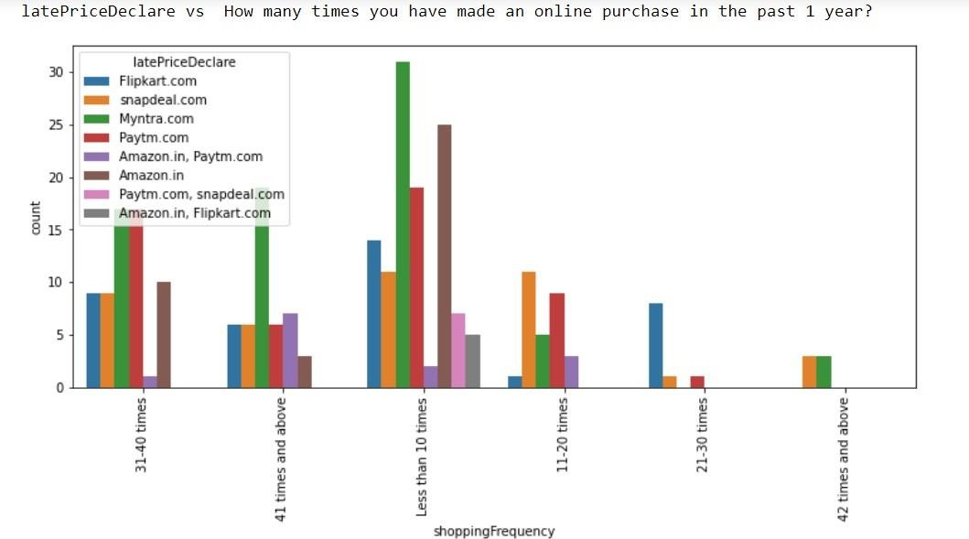

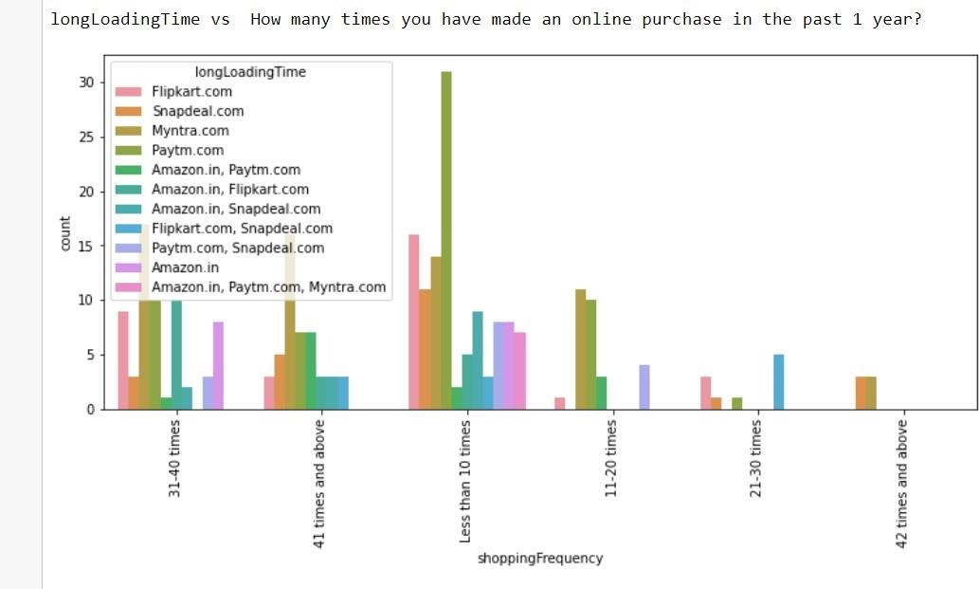

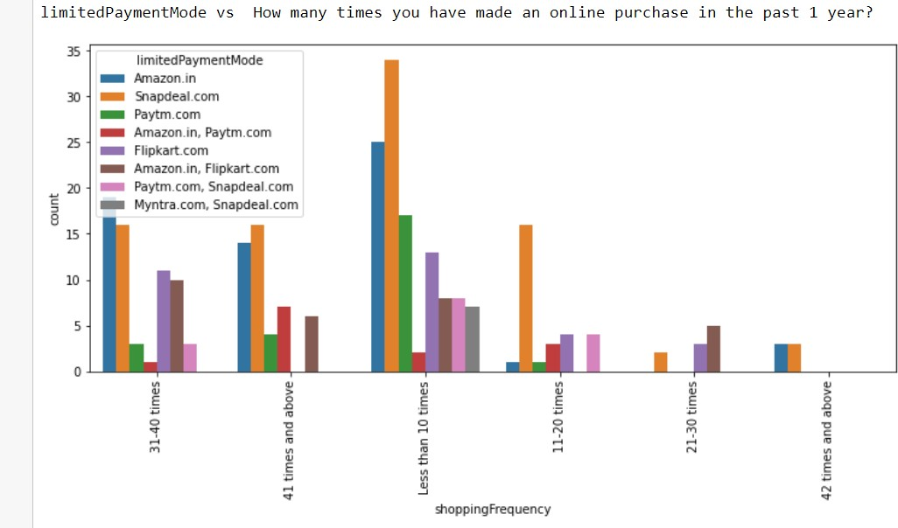

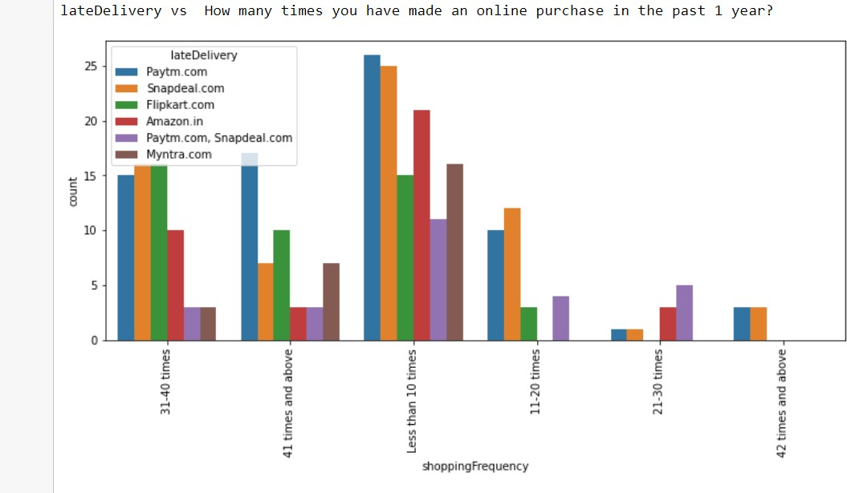

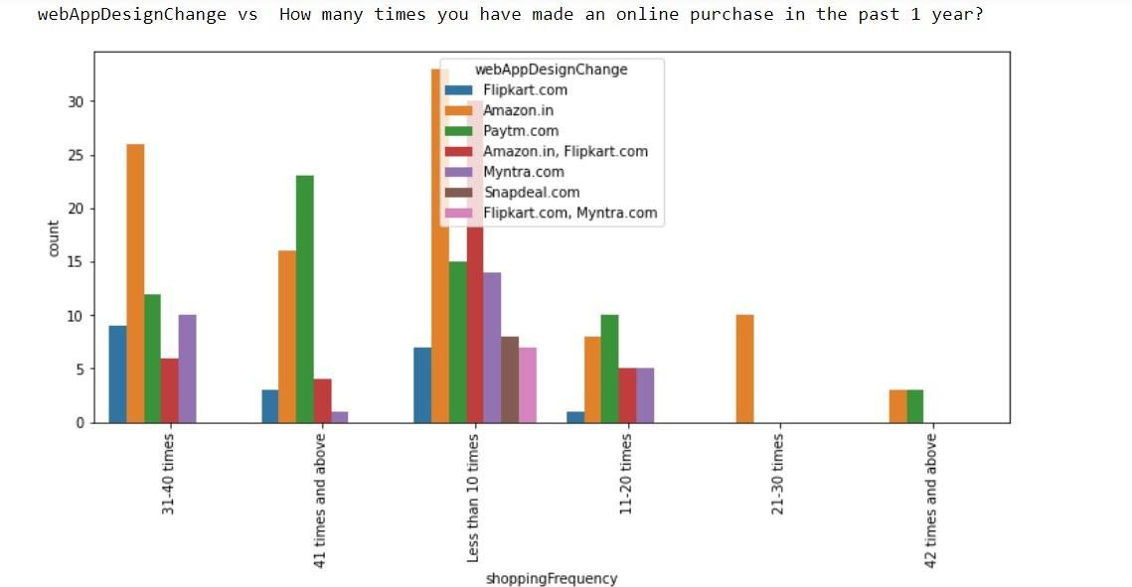

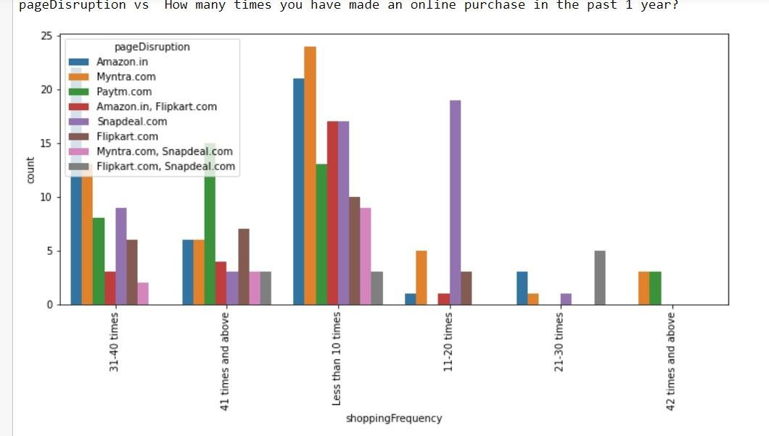

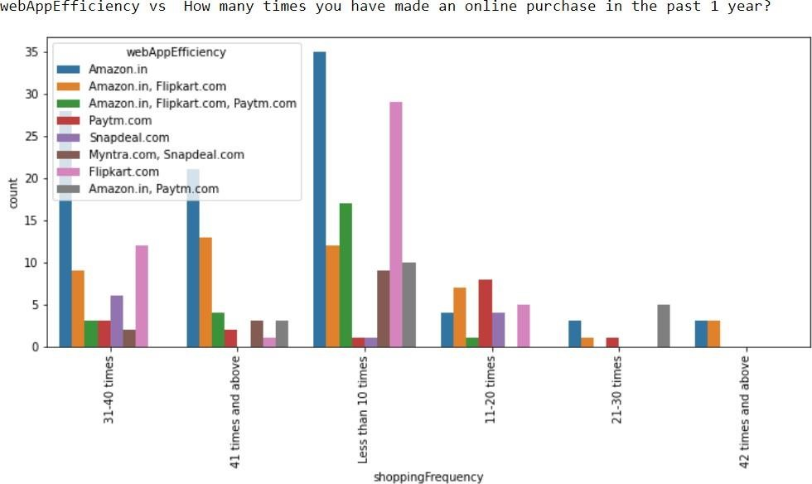

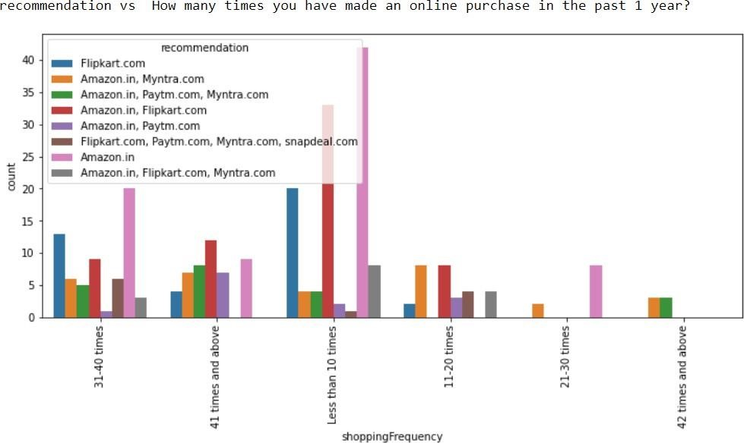

**OBSERVATION**

* Females have shopped more number of times in last 1 year

* Most of the individuals that do online shopping are from the age group 21-30 yrs. and, 31-40 yrs. People below 20 years, &people over 50 years of age do not do much online shopping.
* Customers from Delhi, Noida & Bangalore region have shopped most number of times
* Most customers who are shopping online from 1 to 4 years have shopped less than 10 times and customers shopping online for above 4 years have highest purchase count in all more than 10 times group
* Most customers spends more than 15 minutes before making decision irrespective of the purchase count
* Most of the customers generally preferred credit/Debit cards for payment followed by cash on delivery. Very few customers opt for E-wallet payment.
* Most customers who purchased less than 10 times abandoned the cart due to better alternative offer. Customers purchasing more than 41 times abandoned due to promo code not applied Or better alternative offer

* It can be seen clearly that all customers irrespective of the purchase count strongly agree with the empathy which means empathy is very important for customer satisfaction and hence retention. The reason is insecurity amongst the customers. If they have a provision of a helpline number associated with the website, that sense of insecurity vanishes and the customer can trust the website more. A 24X7 support is a must for these online retail stores.
* Maximum customers agree with online shopping being flexible, irrespective of purchase count as it provides freedom to shop without the influence or pressure from sales staff often encountered in offline stores.
* We can clearly see that return and replacement policy plays an important role in customer satisfaction.
* Displaying quality Information on the website improves satisfaction of customers: Most of the customers strongly agreed to this. Shoppers expect online retailers to provide all relevant and accurate information about the product. Providing appropriate information can help online retailers to dispel concerns and fears of consumers towards a particular product or online shopping
* User satisfaction cannot exist without trust: We see that, user with lack of trust have shopped less number of time. It means, trust is an area where online shopping still lags as several instances have been reported of customers being duped on receiving products that did not match the description claimed or turned out to be knock-offs. So, it is important for companies to learn how to manage consumers' trust
* Customers who have shopped more than 30 times strongly agree that net benefit from online purchase leads to user satisfaction Hence net benefit derived is an important factor for customer retention
* Offering a wide variety of listed product in several categories: Customers having purchase frequency of more than 30 times strongly agree to it. It means product variety increases consumers' likelihood of finding a good match with their preferences
* Customers with high purchase (>30) agree to get monetary savings
* Almost all customers with high purchase agree that they get value for money spent.it indicates that quality of product sold plays an important role in customer retention
* Highest number of customers have shopped from amazon, Paytm and Myntra

* Highest number of customers like amazon, Paytm and Myntra web page layout

* Highest number of customers like amazon and flipkart in terms of variety of product offered
* Highest number of customers like amazon and flipkart in terms of relevant and complete description of products
* High proportion of high purchase frequency customers like amazon and Paytm in terms of website speed
* Highest reliability is obtained by amazon and flipkart

* Highest number of customers like Amazon in terms of quickness to complete purchase
* In terms of payment option Amazon, Flipkart and Myntra are liked most by the high purchase frequency customers
* Amazon stands apart in terms of speed of order delivery and privacy of customers information
* Most of customers like amazon in terms of online assistance through multichannel

* Most user claims flipkart to take maximum login time during sales/promotion

* Highest customers claims Myntra take maximum time in displaying graphics and photos

## INTERPRETATION OF THE RESULTS

Amazon & flipkart are liked by most number of people, in terms of online shopping

# CONCLUSION

## KEY FINDINGS AND CONCLUSIONS OF THE STUDY

Customer retention doesn't improve overnight. Customer retention is fickle when customer service is lacking. Few ways to improve customer retention can be as follows:

* **Easily navigable :** 90% customers agreed that the website should be easily navigable. Website navigation is a key to the success of any e-commerce website. It should be clean, clear and user-friendly. Online store should create easy-to-use navigation on website to make sure that, customers don’t get confused while surfing the site.
* **User-friendly websites:** 87% customers agree with user friendly website interface. The online stores should invest heavily in creating user friendly apps and websites, so that the customers do not have to work around much and the overall shopping experience is smooth,& shoppers get what they want faster and without running into unnecessary complexity that can clog up the path to purchase. It should focus on the user experience by providing shopping categories, filters, and comparison capabilities. User-friendliness requires that your website works on all browsers and devices
* **Improve return & refund policy:** Return policies are an essential feature of any ecommerce website .90% customers agree that return and replacement policy helps them making purchase decision. It is evident from the fact that people cannot actually try & touch the products ,they are purchasing before it reaches home and they would want to return or replace in case of dissatisfaction. Online shopping websites should make strategies around easy return and replacement policy if they want to retain their customers. This is another trust-building feature of online selling. ,which reassures buyers that if they are unhappy or just need a different size, the brand is there for them.
* **Privacy Policy:** Being able to guarantee the privacy of the customer:92% Customer agreed to this. Costumers are concerned about the unauthorized access to their data. Building trust with the customers is crucial for any e-commerce website. An e-commerce privacy policy statement makes business more transparent regarding how you collect, manage, and use data from site visitors.
* **Displaying quality Information on the website:** 90% customers agree all relevant information on listed products must be stated clearly. Content is one of the crucial challenges for any e-commerce website. it’s simply not enough to just list a product name and image on a product page and expect the orders to roll in.

Compiling a compelling array of product data, whether that’s dimensions, MPNs or spec sheets can all help to convert customers better.

* **Responsiveness, availability of several communication channels (email, online rep, twitter, phone etc.):** 90% customers agreed to it. In case one channel is not available, customers can reach out to multiple channels which again is an important factor. Being able to communicate easily can make the difference in both their shopping experience as well as fulfill business goals of online store.

When customers are satisfied with a company or service, there is a high possibility that they will share their experience with other people Therefore it is crucial for E- commerce to take into account their customer satisfaction because this will retain customer loyalty as well as attract potential customers.

## LEARNING OUTCOMES OF THE STUDY IN RESPECT OF DATA SCIENCE

This project has demonstrated the importance of sampling effectively, modelling and predicting data.

Through different powerful tools of visualization we were able to analyse and interpret different hidden insights about the data.

## LIMITATIONS OF THIS WORK AND SCOPE FOR FUTURE WORK

Since the given dataset is very small. The analysis will be limited in scope .More data of such customers will definitely help increasing the probability of findings drawn above